AFB/PPRC.22-23/5

Project/Programme Category: Regular project Country: Armenia
PART I: PROJECT INFORMATION

PROJECT/PROGRAMME PROPOSAL TO THE ADAPTATION FUND
DATE OF RECEIPT:
ADAPTATION FUND PROJECT ID:
(For Adaptation Fund Board Secretariat Use Only)

Title of Project/Programme: “Artik city closed stone pit waste and flood management
pilot project” Type of Implementing Entity: NIE
Implementing Entity: “Environmental project implementation unit” SA Executing Entity: Ministry of Nature Protection of RA
Amount of Financing Requested: 1,435,100 (in U.S Dollars Equivalent)

Table of Contents
PART I: PROJECT INFORMATION 1
PROJECT BACKGROUND AND CONTEXT 5
PROJECT OBJECTIVES 14
PROJECT COMPONENTS AND FINANCING: 15
PROJECTED CALENDAR 22
PART II: PROJECT JUSTIFICATION 23
- PROJECT COMPONENTS 23
- PROJECT ECONOMIC, SOCIAL AND ENVIRONMENTAL BENEFITS 59
- ANALYSIS AND COST-EFFECTIVENESS OF THE PROJECT 68
- CONSISTENCY WITH NATIONAL/SUB-NATIONAL STRATEGIES, PROGRAMS & OTHER RELEVANT INSTRUMENTS 78
- COMPLIANCE WITH RELEVANT NATIONAL TECHNICAL STANDARDS AND ESP OF THE AF 81
- DUPLICATION OF PROJECT WITH OTHER FUNDING SOURCES 87
- LEARNING AND KNOWLEDGE MANAGEMENT 88
- CONSULTATIVE PROCESS UNDERTAKEN DURING PROJECT PREPARATION 89
- JUSTIFICATION FOR REQUESTED FUNDING / FULL COST OF ADAPTATION REASONING 94
- SUSTAINABILITY OF PROJECT OUTCOMES 95
- OVERVIEW OF ENVIRONMENTAL AND SOCIAL IMPACTS AND RISKS RELEVANT TO PROJECT 99
PART III: IMPLEMENTATION ARRANGEMENTS 102
- ARRANGEMENTS FOR PROJECT IMPLEMENTATION. 102
- MEASURES FOR FINANCIAL AND PROJECT RISK MANAGEMENT. 104
- MEASURES FOR ENVIRONMENTAL AND SOCIAL RISK MANAGEMENT 105
- MONITORING AND EVALUATION ARRANGEMENTS 111
- RESULTS FRAMEWORK FOR THE PROJECT 112
- PROJECT ALIGNMENT WITH RESULTS FRAMEWORK OF THE AF 117
- DETAILED BUDGET WITH BUDGET NOTES 121
- DISBURSEMENT SCHEDULE 127
PART IV: ENDORSEMENT BY GOVERNMENT & CERTIFICATION BY IE 128
- RECORD OF ENDORSEMENT ON BEHALF OF THE GOVERNMENT 128
- IMPLEMENTING ENTITY CERTIFICATION 128
ANNEXES
ANNEX 1: Questionnaire ANNEX 2: List of Participants ANNEX 3: Maps
ANNEX 4: Extract from the Decree of Artik City Community Council
List of Tables

TABLE 1: ANNUAL MEAN TEMPERATURE AND PRECIPITATION CHANGES FROM 1929-2012 RELATIVE TO THE 1961-1990 AVERAGE CHANGES 6
TABLE 2: PROJECTED CHANGES IN ANNUAL AND SEASONAL AVERAGE TEMPERATURES IN ARMENIA COMPARED TO THE AVERAGE FOR
1961-1990 ⁰C 11
TABLE 3: CHANGES IN ANNUAL AND SEASONAL PRECIPITATION IN ARMENIA COMPARED TO THE AVERAGE OF 1961-1990 MM 12
TABLE 4: RESULTS OF THE STUDY OF LAND QUALITY INDICATORS IN THE COMMUNITIES INCLUDED IN THE PROGRAM 37
TABLE 5: LANDS SUBJECT TO IMPROVEMENT BY COMMUNITIES 37
TABLE 6: THE QUANTITY OF MINERAL, ORGANIC FERTILIZERS AND SEEDS PER YEAR 39
TABLE 7: CLASSIFICATION OF MUDFLOW STREAMS IN THE TERRITORY OF ARTIK CITY ACCORDING TO MASS COMPOSITION 45
TABLE 8: SOCIAL COMPOSITION OF SURVEY PARTICIPANTS 57
TABLE 9: PARTICIPANTS’ RESPONSES TO QUESTIONS INCLUDED IN THE QUESTIONNAIRE 57
TABLE 10: PREFERRED TOPICS PER COMMUNITIES 58
TABLE 11: COMPARATIVE ANALYSES OF ENVIRONMENTAL AND COST-EFFECTIVENESS OF IMPLEMENTING MEASURES 71
TABLE 12: CODES AND TITLES OF THE FIELDS OF ACTIVITY IN STANDARDIZATION ACCORDING TO THE CLASSIFIER OF STANDARDS OF RA.86
TABLE 13: RISK CATEGORIZATION AND INITIAL BASELINE ASSESSMENT OF THE PROJECT ..99
TABLE 14: FINANCIAL AND INSTITUTIONAL RISKS AND MITIGATION MEASURES 104
TABLE 15: ENVIRONMENTAL AND SOCIAL RISK ASSESSMENT AND MANAGEMENT 105
TABLE 16: TIME FRAME FOR THE GRIEVANCE REDRESS MECHANISM 110

List of Figures

FIGURE 1: DEVIATIONS OF AVERAGE ANNUAL AIR TEMPERATURE IN ARMENIA FROM THE AVERAGE VALUES FOR 1961-1990 6
FIGURE 2: DEVIATION OF SUMMER (A) AND WINTER (B) TEMPERATURES IN ARMENIA IN 1935-2012 FROM THE AVERAGE VALUES FOR
1961-1990 7
FIGURE 3: DEVIATION OF ANNUAL AVERAGE PRECIPITATION IN ARMENIA FROM THE AVERAGE OF 1961-1990 8
FIGURE 4: NUMBER OF EXTREME HYDROMETEREOLOGICAL EVENTS (FROST, HAIL, HEAVY RAINFALL AND STRONG WINDS) OBSERVED IN
ARMENIA IN 1980-2012 9
FIGURE 5: DISTRIBUTION OF ANNUAL AVERAGE TEMPERATURE IN ARMENIA IN (A) 1961-1990 AND (B) PROJECTIONS FOR 2071-2100, RCP 8.5 SCENARIO 12
FIGURE 6: DISTRIBUTION OF ANNUAL AVERAGE PRECIPITATION (MM) IN ARMENIA IN (A) 1961-1990 AND (B) PROJECTIONS FOR2071- 2100, RCP 8.5 SCENARIO 13
FIGURE 7: WIND ROSE FOR ARTIK CITY 45
Acronyms

AF Adaptation Fund
ESP Environment and Social Policy
RA Republic of Armenia
FNC First National Communication
SNC Second National Communication WMO World Meteorological Organization
UNFCCC United Nations Framework Convention on Climate Change MENR Ministry of Energy Infrastructures and Natural Resources EPIU Environmental Project Implementation Unit
NGO Nongovernmental organization
GEF Global Environment Facility
STAR System of Transparent Allocation of Resources EIA Environmental Impact Assessment
EPIU Environmental project implementation unit KfW German Development Bank
PMB Project Management Board
IE Implementation Entity
NIE National Implementing Entity
AFB Adaptation Fund Board
M&E Monitoring and Evaluation
AOP Annual Operating Plan
QSR Quarterly Status Reports
AMR Annual Management Reports
OPM Operations and Procedures Manual GAP Gender Action Plan
PMU Project Management Unit
KM Knowledge Management
Project Background and Context

Shirak province (marz) administrative district where the project is envisaged to be implemented is located in the north-west of the Republic of Armenia bordering Turkey in the west and Georgia in the north. “Arpi lake” national park is located in this marz. The climate of the marz is mountainous with cool summers and severe and long winters. Annual precipitation is 500-600 mm. The absolute minimum temperature in Armenia was recorded in this area which was -46˚C.

Shirak marz in known for its reserves of tufa, pumice, and limestone mines, especially Artik region which is located in the southern part of the marz. The region is located on the volcanic plateau and foothills and is known for its favorable conditions for grain crop and livestock development. For years exploited stone pits have had negative impact on the environment. Previously, more than 60% of the total volume of construction stone products of the country was produced in Artik and its adjacent communities. Many mines were closed due to reduction of construction stone consumption volumes; however, no conservation and reclamation works of these closed mines have been carried out thus causing many environmental problems. Hundreds of hectares of agricultural and natural landscapes were degraded and lost its natural way of restoration due to the exploitation of mines. Dust through strong winds and solid remnants through snowmelt and rainfall spread over great distances polluting natural agro landscapes. As a result, there is a decrease in the yield of agricultural crops, crop quality, and adaptation level of natural landscapes to climate change.

Another problem is increasing the frequency of severe floods in the last 20 years, which is due to the spring temperatures that are not typical for the region. If until 1980s the air temperature reached 20-250C within one and a half months, now it is rising quickly and unevenly. As a result, this accelerates snowmelt causing the emergence of strong floods. The negative impact of such climate change is also lies in the fact that industrial waste of the mines is dumped into two storm canals passing through Artik city territory significantly reducing their capacity. During intense spring snow melt and heavy rains, flood waters overflow residential and public buildings, lands, gardens, streets, and yards. This phenomenon is repeated every year. Flood that occurred in June 2016 caused more than 210,000 USD damage to Artik city infrastructures and population. The elimination of the consequences of such floods cannot be done only by means of the city budget. The budget of the city and adjacent communities does not allow implementing procedures to eliminate negative impact of repeated floods and other issues created by the closed stone pits to the environment.

CLIMATE CHANGE OBSERVED IN ARMENIA

Trends in ambient air temperature and precipitation changes

Changes in annual ambient temperature and precipitation in Armenia have been assessed for various time periods; the results were used in preparations for First National Communication
(FNC) and Second National Communication1 (SNC). These results show that, in recent decades, there has been a significant temperature increase (see table 1 and figure 1). In the period of 1929-1996, the annual mean temperature increased by 0.40C; in 1929-2007 by 0.850C; and in 1929-2012 by 1.030C.

Table 1: Annual mean temperature and precipitation changes from 1929-2012 relative to the 1961-1990 average changes
Time period | Air temperature,  0C | Time period | Precipitation, mm  (%)
1929-1996 | +0.4 | 1935-1996 | -35(-6)
1929-2007 | +0.85 | 1935-2007 | -41 (-7)
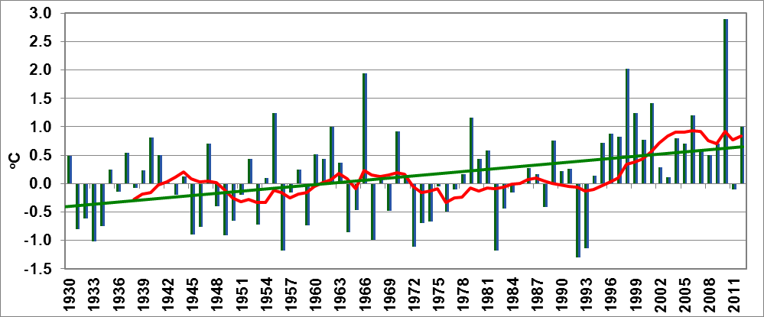
1929-2012 +1.03 1935-2012 -59 (-10)

Figure 1: Deviations of average annual air temperature in Armenia from the average values for 1961-1990

On 31 July 2011 the absolute maximum temperature of 43.70C for the entire period of observations in Armenia was recorded in Meghri region, which exceeded the previous record by 0.70C. Over various seasons of the year ambient air temperature changes exhibit different trends. In 1935-2011 the summer average temperature increased by about 1.10C, and extremely hot summers have been observed over the last 17 years (1998, 2000, 2006, 2010) (see figure 2a). Winter temperature changes look different: seasonal mean temperature increases are insignificant at 0.40C (see figure 2b).

1The Third National Communication of the Republic of Armenia to the UNFCCC has been developed by the Ministry of Nature Protection of the Republic of Armenia in the frames of the “Enabling Activities for the Preparation of Armenia's Third National Communication to the UNFCCC” UNDP/GEF Project. http://www.nature-ic.am/en/publication/THIRD-NATIONAL-COMMUNICATION/7367

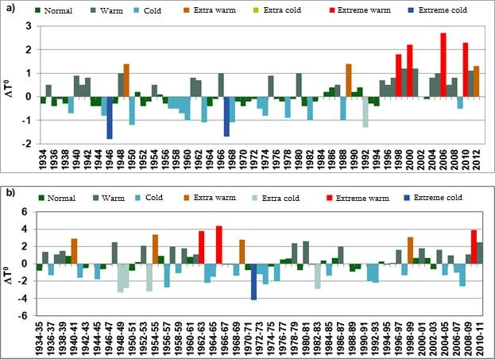

Figure 2: Deviation of summer (a) and winter (b) temperatures in Armenia in 1935- 2012 from the average values for 1961-1990

The comparison of changes in the assessment of precipitation amounts for different periods demonstrates that precipitation continues to decline. Observations showed that, in 1935-1996, there was a 6% decrease in annual precipitation, while in 1935-2012 it was close to a 10% decline (see figure 3).
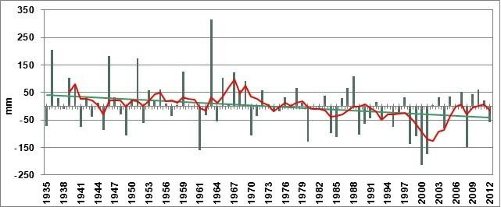

Figure 3: Deviation of annual average precipitation in Armenia from the average of 1961- 1990

The spatial distribution of changes in precipitation amounts is fairly irregular. Over the last 80 years, the climate in the northeastern and central (Ararat Valley) regions of the country has turned arid, while precipitation has increased in the southern and northwestern regions, as well as in the western part of the Lake Sevan basin.

Trends in atmospheric circulation changes

Atmospheric circulation is a key factor for climate formation which, in the territory of Armenia, is expressed as an influence of Western air streams peculiar to sub-tropical zones. There have been changes of general circulation processes in the atmosphere as a result of the global climate change. Climate change related risks and the frequency of hazardous hydro- meteorological phenomena have increased over the last decade as a result of changes in global atmospheric circulation. For this purpose, a study was conducted on the regional daily, monthly, and annual thermo baric fields for 1948-2008; 14 types of processes determining the climate of Armenia have been identified.

Cyclones penetrating into the territory of Armenia mostly come from the Mediterranean Sea, Asia Minor regions (from Syria and northern Iraq), and sometimes from northeastern Africa. Cyclones transiting the country create more clouds and more intensive winds at velocities up to 25-30 m/sec.

The entrance of southern cyclones into the territory of Armenia is accompanied by thunderstorms, heavy precipitation and more intensive south winds. The average amount of penetration of southern cyclones has increased by 24%, which has increased the number of days with intensive rainfall in the entire country. The number of events with heat depression has increased by 107%; therefore, increasing recurrence of summers with high thermal background and scarce rainfall.
Late spring and early autumn frosts, strong winter frosts, and strong winds are mainly due to Scandinavian anticyclones, the frequency of which has increased by 71%. This shows that the recurrence of hazardous atmospheric phenomena in the territory of Armenia caused by these anticyclones is expected to grow. The occurrence of formation of Iranian anticyclones in the territory of Armenia has increased by over 63%, resulting in the increased recurrence of heat waves. The occurrence of weakly expressed steady pressure fields not leading to any hazardous meteorological phenomena has decreased by 26% in Armenia.

Hazardous hydrometeorological phenomena

In recent decades, climate change has significantly increased the frequency and intensity of natural disasters both in Armenia and globally. The marginal values so far recognized characterizing these phenomena have also changed. Damage caused by hazardous hydrometeorological phenomena to the economy and to human life has increased. Extreme events (hail, frost, strong winds, heavy rainfall, floods, droughts, heat waves) may be contributing to the generation of natural calamities (or their escalation), such as landslides, avalanches, mudflows, forest wildfires, rock-falls, outbreaks of infectious diseases, etc.

To reveal trends in extreme hydrometereological events, the dynamics of phenomena most frequently observed in Armenia from 1980-2012 were analyzed, including: frost, hail, strong winds, and heavy precipitation. The maximum aggregate number of 245 hazardous events was observed in 2004; the minimum number of 106 events in 2006. The amount of hail was greatest in Shirak valley; heavy precipitation was most common in Tashir and Ijevan regions; more frost events were observed in Ararat Valley and pre-mountainous regions.
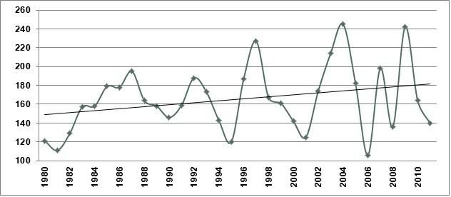

Figure 4: Number of extreme hydrometereological events (frost, hail, heavy rainfall and strong winds) observed in Armenia in 1980-2012

The analysis showed that:
- The number of crop frost events has increased significantly, which may have the following explanation: the annual mean temperature increase in Ararat Valley mostly occurs in March, which triggers the earlier start of vegetation; the sharp temperature fall in April consequently increases the frequency of frost events;
- The number of days with heavy precipitation and hail has increased. This is due to the higher frequency of penetration of high cyclones generating heavy rain and hail clouds.

Extreme Climate Indexes

The increase in the frequency of extreme climatic phenomena is one of the main indicators of climate change. 30 indexes recommended by the World Meteorological Organization (WMO) for the entire territory of Armenia for 1935-2012 have been assessed. These indexes can be applied to several sectors such as: public health, agriculture, water resources, etc.

The number of summer days (Tmax> 250C) has significantly increased, particularly in arid semi- desert and steppe zones (3.9-4.9 days/10 years); the number of tropical nights (4.6 days/10 years) has increased in the dry desert zone. For the same period, the number of cold days (1.1-
3.5 days/10 year) has decreased, while there has been a reduction in the number of frosty days (0.4-3.1 day/10 year). The duration of heat waves has increased from 1.6-5.4 days/10 year, while the duration of cold waves has fallen to 0.3-2 days/10 years.

The average number of consecutive dry days is particularly high in Meghri and Ararat (61 and 58 days respectively). The average number of consecutive dry days in Yerevan is 42; the maximum of 63 days was recorded in 2010.

In 1935-2012 the number of dry days increased in almost all zones: the maximum of 3 days/10 years was recorded in the dry sub-tropical zone.

Given the particular importance of the effect of hot and cold waves on public health and agricultural crops, a deviation of ±30C from the norm of the daily maximum ambient air temperature for the maximum (minimum) daily average of five and more consecutive days was estimated in 1961-1990.

The average value of heat waves in the different climatic zones of Armenia varies between 12- 26 days, while the maximum value is 34-70 days. The average value of cold waves ranged from 10-20 days, and the maximum value is 31-70 days.

It should be noted that the maximum number of cold waves in Armenia was recorded in 1982; the maximum number of heat waves were in 1998, 2000, and 2010. An analysis of annual change trends in the aggregate quantity of hot days in several settlements proves that the duration of heat waves has significantly increased over the last 30 years. For instance, in Yerevan in 1981-2013 the heat-wave average has increased by about 40 days, while the duration of cold waves has decreased by 1.4 days for the same period.
CLIMATE CHANGE PROJECTIONS

Climate change in Armenia is assessed using the CCSM4 model in accordance with the IPCC recommended RCP8.5 and RCP6.0 scenarios for CO2 emissions. Therefore, as per the RCP6.0 scenario (equivalent to the SRES B2 scenario) CO2 concentration will be 670 ppm by 2100 and it will be 936 ppm according to the RCP8.5 scenario (equivalent to the SRES A2 scenario). Future change forecasts for ambient air temperature and rainfall have been developed up until 2100. The results indicate that the temperatures would continue to increase in all seasons of the year (see table 2). However, according to the RCP8.5 scenario, starting from the mid-21th century (2041-2100) the temperature would rise at a more rapid rate. According to the RCP8.5 scenario, it is very likely that, by 2100, the average annual temperature in Armenia would be 10.20C, which exceeds the baseline (1961-1990) by 4.7 0C.

Table 2: Projected changes in annual and seasonal average temperatures in Armenia compared to the average for 1961-1990 0C
Seasons | 1961-1990average | Scenarios | 2011-2040 | 2041-2070 | 2071-2100
Winter | -5.3 | RCP, 6.0 | 1.4 | 2.6 | 3.6
Winter | -5.3 | RCP, 8.5 | 1.7 | 2.8 | 4.4
Spring | 4.3 | RCP, 6.0 | 1.3 | 2.4 | 2.7
Spring | 4.3 | RCP, 8.5 | 1.4 | 2.7 | 3.9
Summer | 15.7 | RCP, 6.0 | 1.9 | 3.0 | 3.8
Summer | 15.7 | RCP, 8.5 | 2.1 | 4.0 | 6.0
Autumn | 7.2 | RCP, 6.0 | 0.8 | 2.3 | 3.0
Autumn | 7.2 | RCP, 8.5 | 1.4 | 3.2 | 4.4
Year | 5.5 | RCP, 6.0 | 1.3 | 2.6 | 3.3
Year | 5.5 | RCP, 8.5 | 1.7 | 3.2 | 4.7

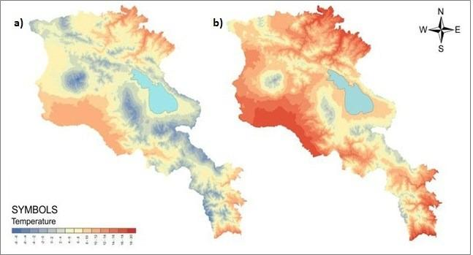

Figure 5: Distribution of annual average temperature in Armenia in (a) 1961-1990 and (b) projections for 2071-2100, RCP 8.5 scenario

Figure 5 presents spatial distribution maps for annual mean temperature for the 1961-1990 baseline, and projections for 2071-2100. It is expected that, by 2100, temperatures will increase in most regions of Armenia. Increased temperature in mountainous regions demonstrates an apparent retreat in negative temperatures (blue-coloured areas, see figure 5b). For instance, 2100 annual mean negative temperatures will be maintained only in the highlands of Aragats, Geghama, and Zangezur mountains. In general, seasonal and annual temperature and precipitation change trends are similar. It should be noted that maximum temperature growth is observed during the summer.

Evaluation results for precipitation change show that, according to the RCP8.5 scenario, there might be 16.3% increase in annual precipitation in Armenia by the mid-21st century. There will be no changes in precipitation according to the RCP6.0 scenario. However, according to both scenarios for the summer months there is an expected significant decrease in precipitation in all three periods: in 2011-2040 summer precipitation is expected to decrease by about 23% compared to the baseline (1961-1990) period.

Table 3: Changes in annual and seasonal precipitation in Armenia compared to the average of 1961-1990 mm
Season | 1961-1990  average | Scenarios | 2011-2040 | 2041-2070 | 2071-2100
Winter | 114 | RCP, 6.0 | 5.3 | 5.8 | 6.2
Winter | 114 | RCP, 8.5 | -5.7 | 16.3 | 2.9

Season | 1961-1990  average | Scenarios | 2011-2040 | 2041-2070 | 2071-2100
Spring | 211 | RCP, 6.0 | 1.2 | 4.2 | 2.6
Spring | 211 | RCP, 8.5 | 4.2 | -8.0 | 2.4
Summer | 148 | RCP, 6.0  RCP, 8.5 | -10.1  -23.0 | -10.8  -3.4 | 12.8  -13.0
Autumn | 119 | RCP, 6.0 | 5.0 | 3.2 | 1.2
Autumn | 119 | RCP, 8.5 | 2.5 | 8.6 | 13.6
Year 592 RCP, 6.0 5.3 5.8 6.2
RCP, 8.5 -5.7 16.3 2.9

The distribution of annual precipitation amount seen Armenia would not undergo significant change; however, in pre-mountainous and mountainous regions there would be a slight increase by the mid- 21st century.

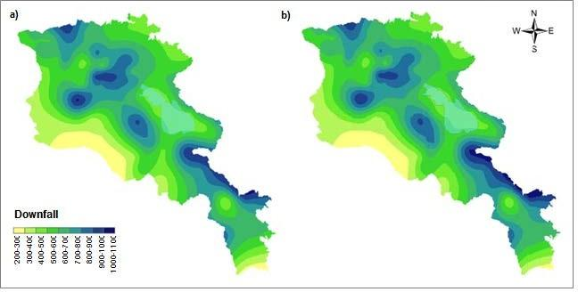

Figure 6: Distribution of annual average precipitation (mm) in Armenia in (a) 1961-1990 and
(b) projections for2071-2100, RCP 8.5 scenario

Summers in most regions of the country are usually characterized by hot and dry weather conditions. According to the model projections, these conditions would worsen, leading to a variety of problems in water resources, agriculture, energy, healthcare and other sectors. Although the results of the CCSM4 model reproduce changes in temperature fairly well, there are large uncertainties in terms of precipitation. Additionally, the resolution of the model for the mountainous terrain of Armenia is insufficient.

Summary
The analyses of the documents “Second National Communication on Climate Change under UNFCCC” country report 2009 and “Climate Risk Management in Armenia, country report 2013 show that after 1994 annual air temperature deviations were only positive.

Climate change in Armenia was estimated by the use of PRECIS, a regional climate modelling system. According to it the annual temperature in Armenia is expected to increase by 10C in 2030, 20C in 2070, while in 2100 by 40C, as well as a decrease in atmospheric precipitation, respectively by 3%, 6%, and 9%.

In recent decades intensification and rapid growth of dangerous meteorological phenomena trends is observed in Armenia. The total number of cases in 30 years is increased by 1.2, while in the last 20 years to 2.1 per year.

In Armenia climatic hazards are mainly expressed by floods, droughts, landslides, hail, and frost. Gradual increase in floods and their consequences is observed in the country. The economic damage from floods in 1994-2007 amounted to 41 million US dollars, of which more than 31% (13 million dollars) goes to the Shirak marz, where the number of downpour alert districts is 8, 41% of the surface area of the marz.

Mudflows and floods temporal distribution by years can be considered to identify the link between those phenomena and climate change. The frequency of mudflow in 2002 and 2007, as well as the frequency of floods of 2003, 2004, and 2007 coincide precisely at a time when the average annual precipitation amount was relatively high.

In Armenia hydro meteorological service information management is carried out by Hydrometeorological Service of the Ministry of Emergency situations of the Republic of Armenia, which carries out systematic observations of 47 meteorological stations, including three professional and 34 agro-meteorological, 94 hydrological stations in seven river basins (including four lake and four reservoir sites).

Project Objectives

The project objectives are to:
- Increase adaptation level of natural and agricultural landscapes,
- Prevent floods and eliminate their consequences,
- restore the natural landscape of the area affected by climate change and anthropogenic impacts, at the same time to demonstrate the possibilities of adaptation level increase of degraded natural landscapes,
- Improve the adaptation potential of community producers, institutions, and other relevant stakeholders regarding to climate change under current climate change conditions.

The project will help local communities and marz (province) authorities to develop and implement sustainable economic development taking into account the adaptation potential.
Project Components and Financing:

Project/Programme  Components | Expected Concrete  Outputs | Expected Outcomes | Amount  (US$)
1. Restoration, management, and increase of adaptation potential of natural landscapes of the area affected by climate change and anthropogenic factors. | - Restored soil cover of mine  - The restored soil layer will be protected against the winds and intense adverse effects of rain  - The area will be provided with irrigation water  - Sustainability of the adjacent natural landscapes to climate change impacts will be increased  - Crop yield and crop quality of the adjacent agro landscapes will be increased  1.1.6 Adverse effects on the health of the population of adjacent communities will be decreased  - Flood risk will be reduced  - Favorable conditions will be created for the recreation of the residents  1.1.9 Forested area will be increased | 1.1 Adaptation and sustainability of natural landscapes of the area affected by climate change and anthropogenic factors increased | 805,140
2. Prevention and management of floods | - Restoring storm canals that carry heavy snowmelt and rain water  - Protecting the storm canals from household garbage that clog these canals  - Improving sanitary condition of Artik city  2.1.4. Reducing risk of | 2.1 Social, economic, and environmental threats caused by floods as a result of climate change is reduced | 376,356

Project/Programme  Components | Expected Concrete  Outputs | Expected Outcomes | Amount  (US$)
 | epidemics
3. Raising awareness and knowledge level of population for the management of stone pit wastes and floods | 3.1.1. The level of knowledge on effective recovery methods of degraded natural and agro landscapes will be increased  - The knowledge level of the population on natural and agro landscape adaptation to climate change will be increased  - Increasing of the knowledge level of the population on the occurrence and prevention possibilities of floods  3.1.4. Promoting the importance of the sustainable thinking related to the landscape adaptation to climate change in communities  3.1.5 The involvement of local media and environmental NGOs in the process of mitigating the negative effects of climate change will be increased  3.1.6. Project results will be available to all interested parties | 3.1 Raising awareness and knowledge level of  population on the recovery of agro landscapes and flood risk reduction | 120,000
4. Total components cost |  |  | 1,301,496
5. Project/Programme Cycle Management Fee charged by the Implementing Entity |  |  | 112,400
6. Total Project/Programme Cost |  |  | 1,322,700/1,413,896
7. Project/Programme Execution cost* |  |  | 21,204
8. Amount of Financing Requested |  |  | 1,435,100
9. Community contribution (in-kind) |  |  | 63,000

Project/Programme  Components | Expected Concrete  Outputs | Expected Outcomes | Amount  (US$)
10. Total Project/Programme Cost |  |  | 1,498,100

Project proposal preparation grant (PPG) – 27,000 USD

*Quality assurance and technical supervision, independent midterm and final monitoring of the project, midterm and final audit.

**Quality assurance and technical supervision which was calculated in accordance with quality assurance and urban planning legal acts of the Republic of Armenia.

- Component 1: Technical supervision of construction works-1.5% of the component cost (11,175 USD) and quality assurance supervision- 0.4% of the component cost (2,980 USD);

- Component 2: Technical supervision of the works – 1.5% of the component cost (5,250 USD), and 0.4% of quality assurance (1,400 USD):

PROJECT AREA

Artik area represents mainly erosion slopes, cut with many permanent and temporary gorges. Artik city is located in south-eastern part of Shirak marz, in north-western foothills of Aragats Mountain at an altitude of 1800 m above sea level. One of the major factors that influence the climate are south and south-west air flows that cause cold weather. The Artik city climate is temperate mountain, with long cold winter and steady snow cover, the absolute minimal air temperature reaches -30ºC. There are sometimes strong winds, often fogs and snow storms. Summer is warm, relatively wet, the maximal temperature is +30ºC. The average temperature in July is 16ºC. The annual rainfall amount is 500-550 mm, snow cover height is 61 cm, soil frost depth is 110 cm. The average wind velocity is 3.0-6.0 m/sec, the westward winds prevail. There is developed non-metal mineral products industry and multi-branch farming. The area is rich in commercial construction sand, tuff, scoria, and pumice stone resources. The area acceleration is 0.3-0.4g and is situated in 8-9 point earthquake probability zone. The natural landscapes are black soil mountain steppes.

The area vegetation mostly relates to steppe type. Among the soil types the black soils prevail where forbs grass is common. The mountain steppes are presented by three vegetative formations of Gramineae Poaceae family species (Stipa, Festuca, and Bromus). Currently, there are no forests in the Shirak floristic zone but in past some areas were covered by forests based on the existence of thorny shrubs.

The common representatives of the area fauna are steppe, alpine species. It is represented by the domestic animals, birds’ reproduction. From amphibians and creepers there are species of toads, frogs, lizards, and snakes. There are large number of hares (Lepus europaeus), foxes (Vulpes vulpes), wolves (Canis lupus) and number of rodents in the area.
There are no vulnerable or special nature protected areas on the project vicinity.

There is developed non-metal mineral products industry and multi-branch farming. The area is rich in commercial construction sand, tuff, scoria, and pumice stone resources.

Mechanical extraction of tuff in Artik mines started in 1928. Since then more than 50 million cubic meters of tuff has been extracted of which only 35-40% was used as a standard building material while the rest was thrown into the environment as waste. Moreover, these wastes and abandoned stone pits occupy more than thousand hectares of fertile black soils.

Within the last 30 years, an increased average annual temperature is observed in Artik region of Shirak marz, as well as in all the regions of the country. According to Gyumri meteorological station data, which is located only 27 km from the city of Artik, the average temperature for Janury reached -7.40C, which is higher by 2.30C from the multi-annual average temperature. Meanwhile the average temperature in the warmest month of the year, which is August is higher by 1.50C from the multi-annual average temperature. The maximum temperature in Gyumri reached +370C and +360C in Artik (multi-annual average temperature was +35.50C). High temperatures were recorded in July 2014 was +330C. In 1998 in the first decade of August lasting high temperature in Shirak marz caused intense fusing of glaciers of the northern top of mount Aragats as a result of which unprecedented floods were recorded in Gegharot river system.

Unprecedented warming has been observed in 2001 and 2004. In March 4-5, 2004 the temperature reached +130C which was not observed in the last 100 years for this month. The temperature for the first 10 days in March was +20C which was higher by 60C from the norm (- 40C). During the second 10 days the air temperature was also higher from the norm with little difference. In the 3rd 10 days the average air temperature was +6.10C (norm 0.90C). March precipitation corresponded to the multi-annual average of 30.5 mm.

This unprecedented warming resulted in mudflows and rapid snowmelt of Shirak marz mountainous zone. In elevations up to 1800 m there was been no cover. Multiannual observation analyses indicate that in Shirak plateau, particularly in Artik region in early spring snow cover removal was not observed in the past. 39 communities of the marz suffered from mudflow damages caused by the early snow melting which amounted to 250,000 USD.

Similar temperature changes were also recorded during the 2010-2016.

Floods: The frequency of most dangerous floods has been intensified since 1996 and they regularly repeated in 2004, 2006, 2007, and following years.

Hail: The damage caused by this atmospheric phenomenon is greater since 2000. Hails are mainly observed in the months of June-July. Each year about 30-60% of sown areas of Artik region are damaged due to the hail.
Drought: Mostly seen in June-August. Since 2000 frequency of drought and damages caused by it has been increased.

Early spring frosts: Decrease of early spring frosts is observed in the region since 1996.

The analyses of data for the last 30 years show a steady increase in the average annual temperature and precipitation decrease in Shirak marz, which creates both environmental and social problems.

The project area covers the closed quarry (in Artik, 40 hectare) located in the administrative boundaries of Artik, Harich, Vardakar and Nahapetavan communities of Shirak marz and lands of agricultural importance.

Artik city community

The city is located 106 km far from Yerevan on the north-western foothills of Mount Aragats, at an altitude of 1800 m above sea level, in the mountainous-steppe zone. The administrative territory of Artik is 3278 ha, the total area of the built-up city is 700 hectares. Gomshadzor and Movrovi streams of the Mantash River flow through the community.

Artik administrative territory is rich in minerals - pumice, perlite, volcanic slag, clay, etc.

The climate is temperate mountainous with long, cold winters and steady snowfall. The absolute null temperature reaches -30oC. There are strong winds, frequent fogs and snowstorms. Summers are warm, relatively humid, maximum temperature reaches + 30oC. The annual average precipitation is 500-550 mm, the snow cover thickness is 61 cm and the underground soil cooling depth reaches 110 centimeters. The average wind speed is 3.0-6.0 m/sec.

The community is located in the potential intensity area of 8-9 magnitude earthquakes.

The area is dominated by the prevalence of mountain-steppe black soils by the spread of cereal grass herbs. Mountain steppes are represented by the formations of three species: Stipa, Festuca and Bromus, with no forest vegetation. Non-forested lands were previously covered with forests, the evidence of which is the presence of shrubs. The wildlife in the area is represented by steppe, high-mountainous widespread animal species.

From amphibians and reptiles here are many types of toads, frogs, lizards and snakes. Mammals include rabbits (Lepus europaeus), foxes (Vulpes vulpes), wolves (Canis lupus) and a number of rodents. There are no specially protected natural areas in the project area.

The arable lands in the administrative territory of the community make up 722.1 hectares, hay meadows are 93.33 ha, remote pastures- 660 ha, community pastures - 400.76 hectares, and
226.0 ha plots of lands (adjoining the house). 105 ha of autumn wheat and 100 hectares barley are cultivated in the community. Autumn and spring wheat and barley can be grown in the community. The cultivation of fruit orchard and vegetable crops is possible only in case of irrigation. In 2017, residents of the community kept 1,030 heads of cattle and 450 heads of small cattle, 670 pigs, 12,000 hens and 580 bee colonies.

Artik's administrative territory is rich in minerals: tuff, pumice, perlite, volcanic slag, clay, etc. Mining and stone processing was traditionally developed in Artik. The automatic production of tuff began in 1928. More than 50 million cubic meter tuff mass has been extracted in the past, of which only 35-40% was used as a standards-driven construction material, and most others were mainly thrown into the environment as waste. At the same time, these wastes and abandoned quarries occupy more than 1,000 hectares of fertile soil.

In 2017, the community's population was 20,360, of which were 9,870 male, 10,490 female-. The number of families is 6120. There are 4320 pensioners registered in the community, of which 1107 are single. The number of socially vulnerable families is 1855, of which 1182 are recipients of benefits. 1446 disabled people of different degrees are registered in the community. There are 2082 students attending school and 420 attending kindergarten.

Currently, there are 4 preschools, 6 primary, 2 senior and 1 special schools, 1 aesthetic education center, 1 art school, 1 music school, 3 higher and secondary specialized educational institutions, 2 cultural centers, 2 sports schools and 1 sport complex in the community.

Harich community

It is situated 3-4 km south-east from the city of Artik. The village is located on the western slope of Aragats Mountain, at a height of 2020 m above sea level. Natural landscapes are black mountain slopes. It has black and red tufa, construction sand reserves, which are of industrial significance. Agricultural activities are mainly geared toward crop-growing. Villagers are engaged in cultivation of cereals, fodder, melons and gourds, as well as fruiting (apple, pear). The cultivation of fruit orchard and vegetable crops is possible only in case of irrigation. Villagers are also engaged in cattle breeding.

In 2017, the community's population was 1550 of which were 698 male and 852 female. The number of families is 450. There are 170 pensioners registered in the community, of which 40 are single. The number of low-income families is 162, of which 47 are recipients of benefits. There are 71 registered disabled people of different degrees in the community. There are 120 students attending school and 35 attending kindergarten.

The arable lands in the administrative territory of the community make up 380 ha, remote pastures - 3000 ha, community pastures - 487 ha, and 120 ha plots of lands adjoining the house. Approximately 110 ha of autumn wheat, 210 hectare of spring barley, 40 ha of potatoes, and 10 ha of melons and gourds are cultivated in the community. Autumn and spring wheat and barley can be grown without irrigation.
In 2017, residents of the community kept 610 heads of cattle, 350 small cattle, 80 pigs, 2000 chickens, and 100 bee colonies.

Vardaqar community

The community is located 8 km north-west of Artik city. The village is located on the Mantash River valley at 1600 m above sea level. The Vardakar reservoir is built on the Mantash River near the village.

In 2017 the population of the community was 845 people, of which 365 were men and 480 women. The number of families is 240. There are 96 pensioners registered in the community, eight of them are single. The number of low-income families is 102, of which 48 are recipients of benefits. There are 40 registered disabled people of different degrees in the community. There are 101 students who attend school and 10 children are in the kindergarten.

Agricultural activities are mainly geared toward crop-growing. Before the shutting down of the sugar plant in Spitak, a relatively large area was occupied by sugar beet sprouts. Villagers are engaged in cattle breeding and poultry farming.

The arable lands in the administrative territory of the community make up of 453.2 hectares, community pastures - 103 hectares and land plots near houses - 67 hectares. Approximately 364 hectares of wheat, 89,2 hectares of barley, and 60 hectares of perennial herbs are being cultivated in the community.

In 2017, residents of the community kept 678 heads of cattle, 380 cattle, and 2,723 chickens.

Nahapetavan community

The community is located 5 km from the city of Artik. The village is located at an altitude of 2025-2100 m above sea level, on the northern slope of Mount Aragats, and its geographical position is mountainous.

Agricultural activities are mainly geared toward crop-growing. People are engaged in cattle breeding and poultry farming. The cultivation of fruit orchard and vegetable crops is possible only in case of irrigation.

In 2017, the community's population was 1032, of which 654 were men and 600 were women. The number of families is 260. There are 63 registered pensioners in the community, of which five are single. The number of low-income families is 92, of which 44 are recipient of benefits. There are 22 disabled people of different degrees in the community. 155 students attend school.
The arable lands in the administrative territory of the community make up of 174.21 hectares, pastures 1034.65 hectares, hay meadows 17.83 hectares, and 96.35 hectares of pastures. Approximately 104 hectares of wheat and 70.2 hectares of barley are processed in the community. In autumn, spring wheat and barley can be grown in the community.

In 2017, the community kept 642 heads of cattle, 67 small cattle, 34 pigs, 1,350 chickens, and 15 bee hives.

Migration, socio-economic inadequacy, low birth rate, illness, increased number of deaths due to polluted atmosphere and the increasing number of outbound employment, lack of financial resources, lack of sales markets for finished products are the major obstacles and challenges for the development in all four communities.

Projected Calendar

Milestones | Expected Dates
Start of Project/Programme Implementation | 2018
Mid-term Review (if planned) | 2019
Project/Programme Closing | 2020
Final Evaluation | 2021

A. Project Components
PART II: PROJECT JUSTIFICATION

The project will improve resilience of highly exposed Artik city of Armenia to hydrometeorological threats that are increasing in frequency and intensity as a result of climate change (Component 2). The project will reduce the quantity of debris flowing to Vardaqar reservoir located downstream of the Artik city and the pollution of agricultural lands (300 hectares of arable land 190 ha of pastures, 15 ha of hay meadows) and 640 ha of artificial forests, 80 ha of water reservoir and other natural landscapes in the project impact area by increasing their resilience and adaptation to climate change.

The Components 1 and 2 are closely correlated as the activities to be implemented under Component 1 will directly diminish the flow of wastes accumulated during mine exploitation to the reservoir located downstream of the Artik city and agricultural lands.

The programme also has a 3rd Component that covers topics regarding awareness and knowledge raising, experience sharing, as well as national policy issues of other countries on climate change adaptation. This component is deemed required for guaranteeing the programme sustainability beyond the programme funding.

Component 1. Restoration, management and increase of adaptation potential of natural landscapes of the area affected by climate change and anthropogenic factors

The main interventions of this component will be implemented in the area of un-operated stone pit which has become degraded landscape (See below picture).
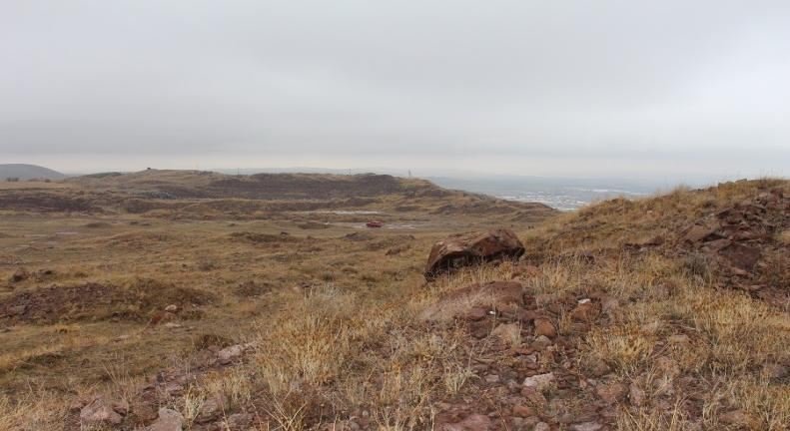
During Soviet and post-Soviet years more than 60% of construction stone of the country was produced in Artik of which only 35-40% was used as a standard building material while most of the rest were dumped into the environment as waste. As there were not any special waste dump sites they were stored at the surrounding areas of the mines. In Soviet era mainly natural landscape of Artik city and surrounding communities were used, while in post-Soviet years lands of agricultural importance which were privatized and later abandoned by the owners were used.

Mountain steppe black soils, gorges and steep slopes were mainly contaminated where forbs grass and bushes are common. As a direct effect, flora and fauna of the given area and adjacent territories has significantly become degraded and most importantly soil physical and chemical composition feature is deteriorated. Under these conditions snowmelt and rainwater surface flow is accelerated, deteriorating the quality of the soil to retain water and absorb moisture, resulting species and quantitative composition loss of flora and fauna. Such changes are accelerating the degradation processes of natural landscapes.

As a secondary effect of the stone pits are the spread of stone dust, soluble substances, and relatively small fractions into adjacent natural and agricultural landscapes through wind, snowmelt, and rain waters. Over the years their gradual accumulation has had negative impact on the sustainability of natural and productivity of agricultural landscapes.

The said effects greatly weaken self-restoration feature of landscapes and adaptation to projected climate changes. Thus, we can generalize that adverse effects of uncultivated mines and wastes can be likened to a chain whose links are natural, agricultural, and artificial landscapes, as well as aquatic ecosystems, adjacent communities, and infrastructures.

The envisaged measures will contribute to the improvement and self-recovery of more than 300 ha of arable land 190 ha of pastures, 15 ha of hay meadows, 640 ha of artificial forests, 80 ha of water reservoir and other natural landscapes in the project impact area, as well as to resilience and adaptation level increase to climate change.

As of now, full reclamation of closed stone pits has not been carried out in the Republic of Armenia and there aren't any comparisons to other available technologies and techniques for climate change adaptation. The list of works and costs was calculated by the specialists of Artik city municipality. Taking into account the area's climate and soil conditions we have come to a conclusion that soil layer recovery and establishment of forest is most effective way to counter climate change and promote adaptation of the surrounding landscapes.

As it was mentioned in the description of climate change trends in the Artik region and in Armenia over the past 30 years a steady increase in the average annual temperature of the region has been observed. In addition, decrease in summer precipitation and intensification of extreme climatic events has created both environmental and social problems.
The situation is further aggravated when current climate change and projections are not taken into account determining anthropogenic impact on ecosystems and landscapes. In case of Artik city, dozens of stone pits have been exploited in the last 100 years which were not reclaimed. Stone pit areas are mainly mountain steppe landscapes with 20-25 cm soil layers and grass vegetation. If until 1990 there was some natural recovery of grass vegetation in the area of disturbed landscapes, then since 1990 that natural process has slowed down due to intensive repeated spring snowmelt and heavy rains. Bare and brittle rocks under high summer and low winter temperatures erode quickly, pour into the runoff canals, clogging them and causing the occurrence of floods in various parts of the city. It can be stated that although the Armenian law provides for the reclamation of exhausted mining areas, unfortunately it has not been implemented for stone pits in this area. Partial leveling of ground pattern has been made in some stone pits without soil layer restoration.

Outcome 1. Natural and agricultural landscapes of the area affected by climate change and anthropogenic factors restored, managed, and adaptation potential increased.

Measures achieved under this outcome will eliminate human-induced adverse effects and would demonstrate the level of increase of adaptation ability of fully disturbed natural landscapes, as well as will create waste management mechanisms, reduce waste impact on the environment, and improve territories.

In the last 30 years due to repeated strong snowmelt and heavy spring rains these areas have lost their ability to restore naturally. Another issue is that piles of wastes have been accumulated during mine exploitation which have changes the physical structure of natural landscapes and made the restoration of landscapes inefficient. New eco-engineering approaches are planned to be applied in the current situation.

Outputs 1.1.1-1.1.3 and 1.1.6-1.1.9

The measures being proposed under Outputs 1.1.1-1.1.3 and Outputs 1.1.6-1.1.9 to address this issue include:
  - Restore the area base on to the principle that the newly developed landscape will be more adaptable to climate change.
  - Selection of trees, shrubs, and herbs that are suitable considering the climate change affects.
  - Increasing vegetative cover (through agro-forestry, vegetative bundles, and trees) for slope stabilization through the planting more resilient trees, shrubs, and herbs to the climate change. This will help rehabilitate vegetative cover in the project impact zone, as well as have a vegetation cover which would contribute to the conservation of fauna specific to the area.
  - Construction of irrigation water system for the effective maintenance of the above mentioned landscape.
  - Landscape design for the creation of a recreational areas for the population and transfer it to Artik municipality for future protection and maintenance.
Components 1 and 2 are closely correlated as the activities to be implemented under Component 1 will directly diminish adverse impact of the debris flow on the reservoir located downstream of the Artik city and agricultural lands.

The component will focus on disseminating the best practices in the adjacent communities where there are abandoned and deserted mines.

The following activities are envisaged to be carried out to reach Outputs 1.1.1, 1.1.7, and 1.1.9:

- Establishment of forested park in the closed stone pit area:
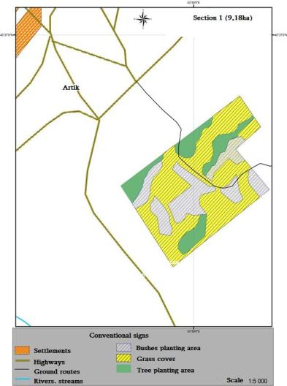
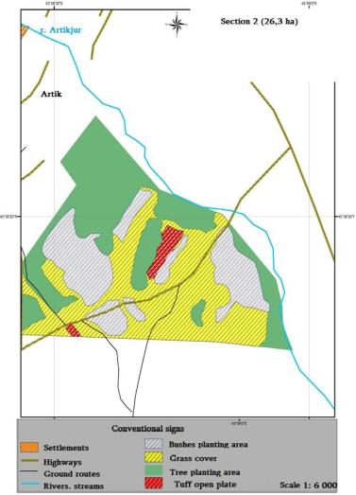
The possibilities of the creation of forest park and recreation area in the territory of the closed stone pit has been studied and evaluated, as well as the planting and fencing of 2 hectares adjacent to the reservoir at the administrative border of Vardakar community. A schematic maps was developed based on Artik city community cadastral map using ArcGIS (WGS-1984- UTM-Zone 38N) system and in collaboration with designers. The area was divided into three sections and schematic maps were drawn for each area (Sections 1, 2, and 3).
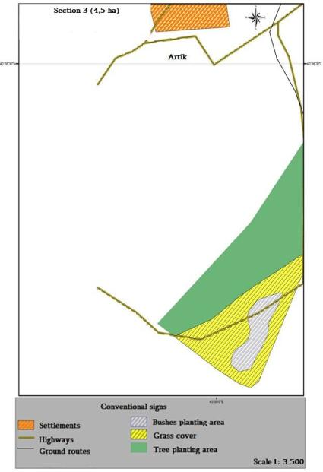

Areas suitable for planting trees and shrubs, sowing of grass, as well as non-usable areas that can be used for the design of the recreation zone (mostly tuff slab) have been identified in the schematic maps.

Besides, a 2 ha area near the reservoir was also studied in the administrative district of Vardakar, where planting and fencing works are planned and accordingly a schematic map of the area has been developed.
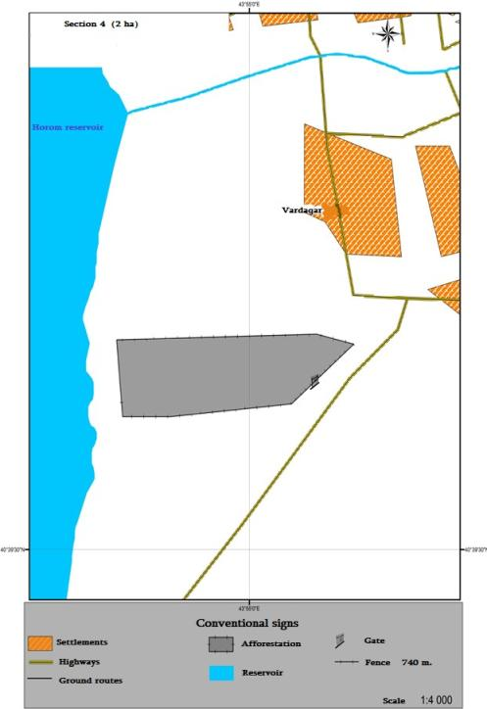

Given the natural climatic, soil conditions, as well as growth and development peculiarities the list of trees and shrubs proposed for the region has been compiled.

The wind protection, water protection, and aesthetic significance of forested area is considered to be primary.

The pine tree (Caucasian) was chosen as the main tree species, in addition ash , maple, and elm trees are considered for planting. Tree planting is planned in comparatively thicker soil layers on about 16 hectares. In approximately 10 ha of land where soil depth is medium, variety of shrubs will be planted, which will form superficial roots that cover the upper layer of the soil and promote the prevention of soil erosion. Thus they slow down wind speeds and flow of snow dust by creating an obstruction.
The dense foliage of the trees decreases the destructive force of rain, keeping a certain amount of water in the foliage, while the root system ensures the soil strength reducing the risks of erosion and landslides.

Tree planting, selection of trees and shrubs types have been done, taking into account the following principles:
  - The necessity of creating green zone near Artik community,
  - Improvement of degraded areas near the community,
  - Characteristics of tree and shrub growth and development,
  - The necessity to increase adaptive capacity of natural landscape and to restore a natural landscape that has been damaged by anthropogenic effects,
  - The need for increased knowledge of the population on climate change, adaptation, and ecology.

- Creation of a recreational zone in the closed stone pit area

Creation of a recreational zone envisages two main stages of work:
- Technical - during which filling of pits, trench digging, ground leveling hydro-technical, and meliorative infrastructure is being developed.
- Biological - during which agro-technical activities are being carried out to improve soil quality and promote adaptability of the area.

Landscape adaptation measures should be systematic, that is to say different options should be envisaged for future use.

Since the stone pits near Artik city have been exploited openly and there are soil accumulations in the area, it is envisaged to carry out the groundwork mainly with accumulated soil, and in case of necessity to use additional black soil.

The area of the closed quarry is a complex of open tuff plates, rock accumulations, open wastes, earth mound with stone scraps. There are also areas with thick layers of soils in the marginal parts of the quarry. It is envisaged to use the soil layer of adjacent mounds and marginal areas for filling the pits and smoothing in certain areas.

Black soil is planned to be used in some areas with thin layer of soil, which will enable to create grassy areas. In those areas, where the soil layer thickness is up to 50 cm, shrub planting is planned, while in areas with a soil thickness of 1 m and more- planting of trees are envisioned.

The following group of activities is envisaged for the creation of recreation zone:
  - Earth works,
  - Tree planting /5.1 ha/,
  - Shrub planting /2.3 ha/
  - Creating green spaces /1 ha/,
  - Installation of leisure pavilions /20 pcs/,
  - Installation of benches /50 pcs/,
  - Waste bins installation /20 pcs /,
  - Construction of alleyways /0.,2 ha/.

The following tree-shrub species (see picture) which are adapted to the climate of the area may be used:

1. | False acacia | 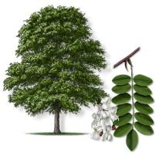 | 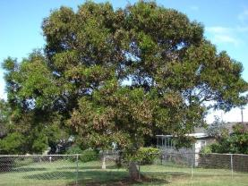
2 | Pine | 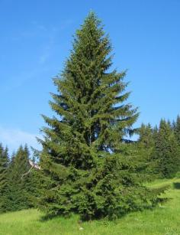 | 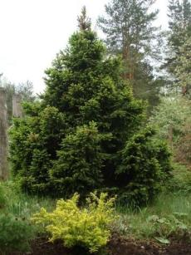
3 | Georgian Mystery | 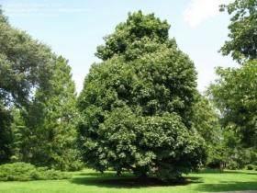 | 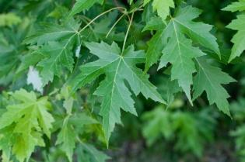

4 | Poplar Canadian, Anthrax | 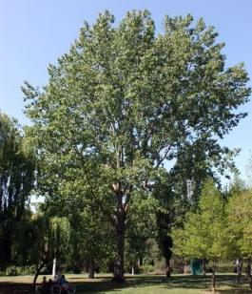 | 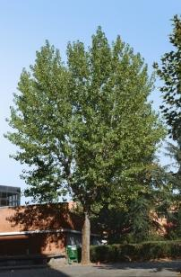
5 | Elm Flat | 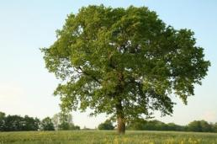 | 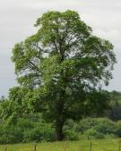
6 | Jungle cossack | 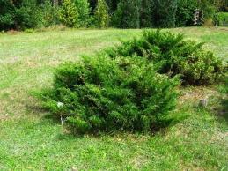 | 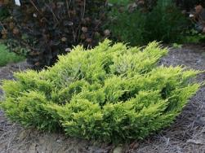
7 | Juniper roof | 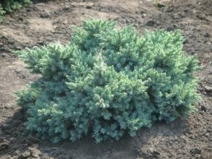 | 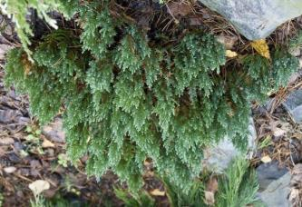

 | Birch stunts | 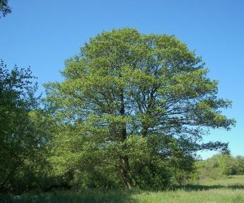 | 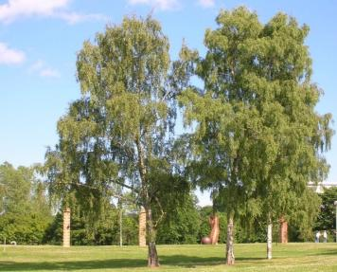
 | Birch Litvinov | 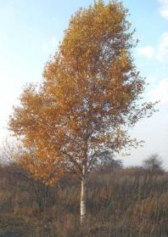 | 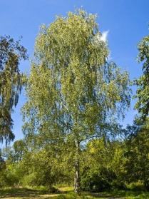
 | Horsemeat | 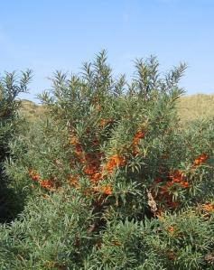 | 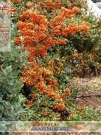

 | Briar | 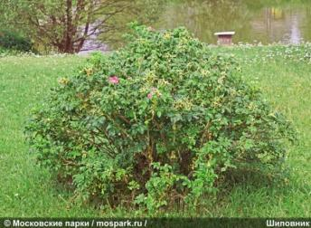
 | Briar | 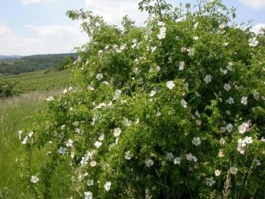 | 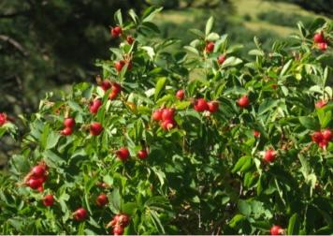
 | Raspberries | 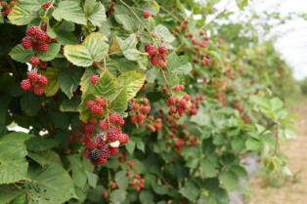
 | Aspirak | 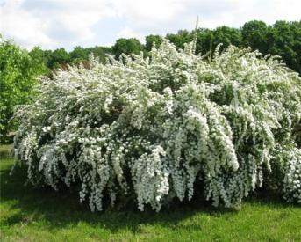 | 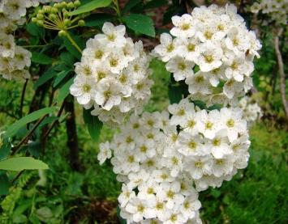

 | Mok oring Caucasian | 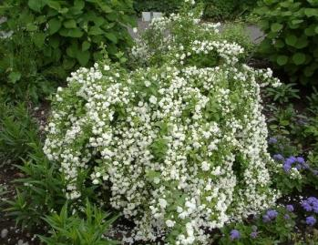 | 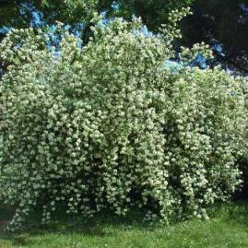

- Agricultural equipment for planting and cultivating trees and shrubs

  - Planting – is carried out in spring or autumn by hand by creating of 0.5X0.5 m pits. Taking into account the soil-ground conditions, 0.01-0.02 cubic meters of black soil is added to each pit (the amount of black soil in terms of trees and shrubs is different ).

  - Additional planting – during the second year of planting, mainly in spring. Before carrying out this activity, it is necessary to make the inventory of trees and shrubs. If the survival rate is 80% and above, the additional planting may not be necessary.

Taking into account soil and growing conditions it is envisaged that due to irrigation, the survival rate may be 60%, which means that in the second year 40% of the new planting should be replanted.

  - Attendance - During the first year of planting 5-time care works are planned through weeding and loosening.

Taking into account growing conditions in Vardakar community, the caring is envisaged four times in the first year. The first care should be done immediately after planting, as the soil becomes hard after planting and there is an intense loss of moisture from the soil, which leads to survival reduction. In the following years, care will be provided by the city of Artik.

  - Irrigation is an important ingredient for the care and protection of the planted trees and shrubs, which is mandatory in the first three years. It is planned to irrigate 3-4 times a year.

  - Creating grassy areas is envisaged in the most unfavorable conditions of forest growth( thin layer of soil rocky and degraded areas).

- Requirements for planting and seedlings
  - The seedlings should be 3-4 years old, have a well-developed, undamaged root system, and must comply with accepted standards and the root system of the pike should be covered with soil.
  - During the whole process of forest park establshment it is necessary to provide adequate specialists (one forest expert and one landscape designer) and availability of equipment (transportataion means, tractor, etc.).
  - Ensure at least 60% of tree survival in the first year.

- Impact forecast/expected outcomes
Implementation of the planned activities will enable to ensure:
- Increase of the adaptive capacity of natural landscape affected by anthropogenic impacts,
- Prevention of flood and dust clouds as well as reducing their effects,
- Raising awareness of the population on climate change and adaptation,
- Creation of jobs and improving social-economic condition,
- Involvement of the population in environmental activities and increased participation of the public in environmental decision-making,
- Improve the attitude of the population towards the environment.

1.1.3. The area will be provided with irrigation water

Irrigation water system is planned to be built to achieve this output. This is conditioned by the fact that in the Artik region no forestation can be carried out without irrigation.

The irrigation system will originate from the springs situated 800 m away from the closed quarry whose water is used to provide water for the livestock of the town and adjacent communities. It is planned to collect unused water and to direct it to the closed quarry area with PVC pipes. In the frontal part of the closed quarry it is envisaged to distribute irrigation water through three PVS pipes to three different parts of the area. Based on the peculiarities of the irrigated areas it is envisaged to build an irrigation network, which will allow irrigating both the area of the forested park, as well as the recreation area. According to the preliminary calculations, the total length of the internal pipeline would be approximately 2,000 m.

    - Adverse effects on the health of the population of adjacent communities would be decreased, 1.1.7. Flood risk would be reduced and 1.1.8. Favorable conditions will be created for the recreation of the residents

The above mentioned outputs are directly linked with the successful implementation of activities envisaged by the outputs 1.1.1, 1.1.7, and 1.1.9. The park with planted trees and the recreation zone will be created with the purpose to protect the city from rainfall during the strong rains, as much as possible, as well as from the dust originating from open and closed
quarries nearby. These outputs have a direct and indirect measurable impact on the population.

      - Direct impact may be measured by created temporary and permanent jobs, by the operating irrigation water system, tree planting activities envisaged by design estimates of forestation and recreational zone, the presence of pavilions, benches, garbage bins, and alleys in the recreational area, as well as gradual reduction of flood flushes and dust spread through the wind.

      - Indirect measurable impact would be more visible in 3-5 years when in the in the area landslide and land degradation processes are stopped, a sustainable vegetation cover is developed, and adequate leisure conditions are created for the residents. The protection and further maintenance of the planted areas will require a labor force.

Recreation area maintenance, care, and service infrastructure will provide jobs for the population, mostly for women. Residents of Artik city and its surrounding communities will have the opportunity to spend their holidays in healthy green microclimatic conditions and if desired, to engage in more active leisure activities (jogging, hiking, etc.).

Indirect measurable impacts, 3-5 years after project completion when the tree-shrub species will protect the city from dust and dirt, will greatly contribute to improving the health of the population, especially the children and active sport and leisure.

Creating the proposed recreational area and green spaces will also be a catalyst for the development of a number of side businesses.

Output 1.1.4-1.1.5

With the activities envisaged under these outputs the program will help to improve and increase the adaptive capacity of 300 ha of arable land, 190 ha of community pastures, and 15 ha of hay meadows.

The first component of the project envisages three different types of activities:

- Transformation of 40 ha landscape, which has completely lost its self-renewal feature, into forest and green recreational areas which will increase the adaptive capacity of the area to the climate change.
- Rehabilitation and enrichment of 300 ha of degraded communal pasture and 15 ha of hay meadow vegetation cover that will not change the ecosystem but will increase the adaptive capacity of these ecosystems to climate change.
- Creation of forest cover in the area released from the reduction of water level of Vardakar community reservoir that will create a new landscape and will contribute to the formation of a relatively mild microclimate.
One of the challenges of improving the efficiency of 190 ha of arable land is to improve the physico-chemical properties of soil affected by mine dust and floods by using bio-humus and mineral fertilizers, to increase productivity and promote the socio-economic situation of the residents.

The activities under these two outputs are given below.

There have been studies in laboratory conditions of the degree of availability of humus and affordable macronutrients in degraded arable lands of flood and pit stone dust impact zone in Artik, Vardakar, Harich, and Nahapetavan communities (Table 4).

Table 4: Results of the study of land quality indicators in the communities included in the program
Community Name | Depth of soil sampling (cm) | Humus | Associated CO2 | Total nitrogen | pH in soil water solution | quantity of available nutrients  in 100 g soil (mg)
Community Name | Depth of soil sampling (cm) | % |  |  | pH in soil water solution | N | P2O5 | K2O
Artik | 0 - 25 | 2.9 | 0.75 | 0.14 | 7.5 | 2.7 | 2.9 | 28.0
Vardakar | 0 - 25 | 2.7 | 0.81 | 0.15 | 7.6 | 2.9 | 1.9 | 27.0
Harich | 0 - 25 | 2.6 | 0.27 | 0.13 | 7.1 | 2.0 | 3.1 | 29.0
Nahapetavan | 0 - 25 | 3.3 | 0.62 | 0.16 | 7.3 | 2.8 | 3.6 | 23.0
Non-degraded  arable land | 0 - 25 | 4.2 | 0.83 | 0.26 | 7.1 | 5.52 | 4.81 | 27.1

Data presented in the table indicates that in the selected areas, the content of humus and macro nutrients is low in all communities compared to non-degraded arable land.

The degree of degradation of pastures and hay meadows in the communities of Vardakar, Harich, and Nahapetavan was studied during field visits. Community areas that have been exposed by intensive pastures and stone pit dust have been selected. These two anthropogenic factors plus the climate change related effects are adversely affecting the adaptive capacity of these natural landscapes. Communal pastures and grasslands have been selected for the areas where the vegetation has been diluted by 15-25%, centuries old herb assortment and percentage ratio have been interrupted.

Based on laboratory results and field surveys in communities, areas in need of improvement was prioritized and selected.

Table 5: Lands subject to improvement by communities
Community | Arable lands subject to improvement/ha | Pastures subject to improvement/ha | Hay meadows subject to improvement/ha

Community | Arable lands subject  to improvement/ha | Pastures subject to  improvement/ha | Hay meadows subject  to improvement/ha
Artik | 132 | - | -
Vardakar | 28 | 55 | -
Harich | 60 | 70 | 15
Nahapetavan | 80 | 65 | -
Total | 300 | 190 | 15

The use of fertilization in combination with the new organic "Organomics" organic fertilizers produced by the Armenian and Norwegian joint ventures has been investigated not only to improve soil quality and plant nutrition, but also to exclude any potential adverse effects on the environment.

For the enrichment of herb species composition and for the increase of vegetation cover level in natural pastures, planting of biologically compatible perennial leguminous plants and Poaceae Bernhart will be considered.

Complex measures to increase adaptability to natural and agricultural landscapes to climate change are envisaged to be implemented within two years. Whereas, the use of the volume of mineral fertilizers in the second year of the works, will be considerably reduced.

Three options of adaptation of natural and agricultural landscapes have been studied, from which the most environmentally safe and effective one has been selected.

First year of measures:
  - Increased fertility of arable lands- N100P100K50+ organic mix 1.0 t/ha
  - Increased adaptation of pastures- N50P70K50+ organic mix 1.0 t/ha
  - Increased adaptation of hay meadows-N100P100K60 +organic mix 1.0 t/ha
  - Restoration of vegetative cover of pastures-with grasses of Arrhenatherum, Dactylis glomerata, Festuca families 2 kg/ha each + 8.0 kg/ha sainfoin seeds,
  - Restoration of vegetative cover of hay meadows with equally blend mixture of 8.0 kg/ha sainfoin + 8 kg/ha of Arrhenatherum, Dactylis glomerata, Festuca family seeds

Second year of measures:
- Increased fertility of arable lands- N30P30K30+ organic mix 0.5 t/ha
- Increased adaptation of pastures- N25P30K25+ organic mix 0.5 t/ha
- Increased adaptation of hay meadows- N30P30K25 organic mix 0.5 t/ha.

As a result of the project activities, the yield of pastures, hay meadows, and arable lands would be increased by 15-25%.

The quantity of mineral, organic fertilizers and seeds required for the activities has been calculated (Table 6).

Table 6: The quantity of mineral, organic fertilizers and seeds per year
Fertilizers | Quantity (t) |  | Cost (USD) |  | Total | Cost (USD)
Fertilizers | 1st year | 2nd year | 1st year | 2nd year | Total | Cost (USD)
Ammonia fertilizer | 41.0 | 14.2 | 10,250 | 3,550 | 55.2 | 13,800.0
Simple  Superphosphate | 44.8 | 15.2 | 11,200 | 3,800 | 60.0 | 15,000.0
Potassium salt | 25.4 | 14.2 | 7,416 | 4,146 | 39.6 | 11,563.2
Organic mix | 505.0 | 252.5 | 47,975 | 23,987 | 757.5 | 71,962.5
Seeds | 2.9 | - | 10,335 | - | 2.9 | 10,335.0
Total |  |  |  |  |  | 122,660.7

The first component of the project envisages 4 significantly different activities aimed at increasing the vegetation cover.
Transformation of 40 hectares of landscape of the closed quarry which has completely lost its self-regeneration capacity into forest and forest-recreational landscapes, which will increase the adaptive potential of the area to climate change.
Rehabilitation and enrichment of vegetation cover of 190 hectares of degraded community pastures and 15 hectares of hayfields that will not change the ecosystems, but will increase the adaptation of these ecosystems to climate change.
Establishment of a forest-covered layer in the area released in the result of reduction of water level of Vardakar community reservoir creating a new landscape and contributing to the formation of a relatively mild microclimate.
One of the challenges of improving the efficiency of 300 ha of arable land is to improve the physico-chemical properties of soils affected by mine dust and floods by using bio-humus and mineral fertilizers, to increase productivity and promote the socio-economic situation of the residents.

All envisaged activities aim at improving the adaptation of 190 hectares of pastures, 15 hectares of hayfields and 300 hectares of arable land. Implementation of this volume of work will have a positive impact on adjacent landscapes.
Improvement of pastures will contribute to increasing their productivity giving the communities opportunity to focus on the improvement of approximately 120 hectares of pastures.
The improvement of 15ha hayfields will contribute to ensuring livestock forage in winter and early spring in which case these stakeholders will not use pastures in the early spring.
Improvement of 300 hectares of arable land will increase crop yield, while the stakeholders will receive additional income, will be able to buy the necessary amount of forage during winter and, as a result, reduce the pressure on the pastures.

The activities aimed at transformation of 40 hectares of landscape of the closed quarry into forest and forest-recreational landscapes and establishment of forest layer in the area released as a result of decrease of water level of Vardakar community reservoir are detailed in pages 26-35.
The following group of activities is planned within the measures aimed at the rehabilitation and enrichment of degraded community adjacent vegetation cover of 190 hectares of pastures and 15 hectares of hayfield:

1. Purchase and transfer of mineral and organic fertilizers to communities
a) Requirements for mineral fertilizers;
Ammonium nitrate (NH4NO3) should contain at least 34.4% nitrogen. It should be packed in 50 kg double-layered waterproof bags. Ammonium nitrate should be supplied in white particles and have high percentage of solubility. It should be 100% free of harmful substances.
Superphosphate should contain at least 17% of total phosphorus. It should be packed in 50 kg double-layered waterproof bags. Superphosphate should have high solubility and be supplied in granular form.
Potassium chloride should contain at least 58% of potassium. Potassium chloride should be of high quality and excellent solubility. It should be packed in 50 kg double-layered waterproof bags. Potassium chloride should have high solubility and be supplied as granular product.
“Organomix” is an ecologically clean, biologically active organic fertilizer, which is a mixture of a biological humus, peat and compost.
Fertilizer requirements:
Chemical Composition:
• Content of organic substances -38-45%
• Total nitrogen (N) 2.5 g / 100 g
• Total phosphorus (P) 0.52g / 100g
• Potassium (K) 1,7 g / 100 g
• Calcium (Ca) 8.2 g / 100 g
• Magnesium (Mg) 0.53 g / 100 g
• Sulphate (SO4) 31000 mg / kg
• PH 7.7

Fertilization of pastures and hayfields
The degradation level of pastures and hayfields in the communities of Vardakar, Harij and Nahapetavan was studied during the field visits. The community adjacent areas extensively exploited for grazing by the community dwellers that are exposed to the mine dust impact were selected for fertilization. These two anthropogenic factors, combined with climate change, adversely impact the adaptability of these natural landscapes. The selected areas of community adjacent pastures and hayfields are characterized by less than 15-25% vegetation cover and violated range and percentage relationship of grass cover formed for centuries.
Combined fertilization will include the application of mineral and organic “Organomix” fertilizers to improve not only soil composition and plant nutrition, but also to eliminate the formation of all possible adverse impacts in the environment.
Implementation of complex adaptation measures for the improvement of natural landscapes under conditions of climate change require 2 years. Moreover, the use of mineral fertilizers will be significantly reduced within the second year of the planned activities.
The proposed activities are based on the peculiarities and methodologies of pasture monitoring and management systems in the Republic of Armenia, as well as the procedures established in accordance with relevant decisions adopted by the government of the Republic of Armenia on sustainable pasture management (Dec. N1477 from 28.10.2010 and decision N389-N from 14.04.2011)
It is envisaged to carry out the activities through surface improvements. It has been studied and proved that it is best to organize combined fertilization in the early spring during plant regrowth period by applying the fertilizers on the moist soil surface. In this case, grazing should be stopped for 2 months.
It is also acceptable to organize fertilization in autumn, in which case the plants rapidly grow in the early spring. The fact that grazing in Armenia's pastures continues until late autumn is resulting in poor enrichment of perennial herbs with nutrients and their subsequent poor wintering.
Final fertilization period /spring or autumn/ will be clarified in communities based on the climatic conditions of the year and the recommendations of the cattle breeders. Fertilization of pastures and hayfields is envisaged to be implemented by scattering fertilizers on the surface of the soil by hand. Mechanized fertilization is not desirable because it will contribute to further degradation of these areas.
3. Purchase of herb seeds and their transportation to communities
Seed requirements
Seeds must be packed in 25-50kg bags. They should be of first reproduction, with no less than 98% of assortment purity, up to 14% of moisture content, weed content not exceeding 0.5%, no less than 80% of germination capacity and disinfected.
In the conditions of Artik region it is appropriate to do seed-sowing in early spring or late autumn. In the case of early spring sowing, grazing in the area should be prohibited for 1 year. In the case of late autumn sowing, grazing should be forbidden for 6 months.
Final sowing period / spring or autumn / will be clarified in communities based on the climatic conditions of the year and the recommendations of the cattle breeders.
Enrichment of pastures and hayfields is envisaged to be implemented by hand sowing. Mechanized sowing is not recommended as it will contribute to further degradation of those areas.
Sowing and fertilization activities are envisaged to be combined and simultaneously implemented. In which case, the seeds will mix with “organomix” increasing the germination capacity.
Fertilizers and seeds will be stored in each area with the involvement of community population in fertilization and sowing activities. Workers will be provided with buckets, laces and gloves.
Preparation and implementation of fertilization and sowing will be controlled by a relevant specialist /agronomist /.

The following group of activities is envisaged within the frames of the rehabilitation measures of 300 hectares of degraded arable land.

1. Purchase of mineral and organic fertilizers and transportation to communities
The requirements for mineral and organic fertilizers are described in the section on the improvement of pastures and hayfields.
Complex measures to increase the adaptability of arable lands in the conditions of climate change are envisaged to be implemented within 2 years. Moreover, in the second year of the activities it is planned to significantly reduce the application of mineral and organic fertilizers.
The amount of phosphoric and potassium fertilizers calculated for the first year is envisaged to be applied in the autumn /October-November/, in the period of deep tillage (25-30 cm) of soil. Nitrogen fertilizer and organomix are envisaged to be applied in spring, /April/ May/ during the cultivation of soil. The amount of phosphoric and potassium fertilizers calculated for the second year is envisaged to be applied in the autumn of the same year /October-November/, during the deep tillage (25-30 cm) of soil. Nitrogen fertilizer and Organomix are envisaged to be applied in spring /April / May/, during cultivation of soil.
Fertilization will be carried out in an automated manner.
Preparation and application of fertilizers will be resumed by a relevant specialist /agronomist/.

Exposure / Expected Outputs:
Implementation of the planned activities will ensure the following:
1. Increase in the level of adaptation of natural and agricultural landscapes that have been violated as a result of natural and anthropogenic impacts.
2. Prevention of further degradation of natural and agricultural landscapes.
3. Raising the level of knowledge among the population on adaptation measures under the conditions of climate change.
4. Generation of additional income and improving the socio-economic situation.
5. Involvement of the population in the activities aimed at adaptation of natural and agricultural landscapes, increasing public participation in environmental decision-making process.
6. Changing the attitude of the population to the environment.
7. Reduction of anthropogenic pressure on approximately 120 hectares of degraded pastures adjacent to 190 hectares of improved pastures.

At the project concept development stage, the key factors that have a direct impact on the adaptation of natural and agricultural landscapes of Artik city and adjacent three rural communities affected by climate change have been identified which have been further elaborated in this fully-developed project document (PROJECT AREA, Component 1. Restoration, management, and increase of adaptation potential of natural landscapes of the area affected by climate change and anthropogenic factors, Outcome 2.1 Social economic and environmental threats caused by floods as a result of climate change are reduced).

Two key (floods, dust from closed and exploited quarries) and four additional factors (overgrazing of community pastures, absence of shift grazing, unilateral fertilization of arable land with nitrogen fertilizers, and absence of crop rotation) of natural and agricultural landscape adaptive capacity decreasing factors have been identified.

The floods are damaging the arable lands of Artik city and Vardakar rural community as well as the areas used as pastures and hay meadows.

Dust from the closed and exploited quarries damages natural and agricultural landscapes as the dust is spreads out through the wind in different directions.

The project activities would directly mitigate the negative impact of two main factors and would ultimately eliminate the main reason for the degradation of natural and agricultural landscapes in Artik city and neighboring rural communities.

For the mitigation of the negative impacts of additional factors it is envisaged to carry out demonstration activities towards increasing adaptive capacity of natural and agricultural landscapes to climate change, as well as increasing population’s awareness and knowledge.

Component 2. Flood prevention and management

Outcome 2.1 Social economic and environmental threats caused by floods as a result of climate change are reduced
The main goal of this component is to reduce hazards caused by floods and to contribute to adaptation of natural and agricultural landscapes and ecosystems in the impact zone of floods. The task of the component is to create flexible system of flood management which would contribute to reducing the vulnerability to flooding in adjacent communities of Artik city.

Climate change in the whole territory of Armenia as well as in Artik region increased the frequency of extreme phenomena which creates both environmental and social problems. Due to regularly recurring high spring temperatures, heavy rains, and intensive snowmelt, the frequency of dangerous floods increases.

Recurrent floods and strong winds due to climate change caused major damages to the city of Artik and adjacent rural communities. River Artikjur flows through the city of Artik. The river Artikjur is the left bank of the Mantash River, which flows over 19 kilometers from its estuary. The length of the river is 26 km. It starts from the north-western slope of Aragats Mountain, at a height of 3079.2 meters above sea level. The river source is a small catchment area covered with eternal snow cover. In the upper streams, the river flows mainly through the canyon and on its way receives water from several streams generated by snow melting. The catchment area is 77.0 km, the average elevation of the catchment basin is 2350 m. Artikjur River Basin has the north-west orientation. The catchment basin is administratively located in Shirak marz.

The water regime of the Artik River has not been investigated. The flow estimates for this have been calculated by the flow rate boundary intensity formula recommended by Building regulations 2.01.14-83, “Technical guidelines for the calculation of maximum river flow in the Caucasus, 1984”.

The river water regime is characterized by the following stages: spring flood, which also extend to the summer season, rainy floods, low autumn levels, low summer-autumn levels, and winter levels. The highest point of river floods which is almost always considered to be the maximum year-round, is observed in May-June. Usually, rainwater is surplused to the total wave of floods in the form of sharp peaks.

The mudflows flowing through the streams of Artikjur often cause great destructions. The water regime of the Artikjur River is characterized by smooth, long-running floods (April- August), which is due to snow and ice melting.

The maximum water level for the entire studies was 178 and 130 cm per year. The maximum water expenditure is formed during the spring thaw, when the peaks of the rainfall are settled on the entire wave of floods.

The floods of the Artikjur River begin in early May and end in June. In some years there are late rainfalls in the summer, but they do not make significant peaks. In their basin the mudflow streams bring large quantities of stone, gravel, sand, sludge, powdery soil, stub etc.
The volume of debris can reach thousand cubic meters within few hours. The flood of June 24, 2016 covered the entire basin of the Artikjur River, including its main right-wing tributary. The amount of precipitations that caused this flood within 3-4 hours was 20 to 25 mm. This flood had its peculiarities.

On June 23, it started to rain in the headwaters which turned into hail. Strong mudflow currents consisting of mud and fragments of rocks coming from steep slopes through tributaries and gorges poured into the Aritikjur River and its right tributary.

The large amount of hail, which covered the upper part of the basin with a thick layer, did not melt until the next day. Heavy rainfall started again within a few hours of the hail. The rainwater mixed with partially melted hail, flowed through all the slopes and water canals taking with it all the debris, stones, and rocks.

The following pictures demonstrate the gorges after the flood:
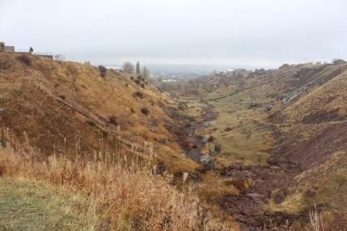
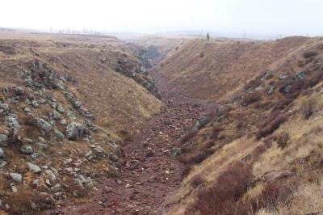
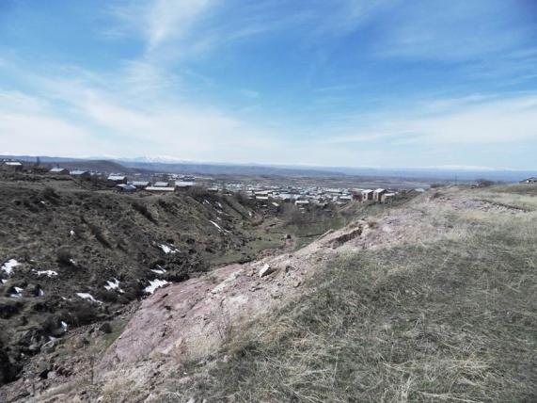

All these mudflows were poured into Artikjur River and its right tributary stream canals, flowing in the direction of the current, demolishing the bridges and buildings on its way. All this caused great damage to Artik city. The rains continued with some interruptions on June 25 and 26.
Table 7 illustrates the classification of mudflow streams in the territory of Artik city according to mass composition. The first column of the table shows qualitative characteristics of flood mass, while the lines- percentage expression of different size fragments in the given mass.

Table 7: Classification of mudflow streams in the territory of Artik city according to mass composition
Qualitative characteristics of flood mass | Percentage
Qualitative characteristics of flood mass | Large fragments, boulders of 250mm and more | Cobbles, 64-256 mm | Gravel, sludge and soil  1.0-0.1 mm | Powdery soil  0.1 mm and smaller
Water stone | 40 | 40 | 15 | 5
Mudflow | >10 | 60 | <40 | >10
Lime-gravel | 15 | 30 - 35 | 40 - 45 | 10 - 15
Mud-gravel | 5 - 15 | 10 - 30 | >50 | <30

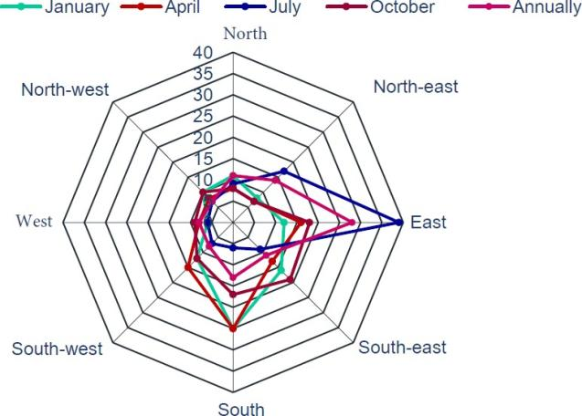

Figure 7: Wind rose for Artik city
Through strong winds, waste dust, and solid residues of mines run great distances through snow and rain, polluting natural and agricultural landscapes. As a result, a decrease in the quality of agricultural crops and adaptation capacity of the natural landscape to climate change are observed. The Figure 7 shows the wind rose of Artik city, according to which the winds are stronger in the summer months and it is directed towards Artik city.

Floods of various intensity have been observed in the area beginning from 1996 and subsequently in 2004, 2006, 2007, 2010, 2013, and 2016 causing significant damage to natural and agricultural landscapes reducing the level of adaptation to climate change. The poverty level is higher from average in the country and the damage caused by floods reduces the household incomes. The communities do not have sufficient resources to prevent floods and to eliminate the damage caused by them.

Frequently observed abnormally high summer temperatures create favorable conditions for the development of dangerous microflora and rodents in untreated or partially treated storm canals.

As it was mentioned in Component 1 the adverse effects of uncultivated mines and wastes can be considered as an integral part of the flood management. Environmental damages have not been calculated in Artik city as of today, which is a relatively large and besides direct impact it also has long-term further impact.

Taking into account Artik city geographical location, storm canals had been built which met the estimated volume requirements of snowmelt and rainwater removal at the time. However, climate changes of the recent years, sharp rise in spring temperatures, and spring heavy rains have caused new problems. Large amounts of snowmelt and rain waters at short time period flood unused stone pits and other surrounding territories bringing large amounts of soil, gravel, and large pieces of stones down into the river. As a result, the storm canals of the city are blocked and water flow floods streets, houses, roads, and backyards. The damage caused to the population by the flood of June 2016 was estimated 210,000 USD which does include infrastructure (roads, drinking water supply network, and so on).

Before reaching the city and thereafter the portion of the wastes carried by the floodwaters pollute agricultural and natural landscapes covering the soil with gravel, dust, and stones. City runoff floodwaters carry a large amount of wastes, where a portion of it pollutes the surrounding landscapes before reaching reservoir. The relatively small portion of wastewater (mainly gravel and dust) is discharged into the reservoir significantly deteriorating water quality features and reducing capacity of the reservoir.

Approximately 300 hectares of arable lands, 190 hectares of pastures, 15 hectares of grasslands, and city buildings which were in the flood impact zone greatly suffered from flood of 2016 (Youtube link https://www.youtube.com/watch?v=eNpVcHnS0S0).

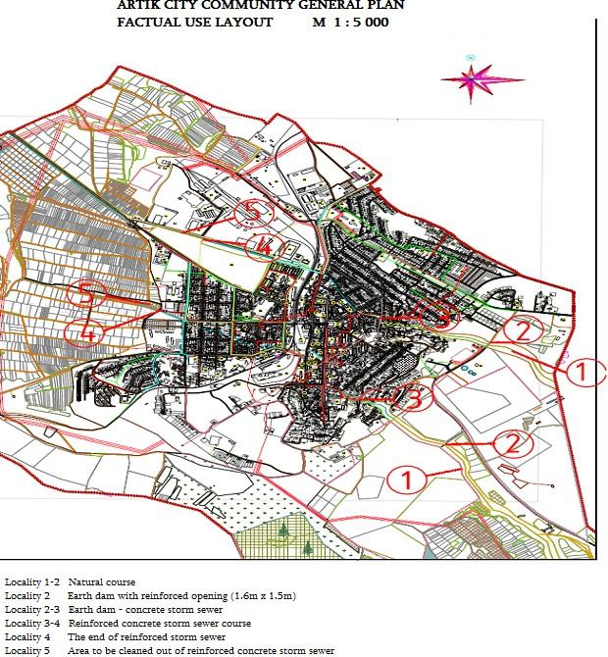

Figure 8: Layout of Artik City

The prevention of floods and stabilization of erosive steep slopes are envisaged to be carried out in the following localities of Artik city community (See Actual use Layout). The localities identified in the layout are the specific sites where the following bio and hydro construction activities are to be carried out.

Locality 1-2
  - ACTIVITY 1 - Strengthening of shores of natural courses with the installation of gabion mattress (Terramesh technology) up to 120 m long (Figure 9).
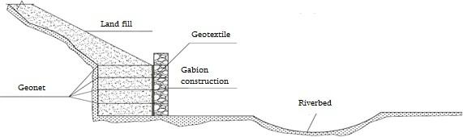

Figure 9: Gabion Mattress

  - ACTIVITY 2 - Reinforcement of earth dam with gabion constructions (Figure 10):

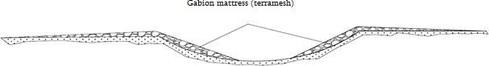

Figure 10: Reinforcement of earth dam

  - ACTIVITY 3 - Stabilization of erosive steep slopes on the right bank of the river with gabion retaining walls up to 100-150 m long.

- Locality 2-3
  - ACTIVITY 1 - Construction of concrete, overfill cascade dams of low pressure (Figure 11):

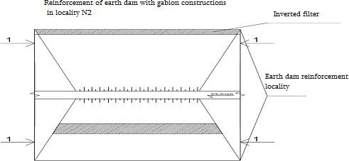

Figure 11: Concrete overfill cascade dams of low pressure

    - ACTIVITY 2 - River bed cleaning activities
    - ACTIVITY 3 - Strengthening and stabilizing of the right shores with gabion retaining walls

- Locality 3 - the bed of storm sewer-cleaning of natural bed from stones, debris and garbage up to 100-120 meters.

- Locality 3-4 and 4-5 - concrete storm sewer and the end of the sewer- annual cleaning activities of the storm sewer bed and reconstruction of its separate damaged parts (This should be done by Artik municipality and State committee of water economy of MENR).

To avoid natural disasters, the project will help to introduce an early warning meteorological system that will allow local municipalities and households to be informed of expected disasters and take appropriate preventive measures.

The pictures of localities where project activities are envisaged to be carried out are shown below:
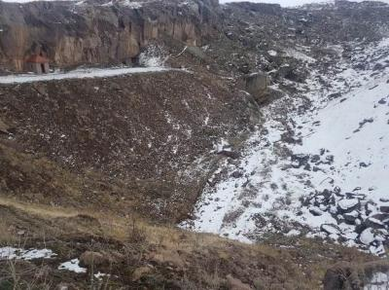
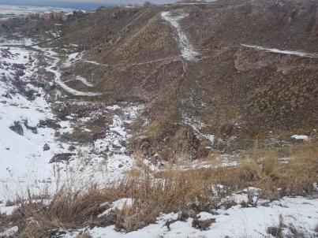

Locality 1 (Artikjur river) Locality 2-3 (Artikjur river)
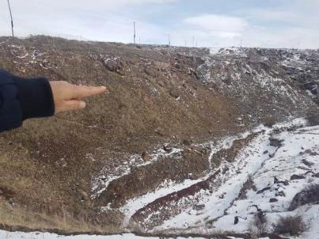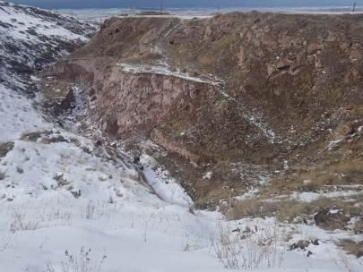

Locality 1 (tributary) Locality 2-3 (Tributary)
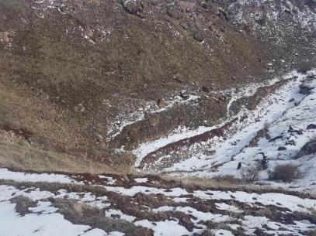
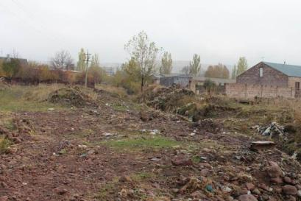
Locality 1-2 (Tributary) Locality 4-5

There is a Meteorological Station in the city of Artik since 1950, the building of which is in poor condition and needs renovation.
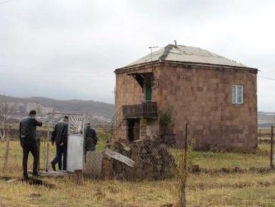
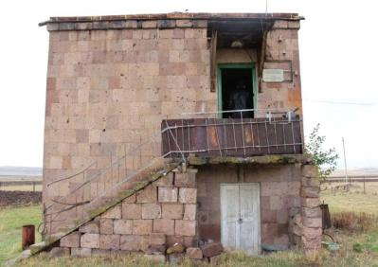
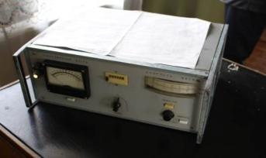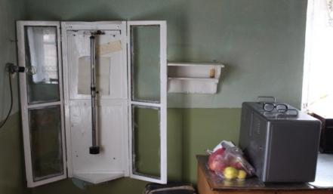

Artik city Meteorological Station

The temperature in the city of Artik, wind direction, atmospheric pressure, and humidity are measured in the station.

It does not allow for hydro-meteorological data on Aragats Mountain slopes, where the intensity and flow of floods increases with intensive snow meltdown and rainfall due to climate change. The early warning meteorological system against extreme hydro-meteorological events is planned to be installed on the slope of Aragats Mountain, which will allow processing the received data, predicting floods, wind intensification, direction, and alarm for expected disasters as well as informing authorities and population to carry out relevant preventive measures. Information on anticipated floods and other natural disasters will be provided by the Ministry of Emergency Situations via radio, television, and SMS. Artik city Meteorological Station will be renovated and provided with new equipment through the proposed project.

The proposed automatic meteorological station will perform the following measurements:

- Atmospheric pressure
- Air temperature
- Wind direction and velocity
- Number of precipitation and intensity
- Soil surface temperature
- The date and time of the measurements are fixed
- Moon phase
- Sunset and sunrise time

The automated system is connected to the computer, which is placed in the meteorological station and automatically transmits the data where data analysis is carried out at 3 hours intervals. The automatic meter system will be handed over to the Ministry of Emergency Situations for the exploitation and data processing.


Proposed System (typical)

As part of this project, trainings to prevent disasters are intended to be conducted for all local stakeholders.

Environmental damage caused by floods can be classified as direct and indirect environmental damage.

Direct environmental damages:
  - Agricultural and natural landscapes are covered with gravel and stone wastes
  - Soil quality gradually deteriorates in agricultural landscapes
  - Levels of contaminants in water increases in aquatic ecosystems deteriorating life cycles of plant and animal species
  - Sanitary and hygiene conditions of the settlements worsen resulting in a number of diseases spread.

Indirect environmental damages:
- After floods the dust is spread over large distances through winds and rain contaminating the surrounding agricultural and natural landscapes.
- Plant growth and reproduction conditions are deteriorating in natural landscapes.
- Conditions of survival and reproduction of wildlife characteristic of the area are deteriorating in the natural landscapes.
- Crop yield decreases in agricultural lands.
- Along with the spreading of dust and wastes, productivity and resilience in agricultural and natural landscapes is decreasing.
- The amount of dust coming from surrounding areas is increased in aquatic ecosystems due to late spring rains and strong summer winds.
- Water turbidity gradually increases, temperature rises, and the amount of oxygen decreases in aquatic ecosystems.
- Aquatic ecosystems are gradually losing self-cleaning feature.
- The spreading of dust through wind in summer causes allergic reactions and other diseases.

It is worth mentioning that social economic and direct and indirect environmental damages are conditioned by extracting tuff stone features. It is rather fragile and during extraction waste piles of different sizes are generated, it is stable over temperature variation (quickly decomposes and turns into gravel or sand), small fractions of wastes are rather light and are easily spread by wind or water over great distances.

Flood prevention and further sustainable management will significantly reduce direct and indirect contamination of landscapes and aquatic ecosystems thanks to which their conservation stability and climate change adaptation capability will be restored.

In collaboration with local communities, direct measures will be developed for long-term flood prevention and risks mitigation. Runoff canals will be cleaned of waste and household garbage bins will be replaced for the collection of solid household waste, tree planting and soil layer strengthening sowing will be carried out along runoff canals. Lessons learned and best practices will be shared with the other communities that are exposed to flood risks associated with climate change.

The Artik city municipality is obliged to make contributions from city budget for the long-term maintenance of project results thus ensuring sustainability of project outcomes after its completion.

This component task is to carry out measures that would reduce and manage the risk of flooding in Artik city and its adjacent communities.

The activities will include:
- Water flow mitigation measures in gorges
- Reinforcement of earth dam and stability increase in gorges
- Stabilization of the most degraded slopes
- Introduction of early warning system
- Installation of garbage bins along storm sewers passing through Artik city
- Cleaning of storm sewer course beginning from Artik city

These interventions will have direct effect on the lands and water areas located in the city as they are indirectly involved in the project impact area.
The Components 1 and 2 are closely correlated as the activities to be implemented under Component 1 will directly diminish the adverse impact of debris flow on the Artik city and agricultural lands.

Component 3. Raising awareness and knowledge of the population for the management of closed stone pit wastes and floods under current climate change conditions

The goal of the component is to raise awareness and knowledge level among decision makers and local population on the landscape and ecosystem adaptation to climate change and on efficient management of floods.

Conduction of trainings in communities covered by the project impact areas has the following objectives:
- To promote community capacity building on climate change challenges.
- To promote awareness and knowledge of the population on climate change adaptation measures.
- To increase the population's knowledge about natural disasters, their prevention measures, and early response options.
- To promote the adaptation of natural and agricultural landscapes and ensure the effectiveness of measures.
- To support the decision-makers to acquire the skills needed to analyse the current situation of natural and agricultural landscapes in the context of climate change, to develop and revise the list of necessary measures, to establish effective and collaborative relationships with stakeholders.
- To support schools to enhance capacity building among students to improve environmental education through Eco-Club establishment.
- To involve mass media and non-governmental organizations in the implementation, promotion of project outcomes and sustainability provision, as well as in the coverage of methods and forms of providing relevant information to the public.
- To provide information related to insurance schemes, particularly flood insurance scheme and the use of index, which can be utilized by private citizens and other stakeholders.

Activities are aimed at forming a base knowledge on the opportunities of the recovery of degraded areas and benefits. In order to increase the effectiveness of the activities specialists both from higher educational institutions and the Agricultural Support Marz (Regional) Centers will be involved. This approach will enable to combine environmental protection, agriculture and the urban economy efforts to develop a joint training program on the restoration of natural, as well as agro-landscapes under climate change conditions and on raising the level of adaptation.

The training program will be based on the idea of the importance of interconnectedness of agricultural, natural landscapes, urban economy and human health, as well as landscape adaptation under climate change. The provision of knowledge on measures aimed at the preservation and continuity of the outcomes of the current program will be highlighted.
Training program will provide a differentiated approach to the needs of different age groups and will develop knowledge enhancement programs for them. Particular attention will be given to the creation of groups possessing the necessary knowledge to be able to ensure the continuity of dissemination of knowledge during and after the project closure.

To increase work efficiency thematic guidelines and public information leaflets will be developed, published and provided to all interested parties. Lecturer-listener based model will be used during awareness raising trainings which will make provided material perceptible through using different actions.

After each training, the participants will evaluate the effectiveness of the program, while the experts will carry out result analysis. The positive and negative aspects of the courses will be highlighted on the basis of which recommendations will be developed to increase the effectiveness of such trainings. To increase access to best practices in knowledge and information summary report will be posted on the web sites of Environmental Projects Implementation Unit (EPIU), Shirak marz’s governor office, and Artik city.

The component would contribute to strengthening the capacity of local media and environmental NGOs, through their involvement in project dissemination, propagation, and implementation activities.

Given the Component’s objectives and problem requiring solutions, the activities will be mainly addressed to awareness and knowledge raising of those vulnerable groups that are directly related to project objectives, ways of achieving them, as well as ensuring stability and continuity. Based on lessons learned from the projects implemented by EPIU and other organizations targeted groups will be selected in communities through needs assessment.

Community administration employees, members of farm households, teachers and high school students, the mass media, as well as employees of stone pits operating in the area are determined as initial target groups.

- Community administration employees: In conformity with the law of the Republic of Armenia on Local Self-government community administrations have rather extensive rights to carry out environmental, reconstruction, health protective, construction, and other activities within their administrative boundaries. Within the project raising the knowledge of the municipal councils and staff members will contribute to the effective implementation of the activities envisaged by the projects, outcome conservation and experience dissemination. At the same time decision-makers having the relevant knowledge would make such decisions in the future that would cause little damage to the environment and in the result to people’s health.

- Members of farm households: The impact zone of the project is mainly agricultural which is carried out on relatively small plots. There are very few large farms, which are able to organize awareness and knowledge raising events for their employees. The selected target group is the
most polynomial and vulnerable as unsatisfactory social conditions restrict their opportunities to get sufficient knowledge on disaster prevention, rehabilitation of degraded areas and harmful effects of waste on human health. These target group members can most successfully spread their knowledge within communities.

- Teachers and high school students: In conformity with the Law "On Ensuring Equal Rights and Equal Opportunities for Women and Men" this target group is highlighted by the fact that they are the direct bearer and transmitter of knowledge. Women teachers’ participation in awareness raising trainings on climate change adaptation measures, introduction of early warning system and other activities of the AF project will be mandatory. Teachers endowed with sufficient environmental knowledge (focusing the objectives of the project) can form stable mindset among students on the importance of environmental events and biodiversity conservation, while among high school students both to disseminate knowledge and to decide on getting professional education. The roles played by women in the home and in the community can be eased by supporting them to develop their response to climate change impacts and natural disasters and women have to play a leadership role in developing and implementing their community’s strategy. Teachers who will take part in the trainings will be given participatory certificates and other guiding brochures as an incentive to spread their knowledge in schools.
- Mass media: Role of this target group is great on the dissemination of information on the project, coverage of event, outcome analyses, propagation of positive experience, transparency, and mobilization of stakeholders. Special training program will provide mass media with the necessary knowledge that will help them to represent the project’s goals, objectives, outcomes, and the importance of ensuring continuity to the broad strata of the society.

- Stone pit employees: This target group is the direct holder of the consequences arising from the indiscriminate use of stone pits and waste pollution of the environment. The representation of environmental, social, economic, and health problems as well as their solutions opportunities will raise their knowledge level and will contribute to be more actively involved in the suggestion of more environmentally safe events of the mines, development of activities and implementation process.

The common idea for all target groups is that the humanity can fight not only to mitigate climate changes, as well as to develop effective measures to increase the level of natural and agricultural landscapes adaptation.

Needs assessment has been done through surveys in the project-affected communities for the effective implementation of this component. A total of 120 people took part in surveys, of which 60 were from Artik community, 20 from Vardarqar community, 20 from Harich community, and 20 from Nahapetavan community. The assessment of community members' knowledge and needs has been accomplished by the following steps:

  - Questionnaires have been developed (Annex 1)
  - In the questionnaires the participants have been given the opportunity to indicate the preferred topics that the respondent considers most important for raising his/her knowledge.

The importance of knowledge and needs assessment as well as relevant training to achieve the program goals was explained in advance in the communities before the completion of questionnaires.

The questionnaires were filled out voluntarily to realistically identify those persons who would like to participate in the trainings; therefore, the survey participants were able to answer the questionnaire freely and honestly (the completed questionnaires are kept in the "Environmental Projects Implementation Unit" State Agency).

Table 8 presents the social composition of participants in knowledge assessment in communities.

Table 8: Social composition of survey participants
Communities | Female | Male | Education
Communities | Female | Male | Secondary | Secondary vocational | Higher
Artik | 35 | 25 | 22 | 8 | 30
Vardaqar | 8 | 12 | 6 | 8 | 6
Nahapetavan | 6 | 14 | 11 | 5 | 4
Harich | 6 | 14 | 12 | 5 | 3
Total | 55 | 65 | 51 | 26 | 43

Of the 120 participants surveyed 67 are working in state, community, and private sectors, 45 of them in Artik, four in Vardakar, 11 in Nahapetavan, and seven in Harich. In the rural communities surveyed participants, who checked that they did not work, had privatized lands and kept large and small cattle.

Table 9 provides results of community knowledge assessment. The level of knowledge about the proposed issues is relatively high in Artik city, where the number of educated and employed population is high. Table 10 presented the preferred topics of the survey respondents per community.

Table 9: Participants’ responses to questions included in the questionnaire
No | Questions included in the surveys | Responses | %
1. | What is your knowledge of the possibility of restoring closed quarries and other degraded areas? | Good- 9  Satisfactory- 57  Unsatisfactory- 54 | 7.5  47.5  45.0
2. | What is your knowledge of the natural disasters, in  particular the possibilities for preventing floods? | Good - 14  Satisfactory -52 | 11.6  43.3

No | Questions included in the surveys | Responses | %
 |  | Unsatisfactory - 54 | 45.0
3. | What is your knowledge on the reasons of global climate change and the projected consequences in the Republic of Armenia in particular about the protection of population’s  health? | Good- 12  Satisfactory -41  Unsatisfactory - 67 | 10.0  34.2  55.8
4. | What is your knowledge of the adaptation of natural landscapes (pasture, hey meadows, forest areas) to global climate change? | Good- 8  Satisfactory - 50  Unsatisfactory - 62 | 6.7  41.7  43.3
5. | What is your knowledge about adaptation of agricultural landscapes (arable lands, orchards) to global climate change? | Good- 7  Satisfactory- 37  Unsatisfactory- 76 | 5.8  30.8  63.3
6. | What do you think about the idea of creating an eco-club in school? | Positive - 99  Difficult to answer - 21 | 82.5  17.5
7. | What do you think about the introduction of an early warning system for natural disasters in Artik? | Positive - 83  Difficult to answer -37 | 83.0  17.0
8. | How do you imagine the possibilities of your involvement in the Awareness and Knowledge Enhancement Component during the implementation of the Project? | Positive- 80  Difficult to answer - 40 | 66.7  33.3
8.1 | Engaged in teaching staff * | 3 | 2.6
8.2 | Involved as a listener * | 112 | 97.4

* 5 participants did not answer to sub-questions 8.1 and 8.2 of the question 8.

Table 10: Preferred topics per communities
Topics | Communities |  |  |  | Total per topics
Topics | Artik | Vardaqar | Nahapetavan | Harij | Total per topics
Global climate change reasons and projected consequences in Armenia | 45 | 16 | 18 | 15 | 94
Enhancing adaptation of natural landscapes (pastures, hay meadows, forested areas) to global  climate change? | 39 | 15 | 18 | 16 | 88
Increasing agriculture adaptation to climate change | 47 | 13 | 17 | 16 | 93

Topics | Communities |  |  |  | Total per topics
Topics | Artik | Vardaqar | Nahapetavan | Harij | Total per topics
Natural disaster prevention to climate change | 68 | 15 | 12 | 14 | 109
The possibility of insurance for natural disasters | 48 | 18 | 8 | 6 | 80
Other topics | 14 | 6 | 7 | 10 | 37

Participants of the Artik and Harich communities also wished to participate in tourism related courses besides the topics mentioned above. Cattle breeding trainings was of interest to 38% of the residents of Vardakar, Harich, and Nahapetavan communities.

The whole process of project implementation will be available for all strata of society. Modern information dissemination tools will be used for this. Regular information on the progress and outcomes of activities will be provided through the websites of the Ministry of Nature Protection, regional administrations, and EPIU. Whistleblower hotlines of Ministry of Nature Protection, regional administrations, and EPIU will make it possible to rapidly respond to all complaints with the participatory problem solving approach.

B. Project Economic, Social and Environmental Benefits

At present the experience of risk management of the climate change is rather low at community and regional levels. There are insufficient skills for decision-making, long-term implementation of activities, and continuity of the experience related to climate change related effects.

The activities envisaged by the project are consistent with the objectives of protecting the population in emergency situations and do not contradict the laws of Republic of Armenia. The project belongs to Category B and some activities require special permits and environmental expertise. The potential areas and stakeholder of the project are determined through consultations at regional and local levels and site visits conducted by the EPIU specialists.

During the preparation of project documents participatory meetings were held with the population of beneficiary communities.

Innovative adaptation measures that are more stable over the long-term effects of climate change will be developed and introduced during the project implementation. These measures are important in terms of socio-economic and environmental benefits as well as contributing to raising the adaptive capacity of natural and agricultural landscapes under projected climate changes. These include:

- Application of the newest organic fertilizer, which will significantly reduce the demand for mineral fertilizers.
- Improvement of degraded natural landscapes with use of mineral and organic fertilizers with combination of herbaceous seeds characteristic of the given area.
- Increasing adaptive capacity of the landscape (exploited and closed quarry) that lost its self-restoration with shrubs and trees typical for the area.
- Mitigation of water flow with gabion retaining walls (cascade shape) instead of a concrete dam.
- Creation of grassland on degraded slopes by using plastic nets for soil stabilization.
- Installation of the new instruments in meteorological station for rapid response.
- Implementation of a comprehensive program to increase knowledge and awareness.

The implementation of the activities given in Component 2 would have direct effect on more than 13,000 residents who are considered as direct beneficiaries of the adaptation measures to be implemented in the Artik city and project impact zone. Among them majority are women, elderly, and children. Flood prevention will contribute to saving the allocations from Artik City budget, which are channeled each year to eliminate flood consequences. These funds will then be spent for the implementation of socio-economic and environmental programs.

Land pollution and degradation would be prevented in the areas that are geographically downstream from the city of Artik, and subsequent measures would help increase their productivity and increase incomes of the residents.

The expected environmental benefits and impacts within the program are of great importance and would contribute to solving a number of environmental issues. Promoting the greater coordination, cooperation and expanding capacities, the project gives an opportunity to create exemplary political atmosphere which will give a chance to increase the adaptability of landscapes and settlements to the negative effects of anthropogenic and natural climate change. It will be implemented through the natural and agrolandscape recovery, sustainable management capacity building development, and by increasing the efficiency of institutional structures.

The program will create a new bioengineering model for the preservation and restoration of biodiversity conservation which will unite agricultural and natural landscapes into one conservation planning process. In this regard, this will enable to identify and test “the best practice” which reinforces the use, stability, and flexibility of natural resources. Promoting the creation of temporary and permanent workplaces in the region of Armenia with comparatively poor population, the project would contribute to reducing poverty and welfare improvement, thus reducing the anthropogenic further pressure on vulnerable landscapes.

Natural disasters and climate changes have negative impact on the ecosystems of the area. The stream fall into Vardaqar reservoir damaging its ecosystem and decreasing reservoir’s capacity. Reservoir is used for irrigation purposes, it covers 80 hectares with a capacity of 5 million cubic meters. Implementation of the program will also help prevent soil from eroding and contributing to landslides and mudflow and conserve the ecosystems. Favorable conditions will
be created for the collection of necessary irrigation water in the Vardaqar reservoir and irrigation with agro-technical norms.

The benefits of this programme will be from the positive impacts on local livelihoods and the capacity building as well as strengthening of community population within each of the components. The programme has a strong focus on developing Artik city and affected communities’ awareness and capacities on preparedness and planning which would directly benefit local households by enabling them to understand and plan further their own and community driven adaptation actions. The programme will pursue a gender-sensitive approach whereby women’s participation in planning will be strongly promoted (through targeted training within each component and other means) and thereby increasing the beneficiary families and communities ability to adapt and support each other in the process. Monitoring of this approach will be the responsibility of the Gender Specialist.

In addition to the direct benefits of Armenia's agricultural and natural biodiversity protection and guidance, the program will provide global advantages by developing and creating tools, experience, and methodology within the program that will be globally available to all stakeholders ensuring the continuity of the program. The program will create age groups with necessary knowledge who will be able to share their knowledge with other interested communities after the end of the program. The program will promote to strengthen the capacities of local mass media and environmental NGOs. The inclusion of the best practice achieved by the five-year community development plans would contribute to the stability of the project outcomes. It is expected that adaptability and sustainability of natural as well as agricultural landscapes will be ensured through the recognition of the importance of biodiversity role and by displaying capabilities of possible natural disaster prevention under climate change by all stakeholders.

Social-economic situation and benefits

Poverty level is high in the project area, extremely poor make up 9% of the population and the poor- 44%, which is above the national average. The number of children dying under one year of age is high which makes up 12%, while the maternal mortality rate is 2.7%. Disabled people constitute 12% of the population.

The main source of income is agriculture. Climate change and natural disasters are causing great harm both to the environment and agricultural food production.

Migration, socio-economic inadequacy, low birth rate, illness, increased number of deaths due to polluted atmosphere and the increasing number of outbound employment, lack of financial resources, lack of sales markets for finished products are the major obstacles and challenges for development in all communities.
The current situation in crop cultivation and livestock sector is mainly conditioned by climate change, socio-economic disadvantage of the population, pollution with dust coming from non- operating and exploited stone mines and floods.

Community adjacent pastures are located 2-6 km away from communities. They are used by cattle breeders from late March to mid-November. There is no shift grazing. In many areas there are no watering points, as a result of which animals pass through large distances for drinking water. Since remote pastures are not generally used because of the bad roads and the poor social status of the majority of the residents, the whole load is falling on the community pastures. Due to climate warming, low rainfall in summer and prolonged high temperatures pastures are not able to recover after grazing. Pastures near the community are heavily degraded. The fertile layer of the soil has decreased and the vegetation cover becomes poor. Under these conditions many types of inedible plants species rapidly spread. In such conditions, the animals pass on large distances to find fodder and contribute to the strengthening of degradation. Because of this, adaptive capacity of pastures to climate change has diminished.

Approximately 60% of community pastures without taking special measures (grazing, radical improvement, surface improvements, etc.) within 5-10 years will turn into a landscape lacking fertile soil layer and covered with weed vegetation and will completely lose its adaptation to climate change and become a semi-desert ecosystem. Clearly, anthropogenic pressure on the other grazing areas will increase, thus decreasing the adaptive capacity of ecosystems to climate change. This on the principle of chain reaction will affect the social status and living standards of the population.

Land degradation will lead to a reduction in water resources, as well as to the decrease of adaptability of other sectors of agriculture.

Adaptation of ecosystems and landscapes to climate change consequences can only be achieved through the implementation of complex measures. This should include improving the social conditions of the population, increasing agricultural productivity, provision of financial resources for environmental measures in the community budget, using of crops most adapted to dry and hot climates, saving irrigation water, and increasing adaptability of disturbed ecosystems.

Project activities will promote:
  - Restoration of vegetation at the degraded pastures and hay meadows and increase of their adaptive capacity to climate change,
  - Additional income for livestock breeders and farmers,
  - Demonstration (fertilization, grass sowing) of the possibilities of rehabilitation of the ecosystems that have lost their adaptive capacity and cannot be restored naturally.

Lands adjacent to communities are intensively exploited due to which the qualitative composition of the soil has changed. The recurring floods cause great damage to the region that impact residential and public buildings, lands, gardens, sheds, yards and streets, as well as
domestic animals. The dust has a negative impact on agricultural crops, adjacent forests and human health.

Economic benefits

Stone pit dust has negative impact on the health of the population as well as on the forests, arable land, hay meadows, and pastures situated on the impact zone of floods. During the implementation of the project, local population can be attracted as labor force which increasing their income level. Jobless women will be mainly involved in landscaping and reforestation activities.

It is obvious that the most vulnerable groups of the population suffering most from natural disasters are villagers with small plots, adults, women and children, population without permanent jobs and low salaries etc. as they have no sufficient means to eliminate the damage caused to their property by natural disasters due to climate change.

The project will create the opportunity to prevent and minimize damage caused by natural disasters. Costs caused by floods for the reconstruction of buildings, backyard and this will be used for the needs of the families. The envisaged activities will improve 300 ha arable lands, 190 ha community adjacent pastures and 15 ha hay meadows, closed and operating quarries, degraded steep slopes situated in the impact zone of flooding, as well as will contribute to the adaptation of climate change and, as a result, to the production of agricultural products.

Armenia is one of the most vulnerable countries to climate change in the South Caucasus. Already existing climate changes has contributed to increasing the frequency of hydro- meteorological hazards such as extreme high temperatures, summer droughts, severe hail, heavy spring rains, floods, flash floods and associated catastrophic events of mudflows and landslides.

Despite some activities carried out by the government and international organization the country is failing to cope with the mounting pressures from climate hazards that increase in frequency and intensity as a result of climate change.

Damage from natural disasters in Armenia as well as throughout the world is material and intangible, which, in turn, may be direct and indirect. These indirect losses include socio- economic, legal, and political issues that often arise in the organization of temporary displacement and providing shelter to residents who suffered from the disaster-affected areas.

Intangible damages (direct and indirect) are more complex and sometimes undesirable (for example, loss of life, physical injury, loss of heritage, or irreversible damage to an archaeological object), but potentially more significant than just physical damage.

In addition, since 2000 much money was spent on the rehabilitation of roads damaged by natural disasters mainly in mountainous areas. Damage to utilities is also a serious problem and
large sums have been spent by the Government on the rehabilitation of electricity lines damaged by natural disasters.

Comparing these direct damage costs with the annual budgets of the amount/ money allocated each year by the government and local authorities it becomes apparent that the currently reactive framework within which natural disaster are dealt, is highly ineffective and costly to the government and to the communities affected.

The trend analysis provided in the above sections indicates that the magnitude of damages is on rise. If put into the perspective of long term climate change scenario that points at higher temperatures, greater concentration of precipitation amounts in the shorter periods of time and as a result, more frequent and intensive flood and flash-flood events, immediate actions are required to put more robust systems for flood management.

The implementation of this project is seeking to provide direct adaptation measures reducing the likelihood of floods and creating a rapid response system that will enable the population to avoid hazardous areas in case of flooding. In addition, it is seeking to develop long-term sustainable approaches related to the climate change risk management. The project introduces a combined method of structural defense and non-structural prevention that has proven the most effective in many countries of the developed world. Smart flood management options would deliver considerable socio-economic and environmental benefits to the people residing in the Artik region.

The soft, non-structural flood management measures, otherwise termed as bio-engineering, often tend to be more effective than structural and hard protective measures. This is true especially in the complex mountain terrains as of Armenia and particularly for the prevention of freshets that will more frequently occur as a result of the combined effect of localized, intensive rainfalls and early snow melt due to climate change driven warming. Moreover, watertight materials of hard constructions are thought to make runoff 2 to 4 times greater in comparison to terrains with natural coverage (forests, grass cover). Their rehabilitation improves landscape functions for flood management. These will also abate land erosion processes on over 300 ha of natural and agricultural landscapes (both directly and through up- scaling) that delivers significant environmental benefits both in terms of land productivity and stability for all types of land infrastructure.

This approach is especially urgent in the mountainous regions of Armenia where, according to climate change forecasts, there is likelihood of intense rainfalls and early snow melt coincidence.

The focus of the project is on the promotion of the most appropriate mix of structural and nonstructural flood management measures. The increase of adaptive capacity of the closed stone pit and proposed flood management measures include rehabilitation of the quarry area and degraded steep slopes of gorges contributing to the increase in absorption and accumulative properties of soil and as a result, reducing water flow rates and volumes.
Flood management and landscape restoration measures such as these, achieve typical benefits such as avoiding costs of damage to society, human health and well being, economic activities, infrastructure, and the environment. Environmental benefits for the Artik region will comprise a complex set of environmental attributes from which a range of market and non-market goods and services derive. These will include:

- Habitat creation through the restoration of the stone pit area by zoning development (the area will be divided into trees, shrubs, grass covering, and recreational zones);
- Maintenance/restoration of biodiversity by strengthening the functionality of the landscapes;
- Enhanced land use management through increasing knowledge;
- Runoff and soil erosion control through agro-forestry, thereby reducing losses of water, soil material, organic matter, and nutrients by conserving the soil, organic matters, and biological activity at levels satisfactory for soil fertility.

The efficiency of this activity depends on an adequate proportion of tree and shrub species. Typically, a system where at least 20% of the area is planted, improves the accumulation and further increase of organic matter in the soil. Agroforestry maintains more favorable soil physical properties than intensive agriculture, through organic matter maintenance and the effects of tree roots, particularly:

- Improvement in water quality and restoration;
- Improvement in water resources through improved infiltration, due to soil erosion, accumulation, and circulation increase.
- Contribution to the development of a green economy by providing jobs and business opportunities to local people.

In general, the environmental goods and services provided by flood management, relates to local and regional user populations in terms of the final benefits and the primary indirect user populations are households in the Artik city and rural communities that are under the project's impact zone benefitting from flood risk.

In this regard the 1st and 2nd Components will jointly contribute to the improvement of social conditions of vulnerable groups and especially women, as the money to be spent on the reconstruction or renovation of their houses or purchase of new property would be used to improve the living conditions of families, and in case of increasing the efficiency of natural and agricultural landscapes, additional revenues would be created.

Social and economic benefits for Women and vulnerable groups

Article 30 of the Constitution of the Republic of Armenia adopted in 2015 defines the equality of men and women. Article 86 of the Constitution defines that the main purpose of the state policy is to promote equality between men and women.
The main tool for achieving gender equality in the Republic of Armenia is the Law "On Ensuring Equal Rights and Equal Opportunities for Women and Men" adopted on 20 May 2013.

The Law "On Equal Rights and Equal Opportunities for Women and Men" defines main directions of the state policy aimed at ensuring gender equality, including gender equality guarantees within the state governance and public service, clarifies the forms of gender discrimination, policy development.

Based on provisions of the Law, the Government has initiated the development of a new Strategy on Providing Equal Rights and Equal Opportunities for Women and Men for 2017-2021. In relation to this programme Chapter VI. Funding for the implementation of the State Policy on Ensuring Gender Equality, Article 20: Funding for the implementation of the state policy on ensuring gender equality defines:

Financing of programs and activities provided by the state policy on ensuring gender equality is implemented through the state budget of the Republic of Armenia.

For the implementation of programs and activities by the state policy on gender equality, allocations from other sources not prohibited by law, may also be made from foreign states, international organizations, as well as allocations from other organizations (regardless of organizational and legal form) and individuals, donations and allocations, which are used exclusively to finance state, regional, and community development programs and measures to ensure gender equality.

According to the new Constitution Article 210, the new Electoral Code became effective on 1 June 2016. It provides clearer mechanisms for protection of women's rights in the political sphere which would contribute to their more active participation in the political life of the country. More effective quota for women's representation has been prescribed (25% representation of women in elective bodies instead of 20%). At the same time, a gradual approach has been stipulated, and a higher quota has been prescribed for 2021 (30%).

Moreover, the rotation mechanism is also applied, according to which in case a female deputy quits her position or assumes another one, the latter should again be replaced by a woman. As a result of implementation of Action Plan "On Promoting Gender Balance among Candidates for Judges" the tangible results targeted at increasing the level of involvement of women in the judicial system of the Republic of Armenia are already noticed.

UNDP Armenia Country Office has developed Gender Equality Strategy (2016-2020) document. The objectives of this document are twofold:
- introducing standardized system to apply gender mainstreaming (GM) across programme and operations, in line with corporate gender equality policies and benchmarks; and
- “de-mystify” for the staff the practical application of “gender mainstreaming”, “gender equality”, and other gender-related concepts and policies.

The law on "On Ensuring Equal Rights and Equal Opportunities for Women and Men" guides the project’s outcomes and promotes equality amongst all the population in the project impact zone. The project is in line with Adaptation Fund’s gender policy. This project prioritizes women and vulnerable groups within population, which is in line with the Paris Agreement and the Constitution of Armenia. Gender equity and equality are well promoted in the project as women and men both are direct beneficiaries of the project outcomes. The project will contribute to gender equality, through strategies to empower women and girls with concrete commitments to ensure equal rights, access and opportunities for participation and leadership in the project, and in community decision making. A gender sensitive approach will be integrated in all training modules and awareness campaigns. Knowledge and awareness raising activities will make sure that women and vulnerable group members have enough knowledge and can build resilience towards climate change.

Moreover, women and vulnerable group members will have direct economic benefits from adaptation measures. As a part of project components, the recovery of agricultural and natural landscapes, women will benefit from increasing productivity and efficiency of agricultural lands, as women are the main workforce in agriculture industry. Also increasing knowledge and awareness about climate change as well as adaptation would help women to plan their work more efficiently.

Activities envisaged by other component would also bring benefits to women and vulnerable groups. The establishment of eco-clubs in schools will have its contribution towards promotion of gender equality and equity. Boys and girls will attend the classes and trainings in the eco- clubs and the existence of the eco-clubs will promote equal participation and access to knowledge resources.

Through these actions the project will generate the following social and economic benefits for women:
- Increased participation of women in decision-making process in community’s development strategies
- Increased awareness and knowledge for women on climate change and adaptation mechanisms.
- Increased productivity and efficiency of agricultural lands, which will lead to increased income and improvement of livelihood for women.
- Gender sensitive approach integrated in all training modules and awareness campaigns.

Before the elaboration of the complete project document, the EPIU developed an initial study plan of Social and economic benefits for Women and vulnerable groups, which envisaged the following:
- Review of the RoA Constitution and laws;
- Study of international legal documents related to the sector;
- Study of the international conventions the Republic of Armenia has ratified;
- Analysis of the results of studies conducted by international and local organizations in Armenia;
- Data analysis of the National Statistical Service;
- Collecting and analyzing data on different social groups in the communities included in the project;
- Meetings and outcome analysis with representatives of different social groups of the communities included in the project;
- Clarification on how the project outcomes will affect women and vulnerable groups.

The analysis of the international legal documents shows that the Republic of Armenia has ratified international documents on the protection of human and women's rights, which are enshrined in the RA Constitution and the laws.
Analysis of the results of studies conducted by the international and local organizations in Armenia shows that even though human rights and gender equality are enshrined in the country's legislation, however, due to the lack of awareness and knowledge level, certain issues arise during the exercise of the fundamental human freedoms.
The analysis of data from the National Statistical Service on different social groups of the communities included in the project revealed the following:

Artik city community

In 2017, the community's population was 20,360, of which 9,870 were male and 10,490 female-. The number of families was 6120. There were 4320 registered pensioners in the community, of which 1107 were single. The number of socially vulnerable families was 1855, of which 1182 were benefits recipients. 1446 disabled people of different degrees were registered in the community. There were 2082 students attending school and 420 attending kindergarten.

2. Harich community
In 2017, the community's population was 1550 of which 698 were male and 852 female. The number of families was 450. There were 170 registered pensioners in the community, of which 40 were single. The number of low-income families was 162, of which 47 were benefit recipients. There were 71 registered disabled people of different degrees in the community. There were 120 students attending school and 35 attending kindergarten.

3. Vardakar community
In 2017 the population of the community was 845 people, of which 365 were men and 480 women. The number of families was 240. There were registered 96 pensioners in the community, eight of them were single. The number of low-income families was 102, of which 48 were benefit recipients. There were 40 registered disabled people of different degrees in the community. There were 101 students who attended school and 10 children were in the kindergarten.
4. Nahapetavan community
In 2017, the community's population was 1032, of which 654 were men and 600 were women. The number of families was 260. There were 63 registered pensioners in the community, of which five were single. The number of low-income families was 92, of which 44 were benefit recipient. There were 22 disabled people of different degrees in the community. 155 students attended school.

Analysis of the results of meetings, discussions and studies with representatives of different social groups in the communities included in the project shows that women mostly work at schools, hospitals, social services, shops, and private offices. Women's involvement is also great in agricultural work. Women are mainly engaged in the cultivation of vegetable crops. Cereal cultivation is mainly mechanized, while men are engaged in cattle breeding. Women perform 95% of housework (home care, cooking, child care, training of school-age children, etc.). During the meetings, women mentioned that these works are not compulsory. Most men help with the domestic chores, if necessary, but due to traditional perception it is considered woman's activity, which is better done by women.
All of the studies showed that families with children do not encourage performance of housework or other activities by children. In all even most poor families, priority is given to the provision of education for children at schools and higher education institutions. Parents provide the children with the opportunity to study at school and seek financial resources to further continue their children's education.
However, this does not mean that children do not help their parents with housework and the cultivation of their land plots. In many families, after completing their homework children (over 13 years old) help parents with housework and cultivation of land. This carries a learning element and gives children an opportunity to get acquainted with household and agricultural works.

Gender Mainstreaming

The gender mainstreaming approach for the project will therefore be focused on maximizing and ensuring women’s active participation as well as engagement during consultations, trainings, and awareness programs.

A Gender Action Plan will be prepared during Inception to outline proposed activities and targets in line with the gender mainstreaming approach and maximize benefits to both men and women during project implementation and an outline is attached.

The Project's GAP will be implemented by Project Management Unit (PMU) which will contract a social Gender specialist in the Project team. The specialist will be responsible for incorporating the GAP into project planning and program, including awareness workshops and establishment of gender-disaggregated indicators for project performance and monitoring. PMU will include reporting on progress of GAP activities in quarterly progress reports to the NIE.

C. Analysis and Cost-Effectiveness of the Project

The project has considered the option of addressing the climate change problem through alternative solutions. For example, consideration was given to scaling up in place traditional structural measures (including embankments, building fences and dikes etc.) by considering forward looking hazard profiles in relation to climate change scenarios and adjusting engineering parameters of define structures, including locations and scale. The cost of this would be approximately 3-3.5 million USD. This cost is calculated based on the cost of existing flood protection infrastructure of Artik city and three rural communities surrounding it that with the view of anticipated increase in intensity and frequency of floods would need to be at least doubled given the necessity of expansion. With the view of anticipated increase in intensity and frequency of floods. However, based on the latest data of past 30 years that indicate increased occurrence of devastating flash floods this solution, was deemed to be not cost-effective.

Given the inherent uncertainties with how climate change will alter hydrological regime and how the inevitable changes will be expressed locally, the measures that yield immediate and long term adaptation benefits are required as opposed to localized, short-term and typical, defense infrastructure oriented, disaster risk reduction methods. AF project will therefore deliver adaptation benefits in the most cost-effective way. With slightly over 1.4 million USD critical functions of water saturation, storage and transmission will be improved and even restored at Artik region. From the hydrological point of view, factors that have a decisive influence on the occurrence of flash floods – apart from the intensity and duration of the rainfall - are the topography, soil conditions, and coverage of the terrain. Disadvantageous topographical conditions such as high-exposure (steeply sloping) highland terrains or ravines hasten the runoff and increase the likelihood of flash flood occurrence.

It is well known, that urbanization processes and affiliated construction, including hard structural defense infrastructure with watertight materials make run off two to four times
greater in comparison to terrains with natural coverage (grass cover, forests). Hence, the latter option allows for more saturation, transmission, and storage and as a result, minimizes the flood water volume, velocity, and subsequent impacts. This therefore allows delivering adaptation benefits towards achieving greater resilience at a broader landscape level than location specific structural defense options. This ratio can directly correlate to the ratio of minimum adaptation benefits that the project will deliver by minimizing the exposure to and impacts of floods (2-3 times greater than without the project in business-as-usual scenario). The project is cost-effective in as much as it implements flood / flash flood management measures that are more resilient to long term impacts of climate change on hydrological dynamic and increased frequency and intensity of climate hazards.

Each year since 1990 the region suffers a loss of an average of 150,000-250,000 USD from floods and other climate related disasters. In this regard it is necessary to defense structures requires a more long term vision to effectively prevent and adapt to climate hazard risks that are to be exacerbated based on regional and national climate change scenarios. The project has closely examined the current, business-as-usual scenario of flood / flash flood risk management that progresses in cost and regresses in effectiveness due to aggravated forces of climatic hazards. As such, abundant snowfalls /thick snow cover in mountains, intensive early snowmelt together with increasing amounts of rainfall; more frequent heavy rainstorms during spring and beginning of summer; are key conditions that get intensified as a result of climate change.

Therefore, effectiveness of business-as-usual measures is already questionable, under the current climate variability, let alone the future climate change scenarios described above. Doing “more of the same” has been considered among the options. However, the cost of structural measures will be extremely high and barely not affordable for the country like Armenia and particularly Artik region facing intensified catastrophic events. Given the complexity of the topography such measures may not always be effective. With more forceful floods and flash floods in the upper reaches of Artik region, the flow velocity can be so high that can often destroy the defense structures and pick up the solid matter that has even stronger destructive powers. The 3rd national report stressed the increase of climate-related hazards (e.g. floods, landslides, hail, high temperatures).

The project takes a more context specific approach in designing flood plain development policy and offers a suite of structural and non-structural measures the best suited to the local circumstances and the long term hydrological alterations due to climate change. Based on initial calculations of payback rate per unit of investment in types of measures offered by the project (vegetative revetments, restoration of exploited stone pit with climate change resistant trees and shrubs, cleaning of storm sewers, water flow softening in ravines by bioengineering methods etc.) can amount to at least 1:3 ratio compared to current modes of flood management by artificial embankments and structural protection measures.

The return period of the events resulting in damages in each year is not known (in fact it is not known whether the damages are incurred in one event, or several over the year); however, the figures can be used as a means of assessing the benefit-cost ratio at a very high level. The
project will undertake more detailed assessment of economic benefits of each component which will provide a better assessment of benefit-cost ratio.

The current approach to flood risk management in Armenia is largely reactive. This includes the implementation of works to reconstruction/repair flood walls to existing levels thus providing the same standard of protection despite the increasing risk (frequency and magnitude) of failure of defenses under climate change. Indeed, present disaster risk reduction activities in Armenia, including Artik region are mainly focusing on developing local capacities to cope with recurrent disasters: floods, flash floods, mudflows, etc. These actions are not taking into account long-term efforts to adapt to changing climate. Thus, this proposed project is the first ever attempt to address long-term flood management measures and to strengthen capacity of relevant institutions.

The aim of this project is to put in place, long-term flood management measures which will enable the Government of Armenia to manage flood risk in a more sustainable manner. Under this project, direct measures including the construction of structural defenses which take account of climate change will provide a higher standard of protection that takes account of changing flood levels with climate change. This will reduce the risk of defense structure failure (operational and structural failure). Under this project a number of direct intervention structural measures will be implemented, which will complement and improve on the Government’s annual river wall defense work. This project therefore offers the critical long- term adaptation and climate resilient flood management measures required for the basin. It will also develop and provide the tools (e.g. modeling, monitoring, forecasting, and early warning) that will enable the government to manage flood risk in a more sustainable and cost- effective manner.

As described in the program over the past 30 years, restoration of reclaimed stone pit landscapes, improvement of natural and agricultural landscapes of different levels of degradation from quarry dust and debris and the level of implementation of complex flood prevention measures is still insufficient in Armenia. With insufficient or limited funding, the main focus has been on eliminating the consequences and fortification of the river banks with gabion retaining walls in most dangerous parts.

The project, in terms of flood occurrence, would demonstrate the possibility of reduction of hazard prevention, creation of new landscapes more adaptive to climate change, as well as sustainable management of waters flowing to the city.

Increasing the knowledge of the population on flood management and ecosystem adaptation to climate change will provide a sustainable basis for the successful implementation of similar programs. The monitoring of project activities and outcome analyses will enable the relevant authorities and the government to model the necessary actions and implement it in other areas.
The reduction of flood risk occurrence from exploited and reclaimed quarries, creation of safe landscapes and mitigation of water flow in gorges, the increase of adaptive capacity of natural and agricultural landscapes will enable the government to address other areas facing similar issues, assess the risk level of each area and based on the best practices of the given project to develop measures for the prevention of local floods in each particular area.

Table 11 presents results of the cost-effectiveness analysis of the proposed measures and identifies the most effective one for the country.

Table 11: Comparative analyses of environmental and cost-effectiveness of implementing measures
Options | Fertilization | COST (USD) | Environmental risks | Opted version | Note
INCREASING ADAPTIVE CAPACITY OF 300 HA ARABLE LANDS TO CILMATE CHANGE
Traditional | N300P300K150  kg/ha | 123,750 | Contamination of natural resources (water, soil), intensive growth of harmful plants, poisoning of the population, violation of ecological balance of  environment. | Alternative 2 | The opted variant is ecologically safe and relatively cheap
Alternative 1 | “ORGANOMIX” 3  t/ha | 159,375 | no environmental  risks | Alternative 2 | The opted variant is ecologically safe and relatively cheap
Alternative 2 | N100P160K75  kg/ha+ ”Organomix“ 1.5 t/ha | 109,750 | no environmental risks | Alternative 2 | The opted variant is ecologically safe and relatively cheap
INCREASING ADAPTIVE CAPACITY OF 190 HA PASTURES TO CLIMATE CHANGE
Traditional | N200P300K150 kg/ha | 64,125 | Contamination of natural resources (water, soil), intensive growth of harmful plants, poisoning of animals, violation of ecological balance of  environment. | Alternative 3 | The selected option is environmentally safe with high efficiency
Alternative 1 | “ORGANOMIX” 4  t/ha | 71,250 | There is no environmental risk, but the recovery of the grass cover is very  slow | Alternative 3
Alternative 2 | N50P100K50+ “ORGANOMIX” | 27,708 | There is no  environmental risk, | Alternative 3

Options | Fertilization | COST (USD) | Environmental risks | Opted version | Note
 | 1.0 t/ha |  | but the recovery of the grass cover is very  slow
Alternative 3 | N50P100K50+ “ORGANOMIX” 1.0  t/ha+additional sowing | 45,522 | There is no environmental risk and the grass cover recovers quickly.
INCREASING ADAPTIVE CAPACITY OF 15 HA HAY MEADOWS TO CLIMATE CHANGE
Traditional | N200P300K150 kg/ha | 5,063 | Contamination of natural resources (water, soil), intensive growth of harmful plants, poisoning of animals, violation of ecological balance of  environment. | Alternative 3 | The opted variant is ecologically safe and relatively cheap
Alternative 1 | “ORGANOMIX” 5  t/ha | 7,031 | There is no environmental risk, but the recovery of the grass cover is very  slow | Alternative 3 | The opted variant is ecologically safe and relatively cheap
Alternative 2 | N100P150K60 kg/ha + “ORGANOMIX”  2.0 t/ha | 4,606 | There is no environmental risk, but the recovery of the grass cover is very  slow | Alternative 3 | The opted variant is ecologically safe and relatively cheap
Alternative 3 | N100P150K60 kg/ha + “ORGANOMIX”  1.0 t/ha + additional sowing | 3,751 | There is no environmental risk, the grass cover recovers quickly and  is very efficient | Alternative 3 | The opted variant is ecologically safe and relatively cheap
INCREASING ADAPTIVE CAPACITY OF THE CLOSED QUARRY
Traditional | Increasing adaptive capacity of 16 ha landscape by land leveling, stone waste removal, 40 cm black soil and grass sowing | 295,000 | Secondary degradation of the landscape, contamination of adjacent areas with stone waste, using large amounts of black soil, spreading of dust through the wind until the  formation of | Alternative | The opted variant will enable to quickly increase adaptive capacity of degraded landscape, is efficient and relatively cheap

Options | Fertilization | COST (USD) | Environmental risks | Opted version | Note
 |  |  | sustainable grass
 |  |  | cover
Alternative | Increasing | 182,788 | Environmental risks
 | adaptive capacity |  | are minimized.
 | of 16 ha
 | landscape via tree
 | planting
Traditional | Increasing | 274,375 | Secondary | Alternative | The opted
 | adaptive capacity |  | degradation of the |  | variant will
 | of 10 ha |  | landscape, |  | enable to
 | landscape by land |  | contamination of |  | quickly increase
 | leveling, stone |  | adjacent areas with |  | adaptive
 | waste removal, |  | stone waste, using |  | capacity of
 | 40 cm black soil |  | large amounts of |  | degraded
 | and grass sowing |  | black soil, spreading |  | landscape, is
 |  |  | of dust through the |  | efficient and
 |  |  | wind until the |  | relatively cheap
 |  |  | formation of
 |  |  | sustainable grass
 |  |  | cover
Alternative | Increasing | 133,384 | Environmental risks
 | adaptive capacity |  | are minimized.
 | of 10 ha
 | landscape via
 | shrub planting
Traditional | Increasing | 287,200 | Secondary | Alternative | The opted
 | adaptive capacity |  | degradation of the |  | variant will
 | of 11 ha |  | landscape, |  | enable to
 | landscape by area |  | contamination of |  | quickly increase
 | leveling, stone |  | adjacent areas with |  | adaptive
 | waste removal, |  | stone waste, using |  | capacity of
 | covering by 40 cm |  | large amounts of |  | degraded
 | black soil and |  | black soil, spreading |  | landscape, is
 | grass covering of |  | of dust through the |  | efficient and
 |  |  | wind until the |  | relatively cheap.
 |  |  | formation of |  | Creation of a
 |  |  | sustainable grass |  | recreational
 |  |  | cover |  | zone will
Alternative | Increasing | 233,959 | Environmental risks |  | contribute to
 | adaptive capacity |  | are minimized. |  | the protection
 | of 11,0 ha |  |  |  | and further
 | landscape via |  |  |  | development
 | creation of |  |  |  | enhancement of
 | recreational zone |  |  |  | the area, the
 |  |  |  |  | organization of
 |  |  |  |  | healthy

Options | Fertilization | COST (USD) | Environmental risks | Opted version | Note
recreation for the residents of Artik and adjacent communities and creation of
additional jobs.
INCREASING ADAPTIVE CAPACITY OF 2 HA DEGRADED LANDSCAPE IN VARDAQAR COMMUNITY
Traditional | Tree planting in the hollows dug in trenches and construction of a fence with a metal net for  protection | 14,917 | Secondary degradation of landscape | Alternative | The opted variant is efficient and relatively cheap
Alternative | Tree planting with pit method (establishment of forested park) and Construction of a fence with barbed wire for  protection | 7,161 | Environmental risks are minimized. | Alternative | The opted variant is efficient and relatively cheap
FLOOD PREVENTION
Traditional | Reinforcement of earth dam with iron concrete constructions | 100,100 | Artik city is in a seismically active zone. Concrete constructions are destroyed under dynamic shock vibrations. | Alternative | During construction, a large amount of cement, sand, reinforcement and other construction materials are used which pollute the environment.  Under Artik's climatic conditions it is necessary to use frost-resistant concrete which cost twice more expensive than  usual.

Options | Fertilization | COST (USD) | Environmental risks | Opted version | Note
Alternative | Reinforcement of | 80,000 | Environmental risks |  | Artik city is in a
 | earth dams with |  | are minimized. |  | seismically
 | gabion |  |  |  | active zone and
 | constructions |  |  |  | gabion
 |  |  |  |  | construction do
 |  |  |  |  | not break under
 |  |  |  |  | dynamic shock
 |  |  |  |  | vibrations. The
 |  |  |  |  | natural basalt
 |  |  |  |  | stone found in
 |  |  |  |  | the natural
 |  |  |  |  | course and
 |  |  |  |  | stone waste of
 |  |  |  |  | the closed
 |  |  |  |  | quarry can be
 |  |  |  |  | used in gabion
 |  |  |  |  | constructions.
 |  |  |  |  | The term of
 |  |  |  |  | operation of the
 |  |  |  |  | gabion
 |  |  |  |  | constructions is
 |  |  |  |  | about 1.5 times
 |  |  |  |  | longer than
 |  |  |  |  | those of the
 |  |  |  |  | concrete
 |  |  |  |  | constructions.
Traditional | Reinforcement of | 75,000 | Artik city is in a | Alternative | During
 | natural river bed |  | seismically active |  | construction, a
 | shores with iron |  | zone. Concrete |  | large amount of
 | and concrete |  | constructions are |  | cement, sand,
 | slabs |  | broken under |  | reinforcement
 |  |  | dynamic shock |  | and other
 |  |  | vibrations. |  | construction
 |  |  |  |  | materials are
 |  |  |  |  | used which
 |  |  |  |  | pollute the
 |  |  |  |  | environment.
 |  |  |  |  | Under Artik's
 |  |  |  |  | climatic
 |  |  |  |  | conditions it is
 |  |  |  |  | necessary to use
 |  |  |  |  | frost-resistant
 |  |  |  |  | concrete which
 |  |  |  |  | cost twice more
 |  |  |  |  | expensive than
 |  |  |  |  | usual.

Options | Fertilization | COST (USD) | Environmental risks | Opted version | Note
Alternative | Strengthening of | 50,000 | Environmental risks |  | Artik city is in a
 | shores of natural |  | are minimized. |  | seismically
 | river course with |  |  |  | active and
 | the installation of |  |  |  | gabion
 | gabion mattress |  |  |  | construction
 | (Terramesh |  |  |  | does not break
 | technology) |  |  |  | under dynamic
 |  |  |  |  | shock
 |  |  |  |  | vibrations. The
 |  |  |  |  | natural basalt
 |  |  |  |  | stone found in
 |  |  |  |  | the natural
 |  |  |  |  | course and
 |  |  |  |  | stone waste of
 |  |  |  |  | the closed
 |  |  |  |  | quarry can be
 |  |  |  |  | used in gabion
 |  |  |  |  | constructions.
 |  |  |  |  | The term of
 |  |  |  |  | operation of the
 |  |  |  |  | gabion
 |  |  |  |  | constructions is
 |  |  |  |  | about 1.5 times
 |  |  |  |  | longer than
 |  |  |  |  | those of the
 |  |  |  |  | concrete
 |  |  |  |  | constructions.
Traditional | Reinforcement of | 100,833 | Artik city is in a | Alternative | During
 | steep erosive |  | seismically active |  | construction, a
 | slopes with iron |  | zone. Concrete |  | large amount of
 | and concrete |  | constructions are |  | cement, sand,
 | walls, plastic nets |  | broken under |  | reinforcement
 | and grass seed |  | dynamic shock |  | and other
 | sowing |  | vibrations. |  | construction
 |  |  |  |  | materials are
 |  |  |  |  | used which
 |  |  |  |  | pollute the
 |  |  |  |  | environment
 |  |  |  |  | Under Artik's
 |  |  |  |  | climatic
 |  |  |  |  | conditions it is
 |  |  |  |  | necessary to use
 |  |  |  |  | frost-resistant
 |  |  |  |  | concrete which
 |  |  |  |  | cost twice more
 |  |  |  |  | expensive than

Options | Fertilization | COST (USD) | Environmental risks | Opted version | Note
 |  |  |  |  | usual.
Alternative | Stabilization of erosive steep slopes on the right bank of the river with gabion retaining walls, plastic nets and grass seed sowing | 48,000 | Environmental risks are minimized. |  | The wastes in the closed mines will mainly be used for the construction of the constructions, tuff sand for land fill which is considered as well-draining soil. Plastic nets are made of polymeric materials and do not degrade  over time.
Traditional | Construction of concrete iron, buttress, low pressure, cascade dams | 76,250 | Artik city is in a seismically active zone. Concrete constructions are broken under dynamic shock vibrations | Alternative | During construction, a large amount of cement, sand, reinforcement and other construction materials are used which pollute the environment.  Under Artik's climatic conditions it is necessary to use frost-resistant concrete which cost twice more expensive than  usual.
Alternative | Construction of gabion, concrete, buttress, low pressure cascade dams | 57,500 | Environmental risks are minimized. | Alternative | During construction, the advantage is given to local materials and raw materials.  After the

Options | Fertilization | COST (USD) | Environmental risks | Opted version | Note
expiration of the gabion exploitation, 60-
70% of building materials will serve as a 2-rd raw material. Gabion constructions do not require exterior decoration. The term of operation of the gabion constructions is about 1.5 times longer than those of the concrete
constructions.
D. Consistency with National/Sub-National Strategies, Programs & other Relevant Instruments

This section describes how the programme is consistent with all national and sub-national sustainable development strategies, sector policies, national communications, joint national action plan on climate change, and disaster risk management and other relevant instruments.

The latest official communication by Armenia in relation to climate change is the Intended Nationally Determined Contributions (INDC) of the Republic of Armenia under the UN Framework Convention on Climate Change Protocol Decision No 41, 10 September, 2015 Government of the Republic of Armenia, National Strategy and Action Plan of RA's Biodiversity Conservation, Protection, Reproduction and Use, National Strategy and Action Plan to Combat Desertification in Armenia.

The Republic of Armenia has ratified the UN Framework Convention on Climate Change (UNFCCC) on May 1993 and as a developing country not included in Annex I to the Convention. In December 2002, Armenia ratified the UNFCCC Kyoto Protocol.

The geographical location of the Republic of Armenia (landlocked mountainous country with vulnerable ecosystems) and the country’s need to ensure its national security, necessitates the prioritization of climate change adaptation.
The Republic of Armenia stated its position on the limitation of greenhouse gas emissions in subsequent national communications to the UNFCCC and in the Republic of Armenia’s Statement on Association with Copenhagen Accords:

- In relation to low carbon development Armenia describes the term ”fairness” by applying the UNFCCC definition of ”common, but differentiated responsibility”, which considers the different levels of historical responsibility among countries in contributing to the increase of greenhouse gas concentration in the atmosphere, leading to climate change.

- The climate change mitigation actions should not reverse the social and economic trends, but contribute to the socioeconomic development of the Republic of Armenia. These actions must be based on an “ecosystem approach”, which is preferred by the Republic of Armenia, since it allows to maximize the synergies between mitigation and adaptation actions in most sectors of the economy, facilitating fair regional cooperation and contributing to solidarity.

One of the underlying principles of Intended Nationally Determined Contributions (INDC) of Armenia is to apply an ecosystem-based approach to mitigation and adaptation actions, giving preference to balanced and combined actions.

The following are basis and approaches to adaptation:
- Adaptation strategy and contributions are based on the requirement of the UNFCCC Article 2 “Objective”, which stipulates to restrain climate change within timeframe sufficient to allow ecosystems to adapt naturally to climate change. Thus, the natural ecosystems adaptation approach in INDC is considered pivotal for Armenia’s adaptation strategy and actions (contributions), and a basis for the development of the national adaptation plan.

- The Republic of Armenia embraces the ecosystem approach for adapting to climate change. The approach is in harmony with the environmental policy of the country, can ensure synergy with other international environmental conventions and treaties, will lay the ground for inter-sectoral coordination, and will support establishment of cross-border cooperation and solidarity environment.

- Adaptation activities will be prioritized based on the most vulnerable sectors to climate change:
  - Natural ecosystems (aquatic and terrestrial, including forest ecosystems, biodiversity, and land cover)
  - Human health
  - Water resource management
  - Agriculture, including fishery and forests
  - Energy
  - Human settlements and infrastructures
  - Tourism
A number of main strategic and other documents have been developed in Armenia which are directly connected with environment, biodiversity and agro biodiversity conservation and which relate to the proposed project intervention. The following are short description of each of these:

- Second National Environmental Action Programme of the Republic of Armenia (2008), which includes a number of actions concerning biodiversity conservation (inventory of biodiversity valuable areas, establishment of biodiversity monitoring system and database, assessment of the resources of the most significant flora and fauna species, genetic resources management etc.);
- Strategy of the Republic of Armenia on Conservation, Protection, Reproduction and Use of Biological Diversity (2015), the main goal of the strategy is to ensure conservation, sustainable use and regeneration of the landscapes and biological diversity of the country for sustainable human development;
- Strategy and state program of conservation and use of specially protected nature areas of the Republic of Armenia (2014), the main objectives of the in-situ conservation of biodiversity have been enlarged and clarified here. The action plan covers 5 chapters: improvement of legal field
/ legislation, improvement of management system, enlargement of SPNAs network, improvement of financial- technical mechanisms, and improvement of staffing;
- National Action Programme to Combat Desertification in Armenia (2014), which addresses pressures from habitat loss, land use change and degradation, and unsteady water use. Minimize the rate of loss and degradation of natural habitats. Promote, conserve and restore the main forest ecosystems. Promote, conserve and restore the main wetland ecosystems. Restore the landscapes and their biodiversity degraded due to industrial activity;
- Community Agricultural Resource Management and Competitiveness Project (2010-2020), the action plan includes four components: community pasture and livestock management system; agricultural advisory and community animal health services; competitive grants program; and, project management and monitoring and evaluation. The project is envisaged to be implemented in six Marzes of the Republic of Armenia (Aragatsotn, Shirak, Lori, Tavush, Gegharquniq, Syuniq);
- "National Strategy on Human Rights Protection (2012)". The strategy has the following main objectives: a) protection and development of human rights and fundamental freedoms, b) ensuring efficient mechanisms for the protection of each person's rights and freedom under the jurisdiction of the Republic of Armenia, c) Improvement of existing legislation and proper application ensuring in line with international standards, d) public awareness rising on human rights and their protection methods, and e) promoting the protection of one's own rights.
- The social-economic development program for Shirak region (2014-2017) – The project should contribute to solving urgent problems in the urban and rural communities of Shirak marz (creation of jobs, restoration of damaged buildings, solution of environmental problems, reconstruction of roads of city’s streets and urban settlements, expansion of drinking and irrigation water pipelines, equal development of territories, improvement of infrastructures).
- The social-economic development program for Artik city (2013-2016) - The four-year social economic development program for Artik city thoroughly describes the common understanding of the city’s population and authorities on the main directions of city’s development, sets out
the priority objectives of city’s development, introduces the existing problems and challenges, as well as the planned measures needed to overcome them in the medium-term perspective. When defining the priorities for community development available resources liabilities, local features, internal and external challenges, as well as projections of future developments were taken into account.
- Water Supply and Sanitation Sector Project - Improvement of water supply systems of Shirak marz settlements, subproject (2015) - Implementation of this project will provide a safe, stable, and reliable water supply of Artik city and surrounding villages. This project consists of two components: (i) rehabilitation and improvement of urban infrastructures, (ii) improvement of management and development, including gender-specific features. The project will contribute to poverty reduction (i) decreasing the number of waterborne diseases and medical care expenses, (ii) revealing women from time requiring homework-bringing water from remote places and water collection, allowing them to be more involved in social and economic activities; (iii) ensure safe, reliable, and sustainable water supply, and (iv) improve the quality of life of households in all cities and villages of the project.
- GEF-6 National Portfolio (2015) – Country priorities have been clarified on which project package have been developed which is planned to be implemented under STAR and out of the system of transparent allocation of resources (STAR).
- Program of the Government of the Republic of Armenia adopted by the Decision of the Government of the Republic of Armenia No 646-A of 19 June 2017 - The RA Government presents the programme for activities that will guarantee the country’s sustainable development in the period between 2017 and 2022 with a focus on large-scale sectoral reforms including nature protection. The reforms envisaged in this Programme are Armenian citizen- centered, and the proactive and effective engagement of citizens in the proposed reforms is the guarantee of the Programme’s success. These reforms should ensure that there are sustainable guarantees in order to for continuously expand the opportunities for and the capacity of citizens of the Republic of Armenia to live a good life.
- The Law "On Ensuring Equal Rights and Equal Opportunities for Women and Men" adopted 20 May 2013 - The Law "On Equal Rights and Equal Opportunities for Women and Men" defines main directions of the state policy aimed at ensuring gender equality, including gender equality guarantees within the state governance and public service, clarifies the forms of gender discrimination, policy development.

E. Compliance with Relevant National Technical Standards and ESP of the AF

The programme will ensure potential adverse environmental impacts are identified and avoided, and where impacts cannot be avoided, a suitable plan is prepared for those impacts to be mitigated and managed. Applicable and relevant national technical standards including best environmental practice will be used to deliver the planned activities. The Environment and Social Safeguards (ESS) Specialist engaged under the program will ensure compliance to the environmental and social policy of the Adaptation Fund as well as meet the requirement of the EPIU’s OPM and other relevant laws and legal acts.
All the activities of the project were developed in compliance with national technical standards (Table 12), which do not contradict to the Environmental and Social Policy of the Fund. Activities envisaged by the project are consistent with population protection objectives in emergency situations and do not contradict RA laws.

The state policy in the field of standardization in the Republic of Armenia forms the state administration body authorized by the Government of the Republic of Armenia and is approved by the Government.

The participants of the standardization process are the authorized state body (the Ministry of Economic Development and Investments of the Republic of Armenia), the national standardization body (National Institute of Standards), the Technical Management Council, the technical committees for standardization, other public administration bodies and stakeholders. National institute of standards:
  - Adopts and puts into action national standards,
  - Terminates the operation of national standards,
  - Establish organizational-methodological and general technical rules, procedures for standardization works proceeding, interrelations between participants for standardization
  - Establish procedure of application of international, regional, interstate standards, national standards of other countries in the Republic of Armenia;
  - Participate in international, regional, interstate standardization works.

Activities envisaged by the project (enhancing adaptive capacity of closed quarry landscape, creation of recreational zone, flood prevention, increasing adaptive capacity of natural and agricultural landscapes, enhancing knowledge and community capacity) mainly relate to the following principles of AF Environmental and Social Policy: Compliance with the Law, Access and Equity, Human Rights, Gender Equality and Women’s Empowerment, Core Labour Rights, Pollution Prevention and Resource Efficiency, Public Health, as well as Lands and Soil Conservation.

A preliminary environmental and social assessment was performed as part of the programme design to ensure existing environment and social standards applicable to Armenia, particularly to Artik and affected communities (Harich, Nahapetavan, Vardaqar) are taken into account.

These are described below in the context of the AF Principles:
  - Compliance with the law – It is important that the activities for each component of the programme do not breach existing laws. To assist the programme achieve this an early intervention was conducted by the EPIU Specialists at project concept phase and the technical specialists engaged for the 1st and 2nd Components both at the inception and fully-developed project phase. EPIU’s ESS Policy which is part of OPM will be used. Where relevant, a description of the legal and regulatory framework for any component activity will be required (such as information and knowledge transfer, environmental permits, construction permits, and urban construction expertise). For each activity the
description will include the current status, any steps already taken, and the plan to achieve compliance with relevant national, self-government bodies and AF requirements.
Social considerations:
  - Access and Equity – The compact area affected communities makes it easier to share information and transfer knowledge using mediums like community groups such as, youth and women organizations, staff of operating mines, beneficiary farmer and family groups. The programme, at Inception Phase will demonstrate compliance to AF ESS Policy by describing the process of allocating and distributing programme benefits. It will also state clearly that there will be neither discrimination nor favouritism in accessing programme benefits.
  - Marginalised and vulnerable groups - Over 25.1% of the affected community population is comprised of young children of the age group less than 17 years and the age group 63 plus. Within this group there are people with disabilities and families living with persons with disability, the elderly, as well as people with very low income and with limited access to resources to help them in their normal everyday living. At Inception Phase, the programme will define the characteristics of marginalised and vulnerable groups in the affected communities using categories that define them appropriately. The process will also include identification, and description of impacts that each marginalised and vulnerable group are likely to experience from the programme and how the adverse impacts are to be mitigated.
  - Public Health – Activities envisaged under this project, such as reduction of stone pit dust in the air, creation of forested park and recreational zone, flood prevention, introduction of early warning system, raising adaptive capacity of agricultural and natural landscapes are vital to public health in the project area. In the framework of the third Component of the program, information and further support will be provided to the population on the importance of keeping the environment and landscapes clean and protected in terms to health.
  - Human Rights – The Chapter 2 of the Armenian Constitution recognises fundamental human rights and freedom that exist and shall continue to exist without discrimination by reason of race, national origin, colour, religion, opinion, belief, or sex. The programme activities will not engage in any activity that may result in the infringement on the right of any person during implementation.
  - Core labour rights- Labor rights are protected by the Constitution and Civil Code of the RA. Though in the joint report of ILO and National Statistical Service of the Republic of Armenia, as well as other sources, conclude that particularly in the rural agriculture areas of Armenia there are risks of child labor, according to official data and initial studies conducted by EPIU there are no risks of children being engaged in child labour in the communities included in the project.
  - Gender Equality and Women Empowerment – The programme activities will be designed and implemented in such a way that both men and women 1) have equal opportunities to participate in consultation, training and awareness activities; 2) receive comparable social and economic benefits; and 3) do not suffer disproportionate adverse effects during the development process. The Gender Specialist will ensure equal
participation of men and women during inception phase, and throughout the implementation of programme.
  - Indigenous People –The Constitution of the Republic of Armenia do not use the term ‘indigenous Peoples’, it refers to the Armenia population as having various ‘ethnic groups’ and in conformity with Article 56. Right to Preserve National and Ethnic Identity:
- Everyone shall have the right to preserve his or her national and ethnic identity.
- Persons belonging to national minorities shall have the right to preserve and develop their traditions, religion, language, and culture.
- Exercise of the rights prescribed in this Article shall be regulated by law. There are Russians and Assyrians living in the affected communities, they citizens of the Republic of Armenia, they are fully integrated into the community life and their separation from Armenians can be seen as an excessive nationalism.

  - Involuntary Resettlement – The Programme activities will be designed and implemented in the area of closed quarry, gorges that are flood route, natural and agricultural landscapes where people do not live so there is no need for involuntary resettlement.

Environmental considerations will include the following:

  - Protection of Natural Habitats – There are no protected areas in the project area and the Programme will not involve unjustified conversion or degradation of critical natural habitats, including those that are (a) legally protected; (b) officially proposed for protection; (c) recognized by the Government for their high conservation value, including as critical habitat. In Shirak marz the only specially protected nature is “Arpi Lake” national park located in the northern part of the marz. It consists of five localities which are situated 56-62 km away from Artik city and Vardakar, Nahapetavan, and Harich rural communities.
  - Conservation of biodiversity – Project activities will not have a negative impact on biodiversity conservation as within project design activities will ensure that the flora and fauna within the project area is conserved.
  - Climate Change - The programme will not generate significant and / or unjustified increase in greenhouse gas emissions or any other cause of climate change. Moreover, the creation of forested park will contribute to CO2 absorption and milder microclimate.
  - Pollution Prevention and Resource Efficiency – What is important for this programme and covered under this principle is the reduction of waste generation and dust and the release of pollutants into the environment is minimal. In the case waste generation, release of pollutants, forest creation, dam construction and other project interventions is anticipated, the ESS Specialist will be hired who will use the precautionary approach, evidence-based monitoring, and participation and consultation. The ESS specialist findings and results will be duly documented.
  - Physical and Cultural Heritage –During site assessments, heads of communities were consulted to make sure any cultural sites and sites with unique natural values are
identified. As a result of this EPIU has determined that there are no physical and cultural heritage sites in interventions envisaged by the program: closed quarry, gorges, natural, and agricultural landscapes.
  - Lands and soil conservation – Where land is to be modified for example area of exploited and closed quarry, or dam construction, standards will be followed to maintain the land in its natural state or as close to its natural state as is possible. The programme will also promote soil conservation and prevent degradation or conversion of productive lands, or lands that provide valuable ecosystem services such as natural pastures and hay meadows.

Taking into account these principles we have selected those standards from national standardization network that do not contradict both Armenia's international standardization commitments and the above mentioned principles of the Adaptation Fund's Environmental and Social Policy.

The project will align with and will contribute to the implementation of the RA laws on Population Protection in Emergency Situations; Urban development, Water Code, and Land Code.

According to RA laws and standards, water engineering structures and mine reclamation require EIA and land management permits; therefore, during the project design stage design organizations will comply with RA laws and technical standards.

If the projects require EIA and urban construction expertise, the design organization will submit the project design and the estimates to relevant expertise. Following the positive conclusion of the expertise, it receives permits for construction, after which only EPIU can undertake the organization of the intended activities (tenders and organization selection).

As mentioned previously, it is envisaged to carry out design and estimation during the implementation phase of the Project with the subsequent expertise of urban planning documents and EIA process.
The expertise of urban planning documents examines the compliance of the project with the RA laws, legislative acts and existing technical standards.
Article 16 of the RA Law on Urban Development regulates the system of regulatory-technical documents which is a means of state regulation of urban development activities. It defines the necessary norms, rules and indicators for ensuring reliability, environmental protection, fire protection, sanitary- hygienic conditions, mobility of disabled persons and others, as well as conditions of quality assurance during the design, implementation and operation phases together with requirements set for facilities, separate structures, buildings, constructions or construction materials.
The legal system of urban development includes the regulatory-technical documentation which serves as a basis for expertise, supervision of urban development activities and resolution of disputable issues. The implementation of the requirements of the regulatory-technical documents is mandatory for the entities involved in urban development activities.
The compliance of the designs with the technical standards of the Republic of Armenia is regulated by the decision of the Government of the Republic of Armenia N 96 “on approving the procedure for expertise of urban development documents” from February 2, 2002. During the construction phase, the supervision is conducted by a certified technical supervisor who supervises the quality of the construction work, while the control is exercised by the designing organization which controls the compliance of the work to the design.
Technical supervision and copyright supervision is carried out under N-41-N decree of the Minister of Urban Development, 16 June 2008.
Improvement of arable lands, meadows and pastures is regulated by the RA Land Code and government decisions. Article 2 of the Land Code concerns the state regulation of land relations. The implementation of projects and integrated investment policies concerning increase of land fertility, land-use, protection and agricultural utilization is regulated by Item 5 of the abovementioned article. Improvement of pastures and meadows is implemented in accordance with the requirements of decisions N 1477-N from 28.10 2010 and N 389-N from 14.04.2011 of the government of the Republic of Armenia.
Restoration of landscapes is carried out within the framework of RA strategy on landscape conservation, management and planning and in accordance with RA Government protocol decision N29 from 19 July, 2012 on “Approving the Strategy of Landscape Protection, Management and Planning and Prior and Mid-term Activities Arising from it” arising from the requirements of the European Landscape Convention ratified by the RA National Assembly in 2004. EIA expertise is carried out according to the RA Law "On Environmental Impact Assessment and Expertise" adopted by the RA National Assembly on 21.06.2014.

Table 12: Codes and titles of the fields of activity in standardization according to the classifier of standards of RA
Group and subgroup code | Title
13. ENVIRONMENT. HEALTH PROTECTION. SAFETY
13.020 | Environment protection
13.030 | Wastes
13.040 | Air quality
13.060 | Water quality
13.080 | Soil quality. Pedology
13.100 | Occupational safety. Industrial hygiene
13.120 | Domestic safety
13.200 | Accident and disaster control
13.340 | Protective equipment
13.340.99 | Other protective equipment

Group and subgroup code  65.020 | Title  65. AGRICULTURE  Farming and forestry
65.020.30 | Animal husbandry and breeding
65.020.40 | Landscaping and silviculture
65.060 | Agricultural machines, implements and equipment
65.060.10 | Agricultural tractors and trailed vehicles
65.080 | Fertilizers
91. | CONSTRUCTION MATERIALS AND BUILDING
91.040 | Buildings
91.040.01 | Buildings in general
91.100.01 | Construction materials in general
93.020  93.160 | 93 CIVIL ENGINEERING  Earthworks. Excavations. Foundation construction. Underground works Hydraulic construction

F. Duplication of Project with Other Funding Sources

Presently there are no plans for restoration of the old quarries by state or international donor organizations. Some flood prevention works are being done by the state and municipal budgets in the northeastern part of the country in Haghartsin community of Aghstev River, in Tavush marz. In 2015, 3,100 USD and in 2016 13,400 USD was spent from Artik city budget to clean storm drains.

A number of programs that have been implemented or are being implemented by international organizations are related to ensuring project sustainability. These programs do not duplicate our goals, but they have demonstration, data collection, analysis, suggestion handling, and learning outcomes that will help to ensure the future sustainability of the proposed project or address the further non-climate change related environmental threats.

- GIZ and Austrian Development Cooperation 2018. A Practical Guide for Planning and Implementing Integrated Erosion Control Measures in Armenia;
- GEF Support to UNCCD 2018 national reporting process – Umbrella II’, 6th National Report;
- Secretariat of the UN Convention to Combat Desertification and the Republic of Korea 2018, Implementation of the Land Neutral Degradation Framework in Ararat Valley;
- Green Climate Fund 2018, Readiness Support Proposal;
- Food and Agriculture Organization of the United Nations 2017, Gender, agriculture and rural development in Armenia;
- UNDP Armenia; 2018, "Environment and Energy";
- "Regulatory Framework for Promoting Energy Efficiency in the Eurasian Economic Union" UNDP-RAC Regional Program Armenia, Belarus, Kazakhstan, Kyrgyzstan;
- GEF Small Grants Program 2017-2018:
  - “Solar Power Irrigation Systems for reasonable farming in terms of climate risks”,
  - “Introduction of Energy Efficient Furnaces for Forest Resources Conservation in Tavush marz”;
  - “Use of solar energy in favor of energy independence and forest conservation in Tavush marz”.

The proposed project is not a duplication of any other project / programme funded with other sources. However the data and information obtained from the other ongoing and proposed projects would provide valuable input which can expedite implementation of tasks of the proposed project. Findings of FAO’s gender, agriculture and rural development program will be valuable for proposed project. Another benefit will be guidelines developed in GIZ’s Practical Guide for Planning and Implementing Integrated Erosion Control Measures.

G. Learning and Knowledge Management

The third component of the proposed project is related to the increase of knowledge and awareness of various targeted groups. For this purpose, training programs will be developed for targeted groups having the possibility to share the gained knowledge among other concerned groups. After each training program, an effectiveness evaluation will be carried out by participants and results will be analyzed by appropriate experts. Positive and incomplete aspects of the trainings will be revealed based on which recommendations will be developed to improve the effectiveness of such training courses.

At project concept development stage, EPIU has adopted the Adaptation Fund principle of that knowledge is the understanding of a reality based on people’s experience, analysis, and exchange and to be transmitted, knowledge needs to be captured and systematized. Though Knowledge management (KM) activities can be carried out in a variety of ways based on the environment and resources available, the following key concepts; however, are essential for any KM path: A KM strategy sets the long-term direction, scope, and objectives (short- and long-term) that are systematically pursued and eventually achieved through proper resource planning. It includes an action plan to achieve the goal of learning from experience and sharing that knowledge with all stakeholders and with the global community as reference for future projects.

During the first stage of project implementation professional consulting organization will be selected which will address the provision of synergy, transparency, participation, and inclusion, flexibility, relevance, as well as cost-effectiveness of the activities.

The development of KM plan will include the following steps:

Step 1: Analyze existing knowledge, data, and communication products as well as media Step 2: Design of the KM plan (Actions to be identified for completing Step 2).
Step 3: Implementation and Monitoring of KM plan (Actions to be identified for completing Step 3).
Step 4: Evaluate, generate lessons learned, and disseminate (Actions to be identified for completing Step 4)

Knowledge and awareness component will also focus on the dissemination of best practice through mass media and local self-government bodies. This task will be supported by the elaboration, publication, and dissemination of public information leaflets and booklets. As there are many similar mines in Artik and other regions of Armenia, those areas will directly be benefited from the lessons learned during this project. Project findings would have large scale positive effects in other abandoned mining sites. In addition, flood control procedures which are developed as part of this project could also be implemented in other areas which are prone to floods due to climate change.

Summary report will be posted in the websites of EPIU, Shirak municipality, and Artik city to increase best practice accessibility on knowledge and awareness level.

H. Consultative Process Undertaken during Project Preparation

During the development process of project concept, project budget, and full project document EPIU closely collaborated with Artik municipality as well as with the leaders of mines adjacent to communities and corresponding specialists. They provided us with the necessary information on the current situation of stone pits and storm drains, environmental, social, and health damages, rehabilitation activities and implementation prices.

During the development of the full project proposal, various stakeholders have been consulted and consensus has been reached with regard to specific needs and actions that can contribute to flood management, increasing adaptive capacity of natural and agricultural landscapes.

By the decision of Artik city mayor and heads of rural communities, responsible persons have been selected who directly were responsible for working with EPIU and the specialists hired within the framework of the fully-developed project document preparation to promptly address all the issues that may arise during information collection and drafting.

Preliminary data has been collected through appropriate community representatives responsible for ethnographic, socio-economic status, peculiarities of work done by women, project relevant knowledge, needs and abilities related to the program.

The heads of Eco-education and donor funded project implementation division and other employees of EPIU had visited project site to present to the communities the goals of Adaptation Fund, to have discussions on topics such as needs at the community level, the most vulnerable areas, the current actions regarding these issues and general information about the country’s climate threats and the country’s vulnerability, as well as to clarify community needs, the boundaries of more vulnerable sites, the list and volume of envisaged activities, obstacles to implementation and overcoming capabilities, as well as determining the initial cost of each component.

Discussions and working consultations were organized in the rural communities of Artik, Harich, Nahapetavan, and Vardakar attended by municipal employees, community members, teachers, quarry workers, NGO representatives, media representatives, and farmers (See pictures).
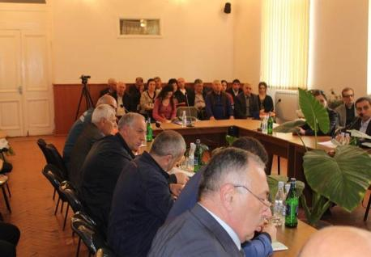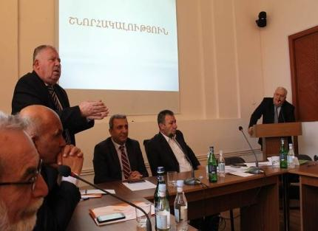
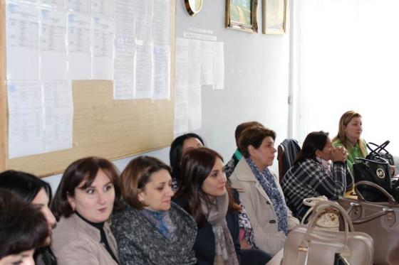

The potential stakeholders and partners of the project were identified and consulted during the project concept development. Further consultations were undertaken during fully-developed project document and field missions organized in the target areas.

Consultation was undertaken at the central and local governmental level. All four targeted community have been covered during the consultations. Through local authorities (governor’s office) the community meetings were organized in Artik city, Harich, Vardaqar, and Nahapetavan communities in order to conduct detailed field surveys. The field surveys have been conducted in all municipalities by the national experts and EPIU staff, as part of the project feasibility.

The meetings were attended by representatives of all municipalities selected according to the list of affected sites. Participants represented a wide range of social groups, such as municipal authorities, teachers, farmers, elderly (pensioners), schoolchildren, and local business community. Such a wide range of representation was necessary to better understand socio- economic implications of floods locally, perceptions of risks, already practiced responses and
the measures that the community would feel fully committed to support to minimize the impacts from floods and flash floods.

Each consultation meeting was structured around the following main topics:
- Perception of community about frequency and intensity of extreme weather events and climate hazards (floods, flash floods mudslides, etc.);
- Type and magnitude of losses due to these hazards (human losses, damage to infrastructure, economic losses such as crop failures etc.);
- Assessment of key vulnerabilities, current coping mechanisms and capacities (infrastructure and settlement expansion towards the floodplain, types of protection, existing compensation and rehabilitation support from the Municipalities and the central government, types of local response measures, plantations, revetments, digging the tranches and sloping terraces etc.);
- Priority needs to address additional vulnerability induced by climatic risks and actions for risk reduction (introduction of risk insurance, landscape level measures, zoning policies).

Better forecasting of floods is necessary. People know that starting from early spring to summer months the flood risk is greatest, so they try prepare accordingly, but more reliable forecasts and early warning system would help enormously.

In general, the participants consider that the planned activities will have a positive impact on the adaptation of natural and agricultural landscapes, flood prevention and knowledge awareness rising of the population in the communities of Artik, Harich, Nahapetavan, and Vardakar under current climate change scenario.

The participants assured that at all stages of the project, they were ready to assist the Project team at all possible levels and to assist in implementing the planned activities. In the course of the meetings, most of the participants proposed to pay close attention to the knowledge- raising activities, especially in the context of climate change to modern agricultural adaptation measures (Annex 2).

Within the framework of the Project Formulation Grant, experts were hired by EPIU (Agronomist, Hydrologist, hydraulic engineer, structural architect, Construction Engineer, Designer, Forest Engineer, Insurance Specialist), who according to their assigned scope of work, clarified the list of planned activities, areas, borders, and volumes of works.

The technical assignments required comparative analyses of environmental and cost- effectiveness of traditional and innovative methods of implementing measures. When calculating the budget, it was required to take into account the current price of goods and labor in the country.

Experts have organized numerous workshops in communities where they discussed and clarified the cost of goods and workforce required for the works. Experts have developed maps,
schematics, and plan (Annex 3), calculated the budget for the implementation of measures, and have developed the terms of references of the implementing organizations.

During all the workshops, protocols prepared that were signed and sealed by community leaders. The project document has been developed by the staff of EPIU using the reports provided by the experts.

In conformity with the Government of Armenia decree N 663 dated June 30, 2016 financial support was provided to 34 households of the Artik city for the restoration of buildings, structures, agricultural animals and crops caused by the flood. At the stage of project development, we have visited 20 households who received compensation, 8 of which belong to women. EPIU staff discussed with them the components of the program and the implementation arrangements as well as the possibilities for introducing insurance.

Beneficiaries emphasized the importance of the proposed interventions, especially the need to introduce early warning system, enabling to prepare for natural disasters and minimize the potential damage. They mentioned that financial support did not fully compensate for the damages and many families, who also suffered from the flood, were not compensated.

Index insurance system has been explained to beneficiaries, agreeing that the insurance system is important, but they believed that they did not have adequate financial means for insurance. Climate Change and adaptation knowledge is low and they expressed their readiness to participate in the trainings and use the gained knowledge in the future. Meetings and discussions were also held in community councils and schools. The expected outcomes of the project have been approved by the participants.

Meetings with the stakeholders involved in the improvement of 300 hectares of arable land and 15 hectares of pastures were held during the preparatory stage of the project. During these meetings pasture improvement activities were discussed. The pastures are community-owned, while the stakeholders are mainly households engaged in cattle-breeding. The total number of stakeholders is 390 families, including ____ families that participated in the discussions. /Annex---/
- The town of Artik has 132 hectares of arable land to be improved. There are 150 stakeholders, including 30 participants in discussions, of which 19 man and 11 women. According to social groups, the picture is as follows: 9 employed, 7 self-employed, 4 social benefit recipients and 10 pensioners.
- Harij community has 60 hectares of arable land and 15 hectares of meadows subject to improvement. There are 100 stakeholders, including 36 participants in discussions, of which 31 man and 5 women. According to social groups, the picture is as follows: 15 employed, 10 self-employed, 1 social benefit recipients and 10 pensioners.
- Nahapetakan community has 80 hectares of arable land to be improved. There are 100 stakeholders, including 28 participants in discussions, of which 10 man and 18 women. According to social groups, the picture is as follows: 6 employed, 11 self-employed, 3 social benefit recipients and 8 pensioners.
- Vardakar community has 28 hectares of arable land to be improved. There are 40 stakeholders, including 28 participants in discussions, of which 10 man and 18 women. According to social groups, the picture is as follows: 10 employed, 12 self-employed, 2 social benefit recipients and 4 pensioners.

This program will provide data and methodology that will enable all interested parties in Armenia to use the best practices in the planned and current work programs. Cooperation with non-governmental organizations, mass media, educational institutions and other interested parties will contribute to innovations and stability.

I. Justification for Requested Funding / Full Cost of Adaptation Reasoning

The total funding requested for this project is 1,435,100 USD, which includes project management and project execution fees.

It is expected that the impact of climate change on the frequency of natural disasters in the country is the result of the intensification of extreme events. According to climate forecasts, more areas in the country might be indirectly affected by hydrometeorological phenomena related to excessive rainfall (flooding) or a lack of rainfall (droughts).

Adaptation measures:

This programme will support costs to reduce flood occurrence to climate change and to increase landscape adaptive capacity. Without this programme, the frequency danger of flooding will increase, while the adjacent landscapes and ecosystems would gradually deteriorate and the communities would be even more vulnerable to climate change. This programme will provide funding for:

  - Improvement of flood management
  - Supporting livelihoods in communities, food security, and biodiversity protection against the impacts of extreme climate events
  - Spread relevant knowledge on climate change adaptation in the selected sectors. Strengthened risk management system and improvement of information on adaptation, climate risk and extreme events will enable to monitor key indicators of climate change and to provide best available technical advice to future activities.

J. Sustainability of Project Outcomes

The aim of this project is to put in place, long-term flood management measures which will enable the Government of Armenia to manage flood risk in a more sustainable manner. Under this project, direct measures including the construction of structural defenses will ensure higher levels of protection taking into account the occurrence and strength of floods.

At the same time under current climate change scenarios the increase of adaptive capacity of natural and agricultural landscapes will contribute to the improvement of social-economic status of stakeholders, while strengthening their capacity to the maintenance of project results.

This project therefore offers the critical long-term adaptation and climate resilient flood management measures. It will also develop and provide the tools (e.g. modeling, monitoring, forecasting, and early warning) that will enable the government to manage flood risk in a more sustainable and cost-effective manner. The capacity building process of the programme allows for training of the local leaders and population who will be able to build capacity within the communities themselves.

Artik community administration will participate in project development by investing USD 63000 and a certain amount of money will be allocated to Artik city municipality budget for the implementation of the project results. Harich, Nahapetavan, and Vardakar communities will support the project in natural and agricultural landscape adaptation and capacity building activities.

A single system of actions will be merged into methods for enhancing natural and agro landscape climate change adaptation, which will demonstrate more efficient opportunities for the recovery of degraded areas. It is planned to create stakeholders’ associations in
communities that are responsible for the use, maintenance, and continuity of the project results. Site management plan will be developed on participatory management basis, which will reflect the envisaged actions and implementation schedule.

During full project development meetings and consultations with stakeholders and representatives of the local authorities, project objectives, goals, solution ways were clarified and formulated a clearer understanding of the importance of preserving and furthering the outcomes of the project. Community leaders are willing to provide manpower and machinery during project implementation, while after its end to protect and maintain the outcomes.

As a result, Artik city community council according to Decree N 20-A of April 3, 2018 recorded, "Each year, after the implementation of the project, allocate funds from the annual budget to ensure the protection of the flood preventive infrastructure, recreation zone created in the closed stone pit area, forested park and irrigation system transferred to Artik City. To assist in the development of the flood insurance index scheme and, if applicable, make investments” (Annex 4).

The possibilities of the Index insurance introduction in the project area

It should be noted that the population insurance mechanisms from floods are not functioning in Armenia yet. In Armenia, the insurance field is regulated by the following laws:

- RA Civil Code, Chapter 54.
- The Law of the Republic of Armenia on Insurance and Insurance Activity.
- The Law of the Republic of Armenia on Establishment of a Unified Financial Regulation and Supervision framework.

The Law of the Republic of Armenia "On Insurance and Insurance Activities" defines the types and classes of insurance, the application of which is applicable by licensed insurance companies in the territory of Armenia. In insurance type called “insurance other than life insurance” there are two classes among others( Article 7) that relate to “Fire and natural forces insurance, which covers all damage to or loss of property ( a) fire; b) explosion; c) earthquake; d) storm; e) nuclear contamination, damage, etc. ) landslide) and “Other damage to property insurance, which covers all damage to or loss of property (due to the events which are not mentioned under the class specified in sub-point 8) hereinabove, as follows: a) hail; b) frost; c) drought; d) epidemic, quarantine disease; e) downpour, flood; f) other natural and man-caused disasters, breakdowns and accidents, including theft of property). All 6 insurance companies operating in the Armenian insurance market has a license issued by the Central Bank for the above two classes.

Highlighting the necessity of introducing insurance in the agricultural sector, the Government of the Republic of Armenia has been attempting to gradually introduce an agricultural insurance system. As a result of the research carried out by the Ministry of Agriculture and the Central Bank in collaboration with the German Development Bank (KfW), as well as with the support of
Swiss Business & Financial Consulting company, it was concluded that at the initial stage the introduction of the insurance system in the Republic is most appropriate in the field of plant growing. According to preliminary version subsidy is envisaged with the introduction of partial mandatory system. The mandatory system is intended to be introduced in farms that have targeted loans, while the insurance for other economies will be voluntary.

In developing countries flood index insurance is most commonly used to cover crop losses from rain and drought. Indemnities are carried out in cases when heavy rainfall is below the set threshold during the insurance period, which can lead to loss of crops. Unlike traditional crop insurance, the insurance company does not consider it necessary to visit agricultural farms to assess losses and to determine payments. Instead, they use objective indicators such as rain gauges near the farm fields. If the data indicate that the number of precipitation is lower than the threshold, the insurance company performs compensation.

One of the benefits of index insurance is that the recoverable amount is not linked to the survival or destruction of the crop, so those engaged in agricultural activities tend to take steps as much as possible to save crops. One of the advantages of index insurance is the fact that insurance is based on objective criteria that cannot be substituted by personal factors, resulting in the reimbursement process becoming more transparent and objective.

In the introduction of index insurance attention should be paid to the fact that this type of insurance is completely new, and the private and public sectors whose involvement is mandatory in the process is not aware of it. Therefore, the issue of informing relevant structures remains a major challenge.

One of the key preconditions for the introduction of index insurance services is the availability of hydro-meteorological statistics and deviations from established norms per administrative districts. The Government's interest is an important prerequisite for the introduction of index insurance.

The implementation of index insurance is envisaged by 6 insurance companies operating in Armenia, which are financially stable and are controlled by the Central Bank with strict normative legal acts on Financial soundness Indicators.

Our neighbor country Georgia with the support of its Ministry of Environment through the National Environment Agency and UNDP via its project approved by AF developed and implemented a project with the introduction of index insurance concept serving a good example for Armenia.

When discussing the opportunities for insurance in agricultural communities, there are usually three types of risks: financial literacy (1), unjustified possible price (2), which can lead to default and human inclination (3).
- Insurance sector in Armenia is quite developed and more than 90% of population is aware of insurance coverage

- Implementation of flood index insurance may be carried out in collaboration with the municipality and private insurance companies operating in Armenia and the index insurance scheme will be applied to different target communities at different risk levels. The index insurance premium payment will be made by indirect subsidy while as a result of paid benefits against floods city budget revenues will be increased.

- Inclination towards insurance service is to compensate for damages caused by flooding in case of reaching the specified water level. Flood index insurance is applied when the water level exceeds the specified average for 3 days.

The possibility of index insurance in Artik and its surrounding communities depends on the combination of the above three factors.

The introduction of innovative index insurance requires access to two basic information:
  - Full historical data on climatic conditions and crop production to assess the agricultural production risk and economic risks associated with harvesting
  - The weather-specific data for a particular administrative region to assess the need to pay insurance indemnities if climatic or environmental phenomena have occurred.

The steps needed to introduce an index insurance system in the Republic of Armenia are:

- Elaboration of the insurance contract, risk identification (in this case the risk of damages caused by floods);
- Determination of insurance tariffs based on actuarial calculations, defining the basic rate of insurance tariffs and risk factors;
- Determination of insurance premiums- based on the size of the insurance tariff the insurance premium and the share of policyholder and the state is determined
- Establishment of Index insurance regulatory body through a structure similar to Armenian Motor Insurance Bureau or through the provision of index insurance regulatory functions;
- Receipt of state share of insurance premiums, presentation of one copy of the contract by the insurance company or its representative to the Project Coordinating Body. Submit the data at regular intervals by the project coordinating body to the Ministry of Finance and transfer the co-financing part of the insurance premium to the insurance company;
- Possibility of privileges or incentive mechanisms in case of using the program: to use the program to getting loans at lower interest rates and affordable terms;
- Unified database development for each administrative territory of the Republic of Armenia. The need for a unified database is conditioned by the effective functioning of the index insurance system, the collection of information on natural disasters, as well as on the hydro-meteorological statistics.
At the stage of project implementation, measures will be taken to develop and introduce mechanisms for introducing index insurance.

At the final stage of project document development an Agreement “On the maintenance of outcomes of the “Artik city closed stone pit wastes and flood management” pilot project drafted by EPIU was discussed with the Ministry of Nature Protection and local authorities (see Annex 3) which was approved and will be signed after the approval of the project by AFB.

K. Overview of Environmental and Social Impacts and Risks Relevant to Project

Table 13: Risk categorization and initial baseline assessment of the project

Checklist of environmental and social principles | Assessment for compliance with Adaptation Fund’s 15 Principles: | Risk to the Project
Compliance with the Law | All activities of the project are in line with RA laws and normative acts. No further assessment of potential impacts and risks is required for compliance with the law, since the project complies with all relevant national legislation and policies on agriculture, water management, climate change adaptation, land tenure, public procurement and other laws. | Very Low
Access and Equity | The project will provide fair and equitable access to the project beneficiaries and will facilitate access to robust institutions, sustainable livelihoods, knowledge, as well as in decision making processes.  The compact area affected communities makes it easier to share information and transfer knowledge using mediums like community groups such as, youth and women organizations, staff of operating mines, beneficiary farmer and family groups.  No further assessment of potential impacts and risks is required for compliance access and equity, since the project planned activities will not reduce or prevent communities in the target areas from accessing basic health services, clean water and sanitation, energy, education, housing, safe and decent working conditions and land rights. | Very Low
Marginalized and Vulnerable Groups | Project activities do not have negative impact on marginalized and vulnerable groups.  Over 25.1% of the affected community population is comprised of young children of the age group less than 17 years and the age group 63 plus. Within this group there are people with disabilities and families living with persons with disability, the elderly, as well as people with very low income and with limited access to resources to help them in their normal everyday living. In this region elderly and poor families receiving benefits from the state are considered marginalized and vulnerable. | Low
Human Rights | The Chapter 2 of the Armenian Constitution recognizes fundamental human rights and freedom that exist and shall continue to exist without discrimination by reason of race, national origin, color, religion, opinion, belief, or sex. The project does not foresee any violation of human rights. The program activities will not engage in any activity that may result in the infringement on the right of any person during implementation. | Very Low
Gender Equity and Women’s Empowerment | Based on culture of Armenia generally there are no issues related to gender similar to other developing countries. Women are empowered in villages and they are involved in day to day activities and decision makings in the field of family and village affairs. Assessments that have been conducted in the past have not revealed any major gender issues. There might be some risks of women’s involvement, further actions regarding mitigation measures will be provided in part 3.  . | Low
Core Labor Rights | Labor rights are protected by the Constitution  and Civil Code of the RA.  In Armenian culture it is essential to obtain education by attending regular schools. There are no child labor issues; however during summer times then there are no schools children typically provide assistance to their parents by performing light activities, which could be considered as training for future farming activities. From our observations there are no child labor issues in the project area.  Studies showed that families with children do not encourage performance of housework or other activities by children. In all even most poor families, priority is given to the provision of education for children at schools and higher education institutions. Parents provide the children with the opportunity to study at school and seek financial resources to further continue their children's education. However, this does not mean that children do not help their parents with housework and the cultivation of their land plots. In many families, after completing their homework children (over 13 years old) help parents with housework and cultivation of land. This carries a learning element and gives children an opportunity to get acquainted with household and agricultural works.  We studied the joint ILO and National Statistical Service of the Republic of Armenia report of 2016 which was not accepted by the public and relevant organizations. There were discussions on the credibility of the report and the data presented was put under suspicion on television.  No further assessment is required for compliance with core labor right principle of the Fund. Mitigating measures are provided in section III. | Very Low
Indigenous Peoples | Main population of the area consisted of Armenians who are the indigenous people of the area. There are no indigenous people to be considered in project vicinity and in Armenia in general. | N.A.
Involuntary Resettlement | Project implementation does not include any resettlement of residents. No further assessment is required for involuntary resettlement. | N.A.
Protection of Natural  Habitats | There are no protected areas in the project area and the Program will not involve unjustified conversion or degradation of critical natural habitats, including those that are (a) legally protected; (b) officially proposed for protection; (c) recognized by the Government for their high conservation value, including as critical habitat. In Shirak marz the only specially protected nature area is “Arpi Lake” national park located in the norther part of the marz. It consists of 5 localities which are situated 56-62km away from Artik city and Vardakar, Nahapetavan and Harich rural communities. | Very Low
Conservation of Biological Diversity | Project activities will not have a negative impact on biodiversity conservation as within project design activities will ensure that the flora and fauna within the project area is conserved | N.A.
Climate Change | The project does not have a negative impact on climate change. The programme will not generate significant and / or unjustified increase in greenhouse gas emissions or any other cause of climate change. Moreover, the creation of forested park will contribute to CO2 absorption and milder microclimate. No project interventions are expected to contribute to release of gases responsible for CC and thus are not expected to contribute to GHG emissions. | Very Low
Pollution Prevention and Resource Efficiency | Project is not expected to generate any environmental pollution and aims for higher resource efficiency for better management of available natural resources. Industrial wastes are stone residues that originate from quarrying. During the exploitation of quarries, the environment has been polluted by dust particles and winds. The residents of the areas adjacent to floodplains crossing the town dump garbage into the floodplain, due to insufficient number of bins causing clogging during heavy rains and snowfall and causing floods thus creating anti-sanitary conditions that can cause infectious diseases during hot summers. Further management of the risks related to waste is demonstrated in section III. | Very Low
Public Health | The stability of ecosystem balance will contribute to the improvement of public health. Thus, no adverse impact on public health related issues is envisaged. | N.A.
Physical and Cultural Heritage | During site assessments, heads of communities were consulted to make sure any cultural sites and sites with unique natural values are identified. As a result of this EPIU has determined that there are no physical and cultural heritage sites in interventions envisaged by the program: closed quarry, gorges, natural, and agricultural landscapes. The activities envisaged by the Project are not implemented in such sites where there are physical and cultural heritage monuments | N.A.
Land and Soil Conservation | Restoration activities are envisaged to help in land and soil conservation and will not create any damages to land and soil resources. | Low

A. Arrangements for Project Implementation.
PART III: IMPLEMENTATION ARRANGEMENTS

The Programme is guided by the Intended Nationally Determined Contributions of the Republic of Armenia under UN Framework Convention on Climate Change approved by the RA Government Protocol Decision No 41, 10 September, 2015 and will be implemented over a three-year period, beginning in 2018. The implementing entity (IE) for the programme will be EPIU, as the National Implementing Entity for the Adaptation Fund. Replicating the longstanding work and experience of EPIU in working directly with national stakeholders (public and private organizations, academy, NGO’s), and considering past success of EPIU implementing Programmes at national and international level, the Government of the Republic of Armenia has explicitly endorsed this AF project to be executed by EPIU. Artik municipality will have its contribution to the project as one of the direct beneficiaries of the project. EPIU role in the framework of the project is fully in line with its leading institutional role in the implementation of environmental sector projects.

The Project Management Board (PMB) will be responsible for making management decisions for the AF project. In addition, the board will: i) undertake project assurance (monitoring and evaluation); ii) ensure performance improvement; and iii) ensure accountability and learning;
- approve and closely monitor the multi-year and annual work plan to ensure its fulfillment and that it contributes to achieving project objectives; and (vi) approve the annual report, multi-year and final report.

The PMB will comprise of designated representatives from relevant ministries and representatives from local self-government bodies and EPIU staff. The Project Management Board will choose a member from its composition to serve as secretary to the PMB. The PMB will approve annual work plans and procurement plans, and review project periodical reports as well as any deviations from the approved plans.

The overall management of the AF project will be executed by EPIU staff as NIE. The following implementation services will be provided by EPIU for the AF project:
  - overall coordination and management of EPIU’s NIE functions and responsibilities, and the facilitation of interactions with the AFB and related stakeholders;
  - oversight of portfolio implementation and reporting on budget performance;
  - quality assurance and accountability for outputs and deliverables at the project development phase, during implementation and on completion;
  - receipt, management and disbursement of AF funds in accordance with the financial standards of the AF;
  - information and communication management to track and monitor progress (financial and substantive) of project implementation;
  - oversight and quality assurance of evaluation processes for project performance and ensuring that lessons learned/best practice are incorporated to improve future projects;
  - monitoring project activities, including financial matters, and preparing monthly and quarterly progress reports, and organizing monthly and quarterly progress reviews;
  - supporting the PMB in organizing PMB meetings;
  - managing relationships with project stakeholders including donors, NGOs, government agencies, and others as required.

The following organigram shows the structure of project implementation arrangements:
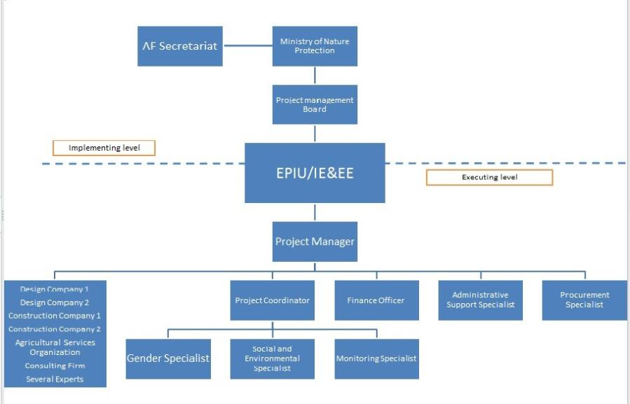

B. Measures for Financial and Project risk management.
Table 14: Financial and Institutional risks and mitigation measures
Risk | Category | Level | Mitigation measures
Mismanagement of resources | Financial | Low | -Financial risk management will be possible by continuous evaluations, audits and reports as mentioned in M&E plan of the project.
Delays in the disbursement of funds. | Financial | Low | -NIE will ensure that all the funds
Insufficient collaboration between implementing body and stakeholders | Institutional | Medium | -All the roles and responsibilities will be clarified during inception workshop, and ownership building will contribute to better collaboration between all  stakeholders.
Delays in project implementation | Institutional | Low | -Project activities are well prepared to be completed in proposed timeframe.  -Monitoring activities will ensure implementation targets are kept during the project implementation.
Limited human resources in national and regional authorities to ensure the sustainability of the project/programme. | Institutional | Medium | -Knowledge and awareness building is one of the key components of the project.  - All relevant authority workers, decision makers and local population will have sufficient knowledge on the landscape and ecosystem adaptation to climate change and efficient management of floods.
Extreme weather conditions diminish the project benefits; create emergency situations and delays during project implementation. | Environmental | Low | -Proper scheduling of the project activities will ensure avoidance of adverse weather conditions impacts during implementation.
Government is not supportive throughout the implementation phase and for the sustainability of the project | Political | Low | -As EPIU is a state institution, government will be supportive from the beginning of the project. Local and National authorities will be notified of the importance of the project and all the relevant support will be given to the project implementation unit.
Project beneficiaries are resistant to change and/or the new technologies applied are difficult to manage | Social | Medium | -During the implementation phase consultations of different stakeholders will ensure the ownership building for the project. Project will ensure active participation of stakeholders. Awareness and knowledge raising activities will increase the capacity for managing the new technologies applied and will ensure that beneficiaries are not resistant towards adaptation activities.

C. Measures for Environmental and Social Risk Management

Given the above and following the initial screening process, the proposed project has a Category B, in accordance with the Adaptation Fund’s (AF) Environmental and Social Policy (ESP). All of the project’s components comply with AF’s ESP’s, and the checklist of ESP principles is presented below. Throughout the inception, implementation and monitoring and evaluation cycles the alignment with AF’s ESP will be sought and managed.

Table 15: Environmental and Social risk assessment and management

Environmental and social principles | Assessment | Potential impacts and risks- further assessment and management required for compliance
Environmental and social principles | Assessment | Description of process for environmental and social and gender safeguards and mitigation measures | Responsible entity
Compliance with the Law | Very Low | According to EPIU’s Operational and Procedures Manual (OPM) chapter IX All proposed projects shall be in compliance with all applicable domestic and international documents ratified by the Republic of Armenia. Likelihood of occasion when the project will not be in compliance with relevant national laws is very low. As state institution EPIU is obliged to act under laws and regulations of the republic of Armenia. Furthermore other companies hired by NIE who will carry out project activities will again act under the laws and regulations of Armenia. Technical specialists, Gender Specialist and other relevant state institutions will make sure projects compliance with the law. | NIE, Technical and Gender specialists.
Access and Equity | Very Low | According to EPIU’s Operational and Procedures Manual(OPM) chapter IX all proposed projects/programmes shall provide fair and equitable access to benefits in a manner that is inclusive and does not impede access to basic health services, clean water and sanitation, energy, education, housing, safe and decent working conditions, and land rights. Projects/programmes should not exacerbate existing inequities, particularly with respect to marginalized or vulnerable groups.  The program, at Inception Phase will demonstrate compliance to AF ESS Policy by describing the process of allocating and distributing programme benefits. It will also state clearly that there will be neither discrimination nor favouritism in accessing programme benefits.  All the beneficiaries of the project will have fair and equitable access to project, as well as in decision making processes (Risk level-Low). Project Management Unit and the EPIU will ensure that the equity and benefits throughout the project is equally accessible to all stakeholders. Through M&E actions the assessment of equity should be carried out throughout all stages of the project. The project implementation will follow a bottom up, participatory approach which is driven by the needs and preferences of the involved communities.  During all implementing processes beneficiary groups will be chosen in participative way. Events will be announced thoroughly. There will be neither discrimination nor favouritism in accessing program benefits.  A grievence redressmechanism will be established as an independent mechanism to objectively handle any conerns or complaints from stakeholers. | Gender and M&E specialists.
Marginalized and Vulnerable Groups | Low | According to EPIU’s Operational and Procedures Manual(OPM) chapter IX all proposed projects/programmes shall avoid imposing any disproportionate adverse impacts on marginalized and vulnerable groups including children, women and girls, the elderly, indigenous people, tribal groups, displaced people, refugees, people living with disabilities, and people living with HIV/AIDS.  At Inception Phase, the programme will define the characteristics of marginalized and vulnerable groups in the affected communities using categories that define them appropriately. The process will also include identification, and description of impacts that each marginalized and vulnerable group are likely to experience from the programme  In screening any proposed project/programme, the implementing entities shall assess and consider particular impacts on marginalized and vulnerable groups.  Marginalized and vulnerable groups, in particular elderly, women and poor families, in the project area are included in the project design phase, and the projects direct benefits will apply to them. A dedicated consultation mechanism will be established, where women, youth and elderly will be provided with a safe forum to contribute to the project design and implementation. An independednt grievence redress mechanism would allow handing any kind of concerns of involved stakeholders. | NIE, Gender specialist, M&E specialist
Human Rights | Very Low | As described in OPM of EPIU all proposed projects/programmes shall respect and where applicable promote international human rights. Human rights in natural resources use, equity, education, health, and other relevant sectors are protected by constitution and other relevant laws. The program activities will not engage in any activity that may result in the infringement on the right of any person during implementation. | NIE
Gender Equity and Women’s Empowerment | Low | The management of women’s involvement in the project should be carried out from the inception of the project. Firstly, there is going to be profiling of stakeholders to ensure that women are direct beneficiaries of the project. During the project implementation women will be encouraged to take positions in the project.  There are women and youth groups who are included in the project. As a process of women’s empowerment the women groups will be given solar dryers and greenhouses.  During the M&E processes, women groups will be targeted to be monitored in order to assess the direct and indirect benefits of the project towards women. Program design focuses on women as direct beneficiaries. During activity selection, project team will ensure that the project effectively responds to the unique needs of women and girls and promotes gender equity. Gender equity will be promoted during the trainings and knowledge awareness raising activities by ensuring up to 40% participation levels for women and youth. Their roles and needs have been considered during project design Women as climate change adaptation participants/leaders will be monitored from outset.  Women's rights are protected and they are included in all stages of project development and implementation. Efforts will be made to ensure equal participation of women in interventions and decision making too. Capacity building and skill development training for sustainable livelihood generation will be provided to the women of communities. This will ensure participation by women fully and equitably, and that they do not suffer adverse effects | NIE, Gender Specialist.
Core Labor Rights | Very Low | Labor rights are protected by Armenian constitution and laws. All persons employed under this program will follow Armenian legislation and will have proper employment contracts. Companies hired by the NIW for construction works or etc. will also follow the procedures prescribed in the labor law of Armenia.  In order to minimize the risk of child exploitation, the work will be implemented in accordance with the requirements of Articles 3, 102, 257 of the RoA Labor Code and Article 132 of the RoA Criminal Code, according to which the exploitation of children is forbidden. In order to exclude the involvement of children in the Project, the Project Implementation Unit will specify a special point in the contracts to be signed with the companies that children should not be involved in the work. The supervision will be carried out by the Social and Gender risk assessment specialist.  Furthermore the OPM of EPIU states that all proposed projects/programmes shall meet the core labour standards as identified by the domestic and international documents ratified by the Republic of Armenia. | NIE, Monitoring specialist.
Indigenous Peoples | N.A. | The Constitution of the Republic of Armenia do not use the term ‘indigenous Peoples’, it refers to the Armenia population as having various ‘ethnic groups’ and in conformity with Article 56. Right to Preserve National and Ethnic Identity: 1. Everyone shall have the right to preserve his or her national and ethnic identity.  Persons belonging to national minorities shall have the right to preserve and develop their traditions, religion, language and culture.  Exercise of the rights prescribed in this Article shall be regulated by law. | NIE, Gender specialist
Involuntary Resettlement | N.A. | Project implementation does not include any resettlement of residents. The Programme activities will be designed and implemented in the area of closed quarry, gorges that are flood route, natural and agricultural landscapes where people do not live so there is no need for involuntary resettlement. There are no risks associated to any kind of resettlement. | NIE, Environmental and social management specialist
Protection of Natural  Habitats | Very Low | The only protected area in the Shirak region is Arpi lake national park, which is 56 kilometers far from the project area, later is demonstrated in the map below. The creation of new forested area and recreational zone will create beneficial conditions for enriching flora and fauna making the landscape more harmonious in terms of natural habitats. | NIE, Monitoring specialist.
Conservation of Biological Diversity | N.A. | Project activities would not have a negative impact on biodiversity conservation as within project design activities will ensure that the flora and fauna within the project area is conserved | NIE, Environemtal and social management specialist,
Climate Change | Very Low | The project does not have a negative impact on climate change. No project interventions are expected to contribute to release of gases responsible for CC and thus are not expected to contribute to GHG emissions. The creation of park with dense tree will contribute to CO2 absorption and milder microclimate. | NIE, Environemtal and social management specialist,
Pollution Prevention and Resource Efficiency | Very Low | During the project implementation phase, waste materials of 40 ha closed stone pit, as well as wastes accumulated during the floods at gorges will be used during construction as construction material /in gabions, landscape improvement works/. Garbage dumbed by residents to the canal will be mitigated by installation of garbage bins and helping the municipality to establish new waste management schedule. 5 ha of land are allocated under landfill 5 km away from the town where household and construction waste is dumped. Garbage disposal is carried out on 4 waste trucks, 2 of which are specialized and 2 are non-specialized. Non-specialized trucks collect garbage from yards at certain hours of the day, while specialized vehicles collect garbage from bins. Every day, garbage trucks transport garbage to a special landfill. After dumping, bulldozes cover it with a soil layer. The project will assist the municipality to prepare a new waste disposal plan and schedule and improve waste transportation to the landfill by using new garbage bins and garbage collection vehicles.  The project will support the sustainable management of land and water resources to avoid, limit and reverse land degradation in the project area and support communities to adapt to the potential impacts of climate change. During the necessary precautions would be made to avoid or limit any impact (for example compaction of soil, localized gully erosion at construction sites). | NIE, Environemtal and social management specialist,
Public Health | N.A. | The project would have very likely no negative public health impacts. Activities envisaged under this project, such as reduction of stone pit dust in the air, creation of forested park and recreational zone, flood prevention, introduction of early warning system, raising adaptive capacity of agricultural and natural landscapes are vital to public health in the project area. In the framework of the third Component of the program, information and further support will be provided to the population on the importance of keeping the environment and landscapes clean and protected in terms to health. | N.A.
Physical and Cultural Heritage | N.A. | There are no any impacts on physical or cultural heritage. Map below outlines cultural heritage sites and the project location showing there are no any impacts on these sites. It is very unlikely that new sites of specific cultural heritage would be discovered by the project. | N.A.
Land and Soil Conservation | Very Low | The project has the objective to avoid, limit and reverse any negative impacts on land water and soil resources in the project areas. In fact the project is expected to have a positive impact on soil conservation and will reverse land degradation through agroforestry and etc. Where land is to be modified for example area of exploited and closed quarry, or dam construction, standards will be followed to maintain the land in its natural state or as close to its natural state as is possible. The programme will also promote soil conservation and prevent degradation or conversion of productive lands, or lands that provide valuable ecosystem services such as natural pastures and hay meadows. | NIE, Environmental and social management specialist, with support from UNCCD

The following map shows the distance between project area and Arpi Lake National Park
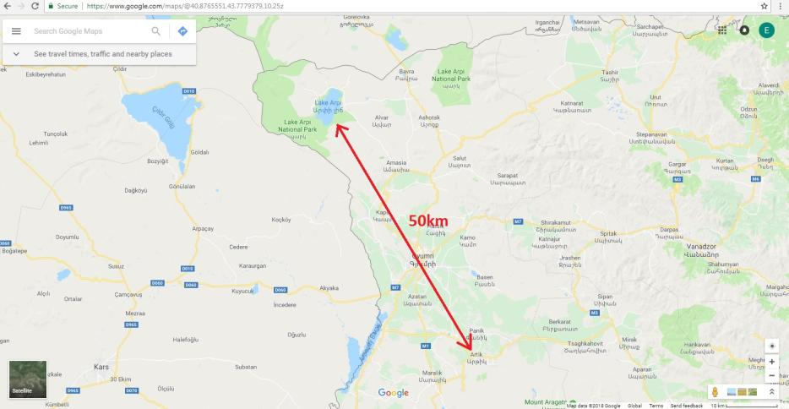

Environmental and social management plan

1. Introduction

The ESMP outlines the preventive / mitigation measures proposed to reduce potentially adverse environmental and social impacts to acceptable levels. The plan also shows how these potential risks and mitigation measures will be further monitored, including responsibilities.

2. Risks management arrangements

(i) Responsibilities: direct management responsibility of the ESMP will be under the EPIU project manager. The project manager will have oversight / final compliance responsibility. Changes or additional activities that arise during project implementation and add value/complement proposed sub-projects and fall within allowable limits set by Adaptation fund will need to be cleared by the project manager and approved by the project management board depending on the scale and type of activity.
(ii) Management and mitigation measures: All project activities have been screened against the 15 environmental and social risks areas during project preparation phase. Outcomes will be presented during the project inception to all stakeholders to confirm the management and monitoring arrangements.

3. General environmental and social risks management reduction measures

In addition to the risk management measures identified above, the following elements will be put in place to ensure the compliance with the ESP:

(i) All activities will include detailed reference to the ESMP, the 15 ESP Principles and especially compliance to law (principle 1), human rights compliance (principle 4), gender approach (principle 5) and labor and safety standards (principle 6 and 13):
• Principle 1: References to standards and laws to which the activity will need to comply will be included in all legal agreements with all subcontractors, including steps and responsibilities for compliance.
• Principle 4: References to relevant Humans rights declarations will be included in all legal agreements with all sub-contractors.
• Principe 6: Employment and working conditions following ILO standards will be included in legal agreements with all subcontractors. Special condition regarding workers under age of 18 will be added in all contracts, demonstrating that there should be not any people working under age of 18.
(ii) EPIU staff will check project compliance to the AF ESP during the project (besides the project manager) (principle 4).
(iii) Continues coordination with technical supervisors responsible for compliance to national and local standards will take place.
(iv) Social and gender and environmental specialists will carry out gender assessments; will carry out studies regarding projects compliance and risks (According to AF’s ESP principle 5
(v) Capacity building and awareness raising: the management teams, executing entity partners and target communities, will receive training / capacity development to understand and manage the 15 Principles, the ESMP and in particular their responsibilities. This will be done during inception.
(vi) Pollution prevention measures are identified in the above table 15. Relevant waste management plan and schedule will be developed during the inception phase with EPIU and Artik municipality.

4. Risks monitoring arrangements:

(v) Monitoring will be done to ensure that actions are taken in a timely manner and to determine if actions are appropriately mitigating the risk / impact or if they need to be modified in order to achieve the intended outcome.

(vi) Annual reporting will include information about the status of implementation of this ESMP, including those measures required to avoid, minimize, or mitigate environmental and social risks. The reports shall also include, if necessary, a description of any corrective actions that are deemed necessary.

(vii) Direct monitoring responsibilities will be under the project manager and monitoring specialists. The overall project manager will have oversight / final compliance responsibility. When changes or additional activities are required, monitoring indicators will be changed or added as well.

5. The grievance resolution mechanism (GRM)

The Grievance Resolution Mechanism (GRM) will implement the policy and guidelines of EPIU GM. As set out in policy, the GRM will support the enhancement of environment and social well-being, including human rights and gender equality. The GRM will receive and facilitate the resolution of concerns, complaints, and grievances about the programme’s environmental, social, human rights, gender performance as well as other general complaints relating to the programme. When and where the need arises, this mechanism will be used for addressing any complaints that may arise during the implementation of the programme.

Concerns, complaints and grievances by affected persons will be directed to the Project Management Unit (PMU) where the Project Coordinator, Environmental and Social Safeguard (ESS) and Gender Specialists will be the focal points to receive, record, review, and address concerns in coordination with relevant stakeholders depending on the nature of the complaint. A complaints register will be maintained to record the date, details, and nature of each complaint, the name of the complainant, and the date and actions taken as a result of the follow-up investigation.
E-mail address, address and telephone of Adaptation fund will also be made public via our website, ministries website and LinkedIn for anyone who wants to raise any concerns regarding to project:
Adaptation Fund Board secretariat
Mail stop: MSN P-4-400
1818 H Street NW
Washington DC
20433 USA
Tel: 001-202-478-7347
afbsec@adaptation-fund.org

The register will also cross-reference any non-compliance report and/or corrective action report or other relevant documentation relating to the complaint.

Table 16: Time frame for the grievance redress mechanism
Stage | Process | Duration
1 | Any affected person or community head, representatives and other concerned party takes  grievance to PMU. | Anytime
2 | Project Coordinator, ESS or Gender Specialist reviews  and finds solution to the problem in consultation with community heads and Artik municipality. | 1weeks
3 | Project Coordinator, ESS or Gender Specialist reports back an outcome to affected person who submitted  the grievance. | 1 week
If unresolved or not satisfied with the outcome at PMU level or has received no report in the allotted
time period
4 | Affected person takes grievance through Artik  municipality or to MoNP or NIE. | Within 2 weeks of receipt of  decision in step 3
5 | NIE reviews and finds a solution which may include recommendation of dispute resolution, including an  appropriate body to oversee. | 2 weeks
6 | NIE reports back to the affected person who made the  complaint. | 1 week
If unresolved or at any stage if concerned party is not satisfied
Affected party can take the matter to Office of the Ombudsperson |  | As per Office of the
or appropriate court or law enforcement bodies |  | Ombudsperson or judicial
 |  | system or law enforcement
 |  | bodies

D. Monitoring and Evaluation Arrangements

The project will be monitored through the M&E activities, M&E budget is provided below. The monitoring will be carried out by the Project Team verified by the NIE. Monitoring and evaluation progress will be based on targets and indicators set in Projects Results framework.

Project Management Unit will create system for project monitoring progress. Relevant data collection and recording process with participatory mechanisms will support the monitoring and evaluation of outcome and output indicators.

Project Launch workshop tasks will include:
- Presentation and introduction of the project’s results framework to all project stakeholders
- Presentation of project team
- Ownership building and planning of work plan, based on projects results framework. This will include of establishing roles, responsibilities, functions of NIE and Project Management team.
- Review of M&E indicators
- M&E budget and work plan will be agreed and scheduled.

Throughout the project, PMU and the division of monitoring and evaluation will be responsible for monitoring and their actions will be guided by Annual Operating Plan (AOP). Annual Operation Plan will display all necessary activities for current year and Quarterly Status Reports will present monitoring process on executed activities. AOP’s will be agreed and scheduled annually during NIE meetings, and AOP will be guided by project results framework.

Following reports and evaluations will be developed throughout the project:
Inception Workshop Report- will be prepared after inception workshop, which will detail about roles, responsibilities, actions, and functions of all stakeholders. Furthermore, it will include first AOP and monitoring plan for the first year.
Annual Operating Plan(AOP)- Annual plan should be approved by the NIE before starting each operating period, and it will detail all activities to be executed, all milestones and goals which will be reached during the year, and dates for each indicator to be executed. AOP will include all the necessary financial activities relevant to the first period.
Quarterly Status Reports (QSR)- project management unit should submit QSRs to the NIE at the end of each operating quarter. QSRs will present how the indicators identified in project results framework are executed, what challenges PMU faces during the execution process and identify any constraints. Quarterly Status Reports will present monitoring process on executed activities.
Annual Management Reports (AMR)- Annual Management Report will cover last AOP, it will compare the actual results with the targets and milestones listed in AOP, and if necessary it will come up with improvements and corrective measures for the upcoming AOP.
External Audit Reports- with the periodic financial statements, external annual audit report will be prepared. Audit reports are made in accordance to Financial Regulations set by the government.
Mid-term Evaluation- Halfway through the project implementation the project will undergo an external mid-term evaluation, which will assess the project’s progress of achieving outcomes. Effectiveness and efficiency of the projects will be taken into consideration, and if needed any corrective mechanisms will be applied after the mid-term evaluation.
Final Report- Final report will be presented three months prior to the end of the project. The main focus of the evaluation is to assess project’s results with planned results. Moreover, the final evaluation will look to impacts of the projects and to the sustainability of the project.
Final External Evaluation- The main focus of the evaluation is the project impacts, project’s sustainability and long-term effects. Final evaluation will also suggest any further actions to be implemented for project’s sustainability.

Monitoring and Evaluation
Quarterly and annual report | EPIU staff
Final report | EPIU staff
Project Management Board meetings | Project  Manager | 500 | 500 | 500 | 1500
Technical supervision | Expert |  | 8210 | 8210 | 16 420
Quality assurance | Expert |  | 2190 | 2190 | 4380
Inception and final workshops | EPIU staff | 1500 |  | 1500 | 3000
Midterm evaluation | Internation  al expert |  | 15 000 |  | 15 000
Final Evaluation | Internation  al expert |  |  | 15 000 | 15 000
External audit |  | 3000 | 3000 | 3000 | 9000
Total |  | 5000 | 28900 | 30400 | 64300

E. Results framework for the Project
Result | Indicator | Baseline | Milestone (target, year 1) | End of project target | Means of verification | Responsibility | Risks and considerations
Objectives :  1.Increase adaptation level of natural and agricultural landscapes  2. Prevent floods and eliminate their consequences  3. restores the natural landscape of the area affected by climate change and anthropogenic impacts, at the same time to demonstrate the possibilities of adaptation level natural landscapes  4.Improve the adaptation potential of community producers, institutions, and other relevant stakeholders regarding to climate change under current climate change conditions. | - Total number of project beneficiaries (direct & indirect)  - Percentage of women beneficiaries | 0 beneficiaries | 6000  60% | 15000  60% | 6 monthly project reports, surveys | EPIU with
Component 1: Restoration, management, and increase of adaptation potential of natural landscapes of the area affected by climate change and anthropogenic factors.
Outcome 1. Adaptation and sustainability of natural landscapes of the area affected by climate change and anthropogenic factors increased | - Total area of land rehabilitated and with increased adaptation capacity |  | 10 ha of land (25%) rehabilitated | 30 ha of land (75%) rehabilitated | 6 monthly project reports, surveys | EPIU and target communities
Output 1.1.1 Restored soil cover of mine | - Design estimates is prepared # ha of stone pit landscape restored  - # ha of park and # ha recreational zone created | Tbd | 1  2 ha of park and 10 ha recreational zone created | 1  2 ha of park and 10 ha recreational zone created | 6 monthly project reports, surveys | EPIU and target communities
Output 1.1.2: The restored soil layer will be protected against the winds and intense adverse effects of rain | # ha restored of soil layer will be protected against the winds and intense adverse effects of rain | Tbd | 10 ha | 30 ha | 6 monthly project reports, surveys | EPIU and target communities | The number of irrigation water has decreased, canals are subject to repair,
Output 1.1.3: The area will be provided with irrigation water | # meters of irrigation water system installed | Tbd | 500 meters | 500 meters | 6 monthly project reports, surveys | EPIU and target communities
Output 1.1.4: Sowing areas of perennial plants are created reducing rangeland degradation; | # ha of perennial sowing areas of perennial plants are created | The qualitative composition of land is decreased | 300 ha of perennial sowing area established | 300 ha of perennial sowing area established | 6 monthly project reports, surveys | EPIU and target communities | Due to intensive grazing the vege-tation cover and the number of edible herbs have dropped
Output 1.1.5: Crop yield and crop quality of the adjacent agro landscapes will be increased | Crop yield and crop quality # ha hay meadows and arable lands  # ha pastures increased | Vegetation and the average crop yields have fallen | 15 ha hay meadows and arable lands  190 ha pastures | 15 ha hay meadows and arable lands  190 ha pastures | 6 monthly project reports, surveys | EPIU and target communities | The production of fodder in hay meadows decreased,
Output 1.1.6 Adverse effects on the health of the population of adjacent communities will be decreased | # garbage bins  are installed  and the  garbage truck  is purchased  and allocated to Artik municipality | There are 4 garbage trucks, of which 2 are specialized and 300 garbage bins, of which 150 are not suitable for operation. | 1 additional garbage truck  150 garbage bins | 5 garbage trucks of which 3 are specialized  300 operational garbage bings | 60% of field tracks degraded  x km of field tracks rehabilitated  # culverts installed | 10% of field tracks rehabilitated  Xx km rehabilitated  # culverts installed | Due to insufficient amount of watering points, the livestock passes through large distances, resulting in degradation of pastures
Output 1.1.7 Flood risk will be reduced | The number of floods with environmental and economic adverse effects | 7 floods | 0 | 0 | Project technical reports, mid-term and final studies. | EPIU and target communities | Due to intensive grazing and climate warming many slopes have degraded, vegetation cover has decreased
Output 1.1.8: Favorable conditions will be created for the recreation of the residents | #ha of recreational zone is established | - Tbd
Outpout 1.1.9:Forested area will be increased | Xx ha of agroforestry planted | - Tbd
Component 2 . Prevention and management of floods
Outcome 2: 1 Social, economic, and environmental threats caused by floods as a result of climate change is reduced | - Increased income, or avoided decrease in income  - Number of early warning systems developed  - Total number of beneficiaries environmental threats caused by floods as a result of climate change is reduced  - Percentage of women beneficiaries benefitting from climate smart technologies | - Tbd  0 | 800 beneficiaries  1  30% women | 900 beneficiaries  1  40% women | 6 monthly project reports, surveys | EPIU and target communities
Output 2.1.1: Restoring storm canals that carry heavy snowmelt and rain water | Design estimates is prepared # ha for the construction of canals  # cubic meter  earth dams  reinforced with  gabion  constructions  in combination  with earth | - Tbd | 1 |  | Project Reports, . | EPIU and target communities
Output 2.1.2: Protecting the storm canals from household garbage that clog these canals | # cubic meter  shores of  natural course  of the river  with the  installation of  gabion mattresses(Ter ramesh technology) Strengthened  # m of slopes with geonets and grass sowing reinforced  # cubic meter of concrete, overfall cascade dams of low pressure constructed  # meters cleaning of storm sewers |  | 150 cubic meter  shores of  natural course  of the river  with the  installation of  gabion mattresses(Ter ramesh technology)  500 cubic meter of slopes with geonets and grass sowing reinforced  100 cubic meter of concrete, overfall cascade dams of low pressure constructed  120 meters cleaning of storm sewers | 300 cubic meter  shores of  natural course  of the river  with the  installation of  gabion mattresses(Ter ramesh technology)  1000 cubic meter of slopes with geonets and grass sowing reinforced  135 cubic meter of concrete, overfall cascade dams of low pressure constructed | 6 monthly project reports, surveys | EPIU and target communities | Greenhouses enable residents to get seedlings of plants in early spring which are more adapted to climate change. They will also allow getting additional revenues.
Output 2.1.3: Improving sanitary condition of Artik city | Waste collection plan and schedule have been prepared | - Tbd | 1 plan |  | 6 monthly project reports, surveys | EPIU and target communities | Residents dry fruits, berries and herbs in their houses resulting in increase of loses and production quality
Output 2.1.4: Reducing risk of epidemics |  |  |  |  |  | EPIU and target communities
Component 3 Raising awareness and Knowledge level of population for the management of stone pit wastes and floods
Outcome 3: Raising awareness and knowledge level of population on the recovery of agro landscapes and flood risk reduction | No of beneficiaries benefitting from awareness raising and on the recovery of agro landscapes and flood risk  % of beneficiaires are women | Xx beneficiaries  10% of beneficiaies are women | 500 beneficiaries  30% beneficiaries are women | 1500 beneficiaries  350% beneficiaries are women | Training reports | EPIU and target communities
Output 3.1.1: The level of knowledge on effective recovery methods of degraded natural and agro landscapes will be increased | # number of beneficiaries of knowledge on effective recovery methods of degraded natural and agro landscapes  % of beneficiaires are women | 0 beneficiaries  10% women beneficiaries | 100 beneficiaries  30% women beneficiaries | 200 beneficiaries  40% women beneficiaries | Training reports | EPIU and target communities | Though community residents have some knowledge on best practices of climate smart agriculture and LDN, it is insufficient. In some communities women and young people have established groups through which they wish to adapt agricultural activities to modern requirements.
Output 3.1.2 The knowledge level of the population on natural and agro landscape adaptation to climate change will be increased | No of farmers and community workers whose knowledge has increased towards the adaptation of natural and agricultural landscapes | # training programs and thematic topics  Awareness raised at community level of climate change threats
Output 3.1.3 Increasing of the knowledge level of the population on the occurrence and prevention possibilities of floods | No of community workers whose knowledge has increased towards management and prevention of floods, of which xx % are women |  | 25 workers of which 30% are women | 25 | Community based adaptation plans | EPIU and target communities
Output 3.1.4 Promoting the importance of the sustainable thinking related to the landscape adaptation to climate change in communities |  |  |  |  |  | EPIU and target communities
Output 3.1.5. The involvement of local media and environmental NGOs in the process of mitigating the negative effects of climate change will be increased | # number of of local media and environmental NGOs in the process of mitigating the negative effects of climate chang |  | 3 | 3 |  | EPIU and target communities,
Output 3.1.6 Project results will be available to all interested parties;

F. Project alignment with Results Framework of the AF

Project Objective(s) | Project Objective Indicator | Fund Outcome | Fund Outcome Indicator | Grant Amount  (USD)
1. To increase adaptation level of natural and agricultural landscapes | 1. Project investments have reduced the spread of dust, and to the increase of adaptation of natural and agricultural landscapes | Outcome 5: Increased ecosystem resilience in response to climate change and variability-  induced stress | 5. Ecosystem services and natural assets maintained or improved under climate change and variability- induced stress | 163053
2. Prevent floods and eliminate their consequences | 2. Water flows by the 1.1 two gorges which lead to Artik city, have adapted to extreme hydro meteorological events  posed by climate change. | Outcome 1: Reduced exposure to climate-related hazards and  threats | 1. Relevant threat and hazard information generated and disseminated to stakeholders on a timely  basis | 376356
3. To restore the natural landscape of the area affected by climate change and anthropogenic impacts, at the same time to demonstrate the possibilities of adaptation level increase of degraded natural  landscapes | 3. Quality of land have increased, the level of erosion is decreased and anthropogenic factors affecting natural and agricultural landscaped have been reduced | Outcome 5: Increased ecosystem resilience in response to climate change and variability- induced stress | 5. Ecosystem services and natural assets maintained or improved under climate change and variability- induced stress | 642087
4. Improve the adaptation potential of community producers, institutions, and other relevant stakeholders regarding to climate change under current climate change  conditions | 4. Costs of flood damage have been reduced. | Outcome 6: Diversified and strengthened livelihoods and sources of income for vulnerable people in targeted areas | 6.1.1.No. and type of adaptation assets (physical as  well as knowledge) created in support of individualor community-livelihood strategies | 120000
Project Outcome(s) | Project Outcome Indicator(s) | Fund Output | Fund Output Indicator | Grant Amount  (USD)
1. Natural landscapes of the area affected by climate change and anthropogenic factors restored, managed, and adaptation potential increased. | 40 ha of closed stone pit area has been restored, of which 30 ha is forest and 10 ha is recreational area with forest park.  During the water flow stone waste is not flowing into the city The ecosystem adaptation of the area has increased.  The dust spread through winds towards residential area, arable land, herbage, etc. is reduced Irrigation system is operating  A recreation zone is | Output 5: Vulnerable physical, natural, and social assets strengthened in response to climate change impacts, including variability | 5.1. No. and type of natural resource assets created, maintained or improved to withstand conditions resulting from climate variability and change | 805140
 | established, where population is able to spend their resting time
2.Social economic and environmental threats caused by floods as a result of climate change reduced | The water flow is regulated during floods The soil of slopes is reduced  Adaptation and productivity of landfills in the flood impact zone has increased  Cost of flood recovery from households and government has decreased on buildings and constructions.  Productivity of agricultural products has increased.  A quick response system is created. | Output 1: Risk and vulnerability assessments conducted and updated at a national level  Output 4: Vulnerable physical, natural, and social assets strengthened in response to climate change impacts, including variability | 1.2 Development of early warning systems  4.1.2. No. of physical assets strengthened or constructed to withstand conditions resulting from climate variability and change  6.1 Percentage of households and communities having more secure  (increased) access to livelihood  assets | 376356
 |  | Outcome 6:  Diversified and strengthened livelihoods and sources of income for vulnerable people in targeted areas | 6.2. Percentage of targeted population with  sustained climate-resilient livelihoods
3. Raising | The number of | Output 3: | 3.1.1 No. and type of risk | 120000
awareness and | community workers, | Targeted | reduction actions or
knowledge level of | households, NGO | population | strategies introduced at
population on the | representatives, Mass | groups | local level
recovery of agro | media representatives, | participating in | 3.1.2 No. of news outlets in
landscapes and | school teachers and | adaptation and | the local press and media
flood risk reduction | students participated in | risk reduction | that have covered the topic
 | awareness and | awareness
 | knowledge raising | activities
 | trainings.

G. Detailed Budget with Budget Notes

Outcome/Output |  |  | Notes | Y-1 | Y-2 |  | Y-3 |  | TOTA L
Component 1 |  | Sub-Total Component 1 |  | 170,239 | 397,609 |  | 237,292 |  | 805,140
1.1 | 1.1.1  1.1.2 | Total activity 1.1.1-1.1.2 |  | 344057 |  | 237292 |  | 573402
1.1 | 1.1.1  1.1.2 | Construction company 1 | Preparation of the soil layer in the territory of the stone pit for the purpose of creation of the forestation and  recreational zone; |  | 168196 |  |  |  | 168196 | N1
1.1 | 1.1.1  1.1.2 | Construction company 1 | Creation of forest park and  recreational area |  | 67232 |  | 81 637 |  | 140859 | N1
1.1 |  |  | Forestation |  | 108629 |  | 155 655 |  | 264347 | N1
1.1 | 1.1.3. | Total activity 1.1.3 |  | 19685 |  |  |  | 19685
1.1 | 1.1.3. | Construction company | Construction of irrigation system |  | 19685 |  |  |  | 19685 | N 1
1.1 | 1.1.4  1.1.5 | Total activity 1.1.4-1.1.5 |  | 121239 |  | 41 814 |  | 163053
1.1 | 1.1.4  1.1.5 | Implementing company | Improvement of arable lands | 80750 | 29 000 |  | 0 |  | 109 750 | N 2
1.1 | 1.1.4  1.1.5 | Implementing company | Improvement of hay meadows | 2813 | 938 |  |  |  | 3751 | N 2
1.1 | 1.1.4  1.1.5 | Implementing company | Improvement of pastures | 37676 | 11876 |  |  |  | 49552 | N 2
1.1 |  | Designing company | Preparation of design estimates | 49000 | 0 |  | 0 |  | 49000 | N 3
Component 2 |  | Sub-Total Component 2 |  | 35000 | 341356 |  |  |  | 376356
 |  | Total activity 2.1.1-2.1.2 |  | 289356 |  |  |  | 289356
 |  |  | Reinforcement of earth dams with gabion constructions in  combination with earth works |  | 90000 |  |  |  | 90000

2.1 | 2.1.1  2.1.2 | Construction company 2 | Strengthening of shores of natural course of the river with the installation of gabion mattresses (Terramesh  technology) |  | 57827 |  |  | 57827 |  | N 4
2.1 | 2.1.1  2.1.2 | Construction company 2 | Stabilization of erosive steep slopes with gabion retaining walls with the installation of  geotextile and geonets |  | 40000 |  |  | 40000
2.1 | 2.1.1  2.1.2 | Construction company 2 | Reinforcement of slopes with  geonets and grass sowing |  | 18000 |  |  | 18000
2.1 | 2.1.1  2.1.2 | Construction company 2 | Construction of concrete, overfill cascade dams of low  pressure |  | 63 029 |  |  | 63 029
2.1 | 2.1.1  2.1.2 | Construction company 2 | Cleaning of storm sewers |  | 5 500 |  |  | 5 500
2.1 | 2.1.1  2.1.2 | Construction company 2 | Current renovation of  meteorological station |  | 5 000 |  |  | 5 000
2.1 | 2.1.1  2.1.2 | Construction company 2 | Installation of automatic early  warning system |  | 3 000 |  |  | 3 000
2.1 | 2.1.1  2.1.2 | Equipment | Purchase of early warning  metrological system |  | 7 000 |  |  | 7 000
 |  | Total activity 2.1.3-2.1.4 |  | 52 000 |  | 52 000
 |  | Acquisition of  equipment | Procurement of garbage bins  and garbage trucks |  | 52 000 |  |  | 52 000 |  | N 5
2.1 |  | Designing company | Preparation of design  estimates | 35 000 |  |  |  | 35000 |  | N 6
Component 3 |  | Sub-Total Component 3 |  | 20000 | 67500 |  | 32500 |  | 120000
 |  | Total activity 3.1.1 |  | 15000 | 4500 |  | 0 |  | 19500
 |  | Consulting company | Workshops 6 x $500 | 3 000 |  |  |  | 3 000
 |  | Consulting company | Development of questionnaires and conducting surveys | 4 000 |  |  |  | 4 000

3.1 |  |  | 4 community x $1000  Training Programs for 4 Target Groups: 1 program  KM plan development | 8 000 | 4 500 |  |  | 12 500 | N 7
3.1 | 3.1.2 | Total activity 3.1.2 |  |  | 23 500 | 8 000 | 31 500
3.1 | 3.1.2 | Consulting company | Development, publication and dissemination of public leaflets and information leaflets on climate change, adaptation of natural and agricultural ecosystems, disaster prevention |  | 7 500 |  |  | 7 500 | 7
3.1 | 3.1.2 | Consulting company | Implementation of knowledge and awareness-raising courses 12 trainings x $ 2000 |  | 16000 | 8000 |  | 24000 | 7
3.1 |  | Total activity 3.1.3 |  |  | 14000 | 12000 | 26 000

 | 3.1.3 | Consulting Company | Implementation of awareness and knowledge raising trainings on natural disaster prevention, rapid response and natural disaster insurance 8 trainings x $2000 |  | 8000 | 8000 | 16000 | 7
 | 3.1.3 | Consulting Company | Rapid response and population issues in the case of natural disasters 5 trainings x $2000 |  | 6000 | 4000 | 10000 | 7
 |  | Total activity 3.1.4 18000 8000 26000
3.1 | 3.1.4 | Consulting company | Establishment of eco-clubs in schools and capacity building 5 schools x $2000 |  | 8 000 | 2 000 | 10 000 | 7
3.1 | 3.1.4 | Consulting company | Capacity building in municipality and village communities 4 communities x  $4000 |  | 10 000 | 6 000 | 16 000 | 7
 | 3.1.5 | Total activity 3.1.5 1 000 4 000 5 000
 | 3.1.5 | Consulting company | Capacity building of NGO’s |  |  | 3 000 | 3 000

 |  |  | Organization of trainings for raising awareness and knowledge for NGO’s and mass 2 trainings x $1000 |  | 1 000 | 1 000 | 2 000 | 7
 | 3.1.6 | Total activity 3.1.6 |  | 5 000 | 6 500 | 500 | 12 000
 | 3.1.6 | Expert | Strengthening of municipality webpage. Preparation of TV and Radio Broadcast materials on project progress and results; |  | 1500 | 500 | 2 000
 |  | Expert | Study of possibilities of the introduction of index insurance  scheme and plan development | 5 000 | 5 000 |  | 10 000
Total: Project Components |  |  |  | 225239 | 806465 | 269792 | 1301496
IE Fee / Oversight Costs (*max  8.5% of total budget) |  |  |  | 21020 | 44420 | 46960 | 112400
Total Project Cost |  |  |  | 246259 | 850885 | 316752 | 1413896
Project Execution costs  (EPIU)1.5% of total budget |  |  |  | 7265 | 7055 | 6884 | 21204
Total Project/Programme Cost |  |  |  | 253524 | 857940 | 323636 | 1435100
Community contribution(in-  kind) |  |  |  |  |  |  | 63.000
Total Project/Programme  Cost |  |  |  |  |  |  | 1 498 100

Budget Notes:

N 1 | Construction company 1 to carry out activities from 1.1.1 to 1.1.4
N 2 | Company to carry out activities from 1.1.5 to 1.1.6
N 3 | Design company to carry out the preparation of design documents for the works  envisaged by component 1;
N 4 | Construction company 2 to carry out activities from 2.1.1 to 2.1.2
N 5 | EPIU will buy the equipment envisaged in activities from 2.1.3 to 2.1.4
N 6 | Design company, which will carry out the preparation of design documents for the works envisaged by component 2;
N 7 | Consulting company to carry out the activities envisaged in component 3

IE Fee / Oversight Costs (*max 8.5% of total budget)

 |  | Y-1 | Y-2 | Y-3 | TOTA L
Project Manager |  | 3200 | 3200 | 3220 | 9620
Project coordinator |  | 2760 | 2760 | 2660 | 8180
M & E Specialist |  | 2520 | 2520 | 2560 | 7600
Environmenatal and Social Safeguard  specialist |  | 2520 | 2520 | 2560 | 5850/7600
Gender Specialist |  | 2520 | 2520 | 2560 | 5850/7600
Monitoring and evaluation
Quarterly and annual report | EPIU staff
Final report | EPIU staff
Project Management Board meetings | Project Manager | 500 | 500 | 500 | 1500
Technical supervision | Expert |  | 8210 | 8210 | 16 420
Quality assurance | Expert |  | 2190 | 2190 | 4380
Inception and final workshops | EPIU staff | 1500 |  | 1500 | 3000
Midterm evaluation | International  expert |  | 15 000 |  | 15 000
Final Evaluation | International  expert |  |  | 15 000 | 15 000
External audit |  | 3000 | 3000 | 3000 | 9000
Translation |  | 1500 | 1500 | 2500 | 5500
Other expenses |  | 1000 | 500 | 500 | 2000
Total cost |  | 21020 | 44420 | 46960 | 112 400

Project Execution costs (EPIU)1.5% of total budget

 | Y-1 | Y-2 | Y-3 | TOTA L
Finance Officer | 2990 | 2990 | 3008 | 8988
Administrative support, | 1900 | 1900 | 1933 | 5733
Procurement specialist | 1000 | 780 | 553 | 2333
Travel expenses | 660 | 670 | 670 | 2000
Misc | 715 | 715 | 720 | 2150
Total | 7265 | 7055 | 6884 | 21204

H. Disbursement Schedule

 | Upon Agreement  signature | One Year after  Project Start | Year 2 | Total
Scheduled Date | June 2018 | July 2019 | July 2020
Project Funds | 225239 | 806465 | 269792 | 1301496
Project Execution | 21020 | 44420 | 46960 | 112400
Total Project Cost | 246259 | 850885 | 316752 | 1413896
Management Fees | 7265 | 7055 | 6884 | 21204
Total Project/  Programme Cost | 253524 | 857940 | 323636 | 1435100


PART IV: ENDORSEMENT BY GOVERNMENT & CERTIFICATION BY IE

A. Record of Endorsement on Behalf of the Government

Mr. Erik Grigoryan, Minister of Nature Protection of the Republic of Armenia | Date: August- 06- 2018

B. Implementing Entity Certification

I certify that this proposal has been prepared in accordance with guidelines provided by the Adaptation Fund Board, and prevailing National Development and Adaptation Plans (“Intended Nationally Determined Contributions of the Republic of Armenia under UN Framework Convention on Climate Change”, "Second National Environmental Action Programme of the Republic of Armenia, “Biodiversity Strategy and Action Plan of Armenia”, “National Strategy and Action Plan of the Development of Specially Protected Nature Areas of Armenia (SPNAs)”, “National Action Programme to Combat Desertification in Armenia”, “Community Agroresources Management and Competitive Project (2010-2020)”)and subject to the approval by the Adaptation Fund Board, commit to implementing the project/programme in compliance with the Environmental and Social Policy of the Adaptation Fund and on the understanding that
the Implementing Entity will be fully (legally and financially) responsible for the implementation of this project/programme.
Mr. Meruzhan Galstyan
Implementing Entity Coordinator
Date: August- 08- 2018 | Tel. and email: +37410 651631; info@cep.am
Project Contact Person: Rubik Shahazizyan, Edik Voskanyan, Anush Lokyan
Tel. and Email: rshahzizyan@yahoo.com; edshw@yahoo.com ;
anush.loqyan@gmail.com

Annex 1

“Artik city closed stone pit waste and flood management pilot project”
Questionnaire

Population need assessment on querry wastes and flood management, as well as on the adaptation of natural and agricultural landscapes to climate change

Community
Date << >>

Title

Sex Male Female

Education (higher, secondary vocational, secondary)

Please answer to the following questions:
- What is your knowledge of the possibility of restoring closed quarries and other degraded areas?
Good Satisfactory Unsatisfactory

- What is your knowledge of the natural disasters, in particular the possibilities for preventing floods?
Good Satisfactory satisfactory
Un

- What is your knowledge on the reasons of global climate change and the projected consequences in the Republic of Armenia in particular about the protection of population’s health?
Good Satisfactory Unsatisfactory

- What is your knowledge of the adaptation of natural landscapes (pasture, hey meadows, forest areas) to global climate change?
Good Satisfactory Unsatisfactory

- What is your knowledge about adaptation of agricultural landscapes (arable lands, orchards) to global climate change?
Good Satisfactory Unsatisfactory
- What do you think about the idea of creating an eco-club in school? Positive Difficult to answer
- What do you think about the introduction of an early warning system for natural disasters in Artik?
Positive difficult to answer
- How do you imagine the possibilities of your involvement in the Awareness and Knowledge Enhancement Component during the implementation of the Project?
Positive difficult to answer

If positive, how do you imagine your participatoin in project implementation?
- Involved in teaching staff
- Involved as a listener

Other preffered status

Preferred topics per communities

- Global climate change reasons and projected consequences in Armenia Yes No
- Enhancing adaptation of natural landscapes (pastures, hay meadows, forested areas) to global climate change?
Yes No
- Increasing agriculture adaptation to climate change Yes No
- The possibility of insurance for natural disasters: Yes No
- Other topics, please specify.

Annex 3

Map of Armenia and Shirak marz
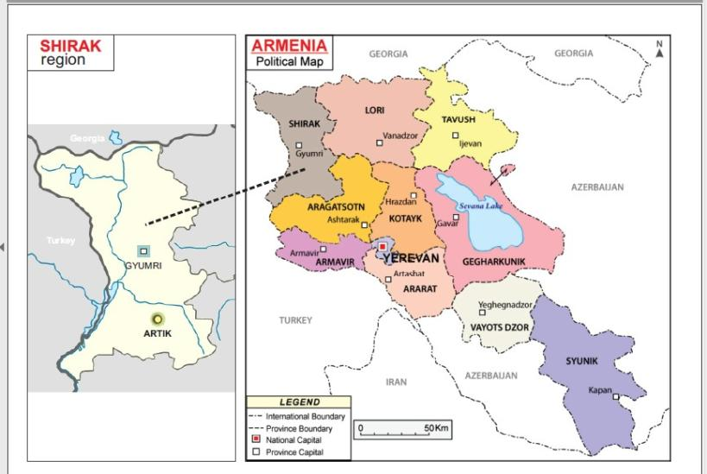

Map of Shirak marz and Artik city community
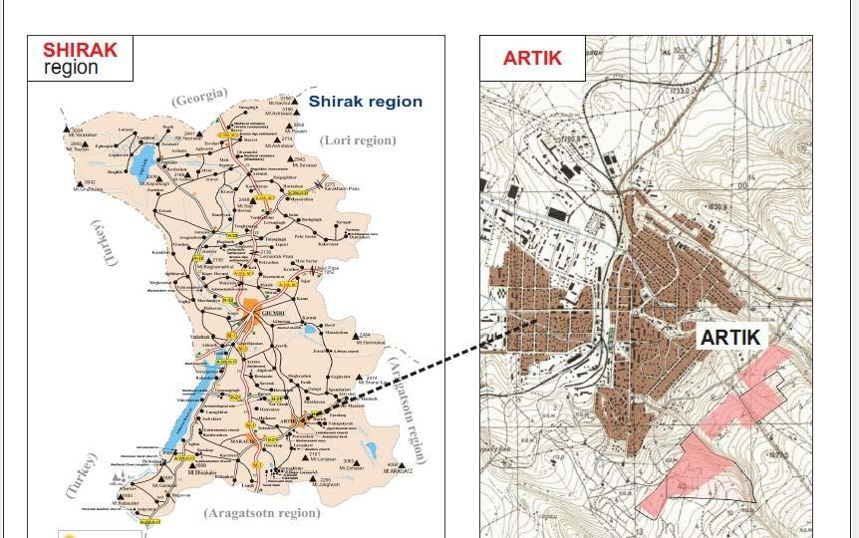
MAP of Project Area(showing Artik City and areas of works)

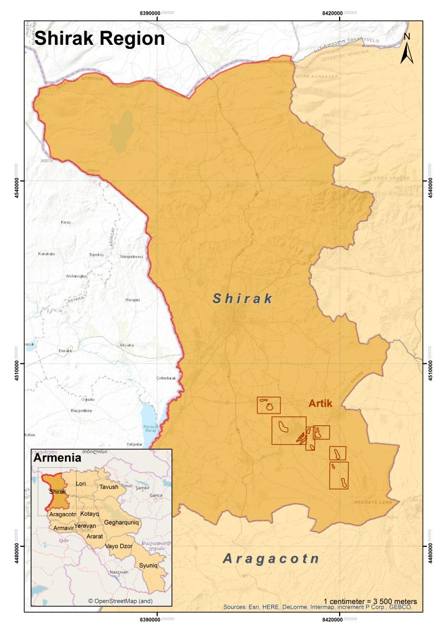

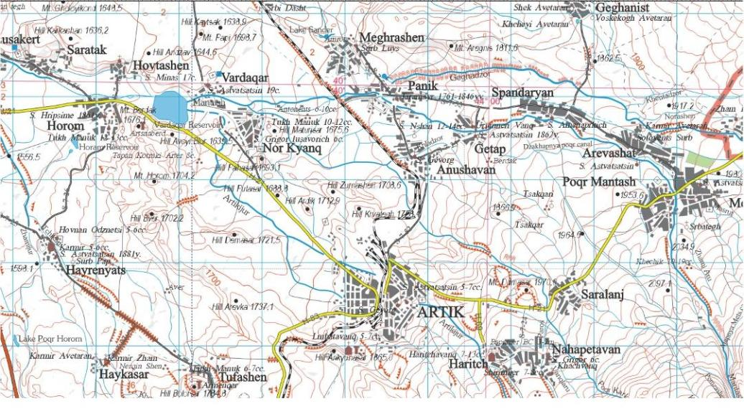
Map of Artik city and adjacent communities

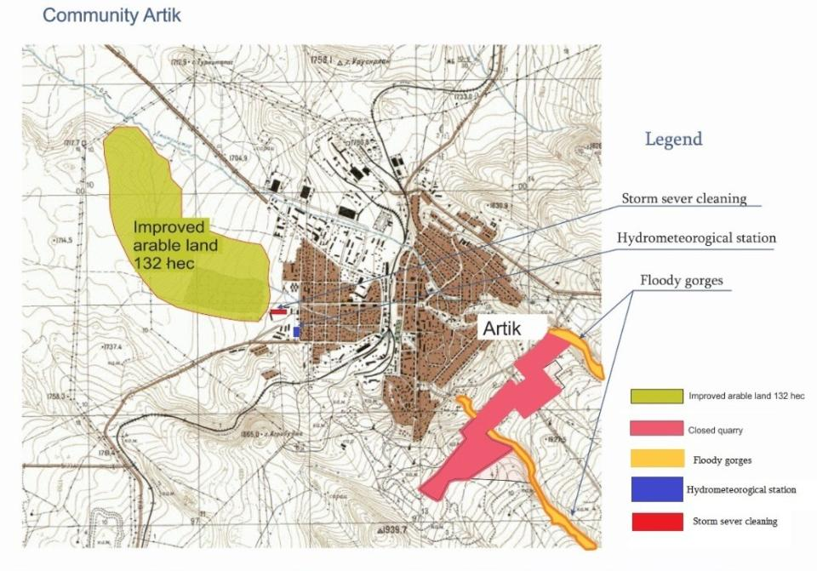
Map of suggested areas under Component 1 and Component 2

Map on the increase of adaptive capacity of natural and agricultural landscapes

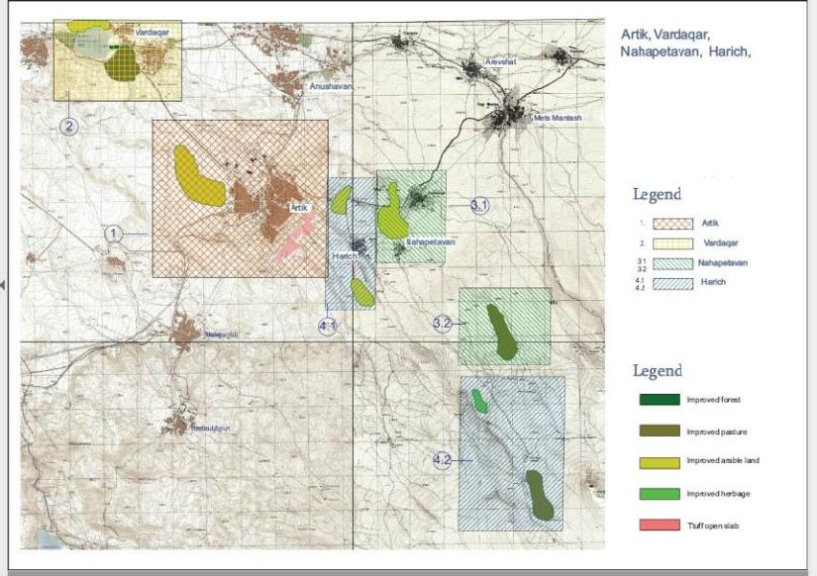

Artik city closed stone pit area
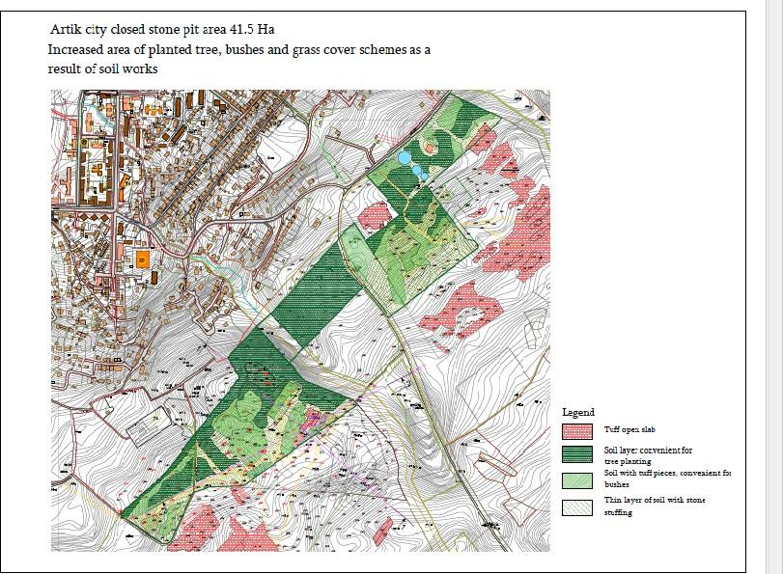

Annex 4

Extract from Decree N 20-A
of Artik City Community Council, Shirak marz, Republic of Armenia

Artik City “03” April 2018
About “Artik City closed stone pit wastes and flod management pilot project” implementing in Artik community of Shirak region of the Republic of Armenia
Guided by Article 21, Part 1, Article 18 of the Law of the Republic of Armenia on Local Self- Government, the staff of Artik community of Shirak region of the Republic of Armenia
Decides
  - To offer 45 hectares of land in the south-eastern part of the community of Artik for the forest park, recreational zone and protective forest to be created within the framework of the “Artik City closed stone pit wastes and flod management pilot project” supported by UN Climate Change Adaptation Fund, as indicated in the extract from the general plan of the city to be attached.
  - Each year, after the implementation of the project, allocate funds from the budget to ensure the protection of the flood preventive infrastructure, recreation zone created in the closed stone pit area, forestry and irrigation system transferred to Artik City. Assistance in the development of the flood insurance index scheme and, if applicable, investing in it.

Stamp Head of Community M. Varagyan Head of Secretary A. Karakhanyan

DRAFT AGREEMENT

On the maintenance of outcomes of the
“Artik city closed stone pit wastes and flood management” pilot project

Between

Ministry of Nature Protection of the Republic of Armenia And

Artik, Vardakar, Harich and Nahapetavan communities

« » « » 2018

Agreement for ensuring sustainability of project outcomes of “Artik city closed stone pit wastes and flood management” pilot project
AGREEMENT

Preface
The parties of agreement:

Take into account, that the “Environmental Projects Implementation Unit” State Agency of the Ministry of Nature Protection of the Republic of Armenia was accredited on 4 November 2016 by the Adaptation Fund of United Nations Framework Convention on Climate Change, by fund board decision B.28-29.1.

Considering, that in the conditions of climate change, there is a great risk of floods, as well as dust emissions from both closed and open stone pits, which greatly affect the population and natural and agricultural ecosystems, on the basis of the proposal from Artik city “Environmental Projects Implementation Unit” State Institution has applied to Adaptation Fund for funding of “Artik city closed stone pit wastes and flood management” pilot project , as a result of which on 13 October 2017 by the decision B.30/11, the Adaptation Fund board has agreed to make a project formulation grant to “Environmental Projects Implementation Unit” State Institution for the development of full project proposal.

Recognizing, that “Artik city closed stone pit wastes and flood management” pilot project is complete and meets the requirements for increasing the level of adaption of natural and agricultural landscapes that have been disturbed due to climate change and anthropogenic impacts.

Emphasizing, that the implementation of the project will help the authorities of Artik, Vardakar, Harich and Nahapetavan to avoid further floods and dust emissions, learn lessons and develop and implement programs for the sustainability of project outcomes.

Are convinced, that the closed mine site is not registered as mine. Here to agree as follows:

Article I Objectives
- Increase the level of adaptation of natural and agricultural landscapes in the context of global climate change.
- Manage floods by reducing their effects.
- Create an early warning system for prevention of natural disasters.
- Increase the population's knowledge on natural disaster prevention and adaptation in the context of climate change.

Article II Cooperation
Each contracting party shall cooperate with the other contracting parties to provide necessary assistance during the implementation of “Artik city closed stone pit wastes and flood management” pilot project, to exchange information and to eliminate possible obstacles.
In the cases provided for this Article, consultation and exchange of information and documents shall be without prejudice to any procedures which may be required to ensure limitations on confidentiality and accessibility of certain information and documents. Such procedures shall take effect upon the termination of any of the agreements signed between the parties in the Memorandum and within the said partnership.

Article III
Project Implementation
The project will be implemented by the Ministry of Nature Protection of the Republic of Armenia in the face of the "Environmental Projects Implementation Unit" State Institution through a grant provided by the Adaptation Fund of United Nations Framework Convention on Climate Change.
The "Environmental Projects Implementation Unit" State Institution selects the appropriate organization in a competitive manner for the purpose of implementing the program as defined by the legislation of the Republic of Armenia.
The “Environmental Projects Implementation Unit" State Institution” implements the monitoring of activities and informs the contracting parties about the results.
During the implementation of the project, the “Environmental Projects Implementation Unit" State Institution” discusses and develops mechanisms for flood index or alternative insurance in the project area with the communities, state authorities and insurance companies involved in the project.
Reports on completed works are discussed within the framework of the contracting parties and a relevant evaluation is given.
The “Environmental Projects Implementation Unit" State Institution” publishes reports and evaluations of the Contracting Parties on its official website, www.epiu.am. The final results of the activities envisaged by the Program shall be taken by mutual agreement of the contracting parties.

Article IV
Sustainability of Project Outcomes
For the purpose of ensuring the sustainability of the project results (the park established in the closed stone pit area, 2 ha of forest established in Vardakar community, recreational zone, barricades constructed in the storm canals), the contracting parties agree as follows:
- Maintenance, operation, care and renovation of the results of the activities carried out within the administrative boundaries of communities included in the program shall be carried out by the relevant local self-governing bodies.
- Local self-governing bodies may apply to the Government of the Republic of Armenia in case of necessity to receive certain assistance for maintenance and repair of project results.
- Local self-governing bodies shall take measures for the introduction of flood index or alternative insurance schemes.
- The Ministry of Nature Protection of the Republic of Armenia permanently monitors the results of the project (quarterly) and reviews the received information with the local self-government bodies.
- The local self-governing bodies immediately apply to the Ministry of Nature Protection of the Republic of Armenia and law enforcement agencies in the event of finding any anthropogenic violations of the program's results.
- The elimination of consequences of violations of the results of the program shall be carried out by the joint efforts of the contracting parties, and, where appropriate, apply to the Government of the Republic of Armenia, with the purpose of providing more appropriate support.

Article V
Term of the Agreement
The Agreement shall enter into force on the date of its signature and shall remain in force for an indefinite period.
The Agreement is signed in Armenian, with five copies. Each contracting party will be given one copy of the agreement.
Amendments and supplements to the Agreement may be made by mutual consent of the Parties by concluding a supplementary agreement which will be an integral part of this Agreement.

Article VI
Notification, addresses
Under the agreement any notification requested or permitted for delivery or presented or any claim shall be in written form. Such notice or request shall be deemed to have been duly filed or filed in the event that it is transmitted in hand, by registered mail, shipper, telegram or cable to the party to which it is required to deliver or submit to the address given below or to any other address will be announced:

Minister of the Nature Protection of the Republic of Armenia

Artik community head

Harich community head

Vardakar community head

Nahapetavan community head

Annex 4

«Ur,ra-r4 12w11wppti hwr,w4pg 41w44.wo i2wr,hwuJ2p u. 2r,hbrtbrtubr,p 4wnw4.wr,nuJ» wupnri2w4wti or,wqr,.
uuuwr,4uwu uwutiw4t,gtibpt,
5Ul/-t/
wJt,u 41wut11wra,11ra-t,

List of participants for the discussion of fully-developed project document on "Artik city closed stone pit waste and flood
management pilot project"

11.04.2018

Ubmti, wqqwumb/Name, surname

1.
2.
3.

4.

5.

fflw2U1nbo/Position Ubn[l/Sex Uriw4wll/tJq.w4wu
Male/female

(bnwtunu/tt hwugb/Telephone/ email

Ut11nrwq.r mra-Jmti/ Signature

j:._

....,


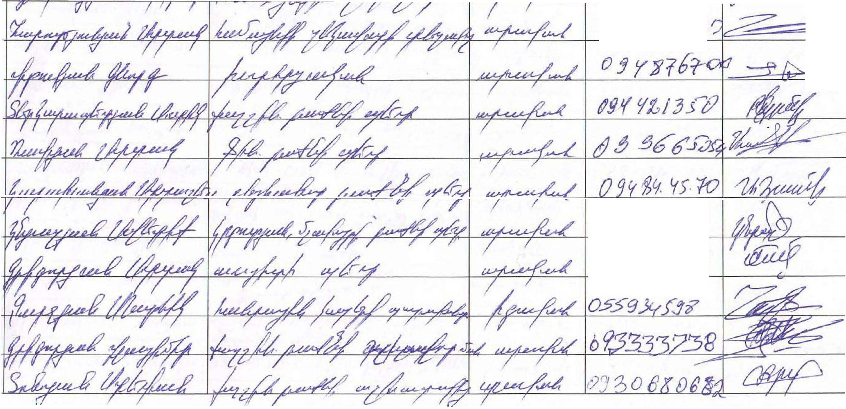
6.

- os- s.s-r.; il:f:t
8. ()�.33 '!£/l/10
9.

10.

11.

"7 �
� � �

r-
l'-")
�
")
�

�
�"" �

� ("l � I "'\. � ..)--. � �
:t

� � �'
� "<) �
:)- cl\ �
I r{.I � �-

- � � ->
� �
� �
� �t;
� --::I--

)";
� 0)
� �
�
)--

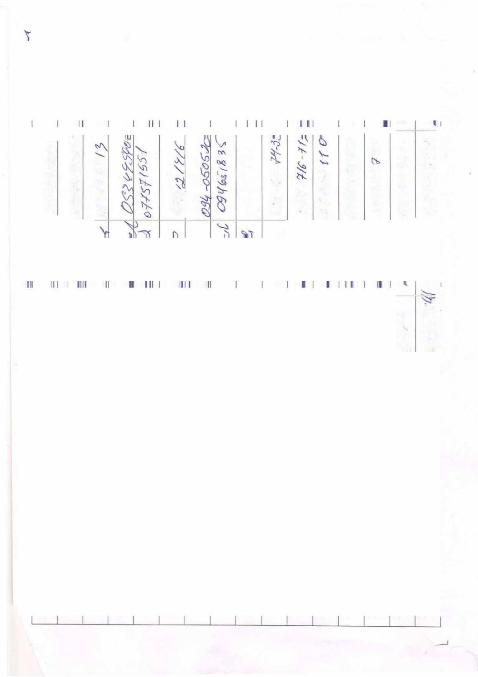
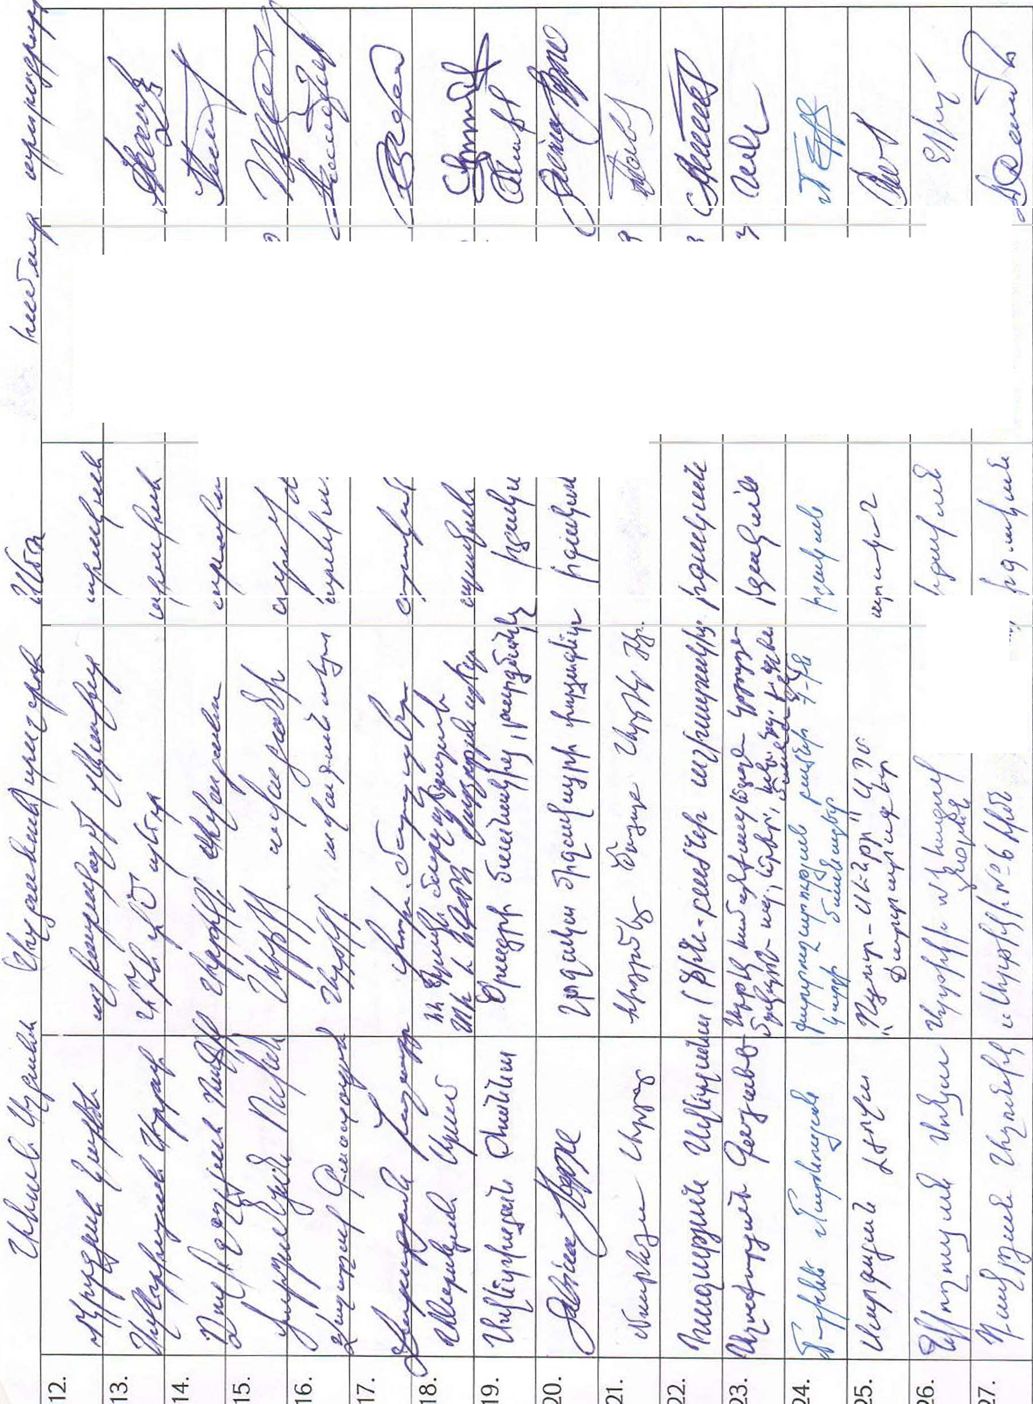
�
�
�
t
� � � �
r �t
�
�l
��


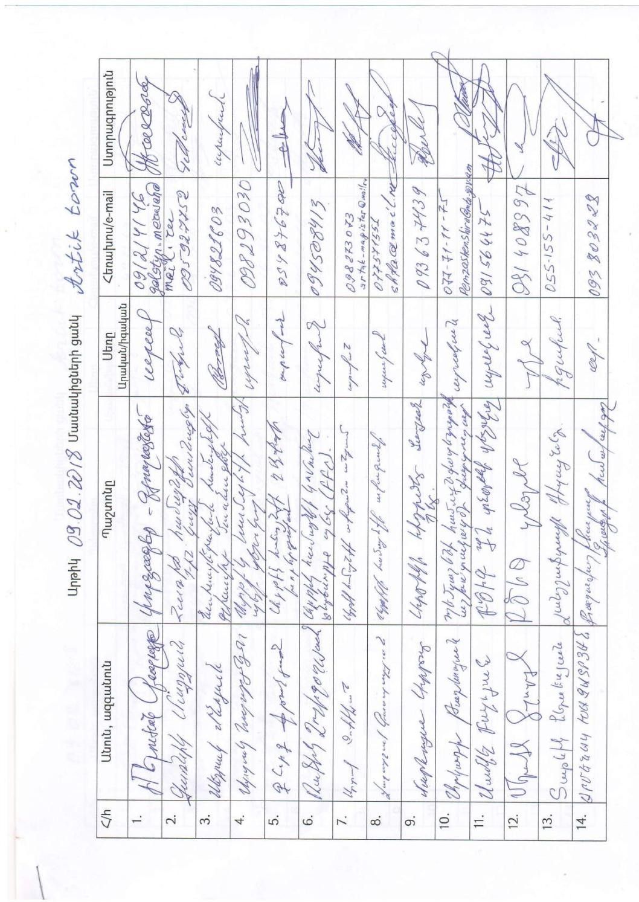
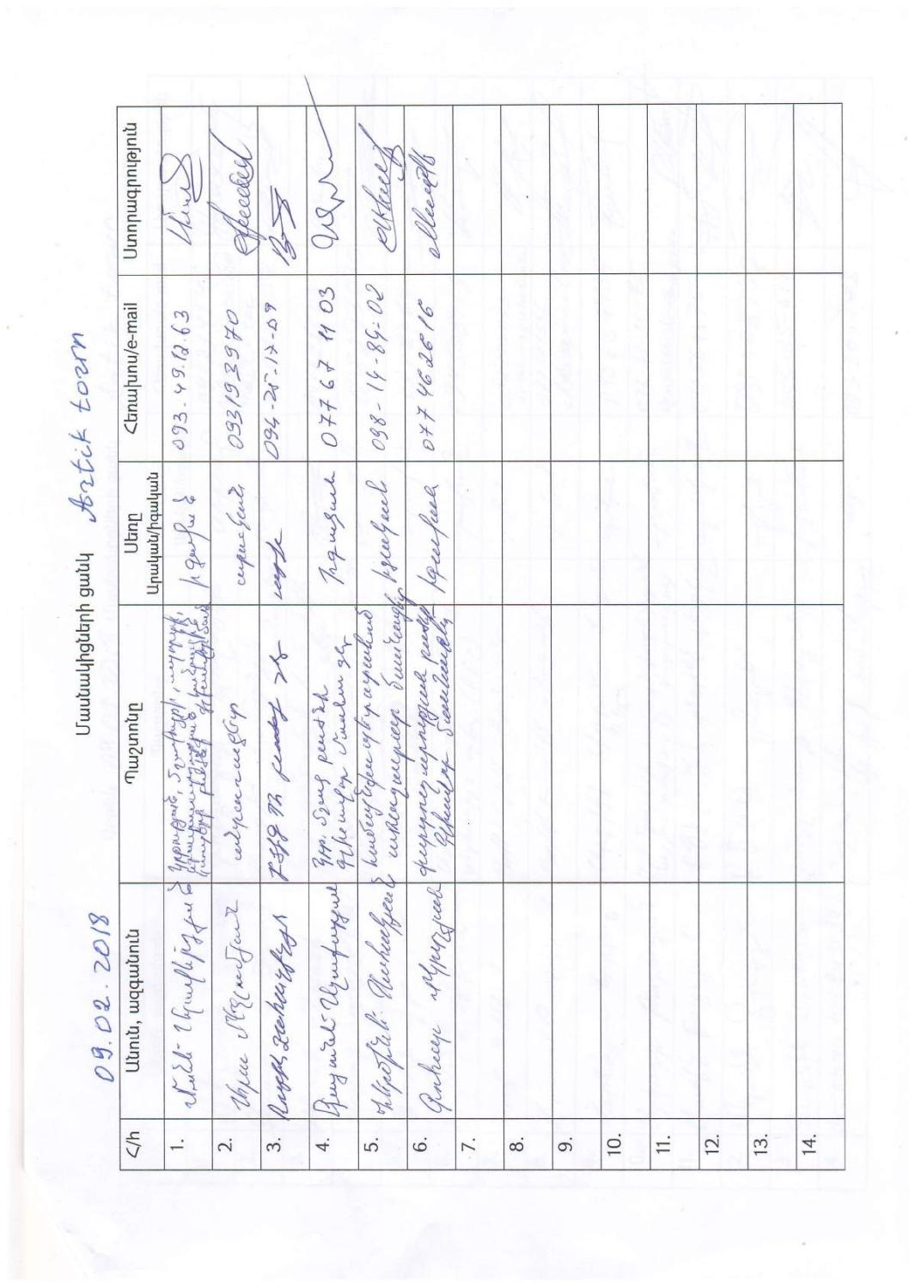
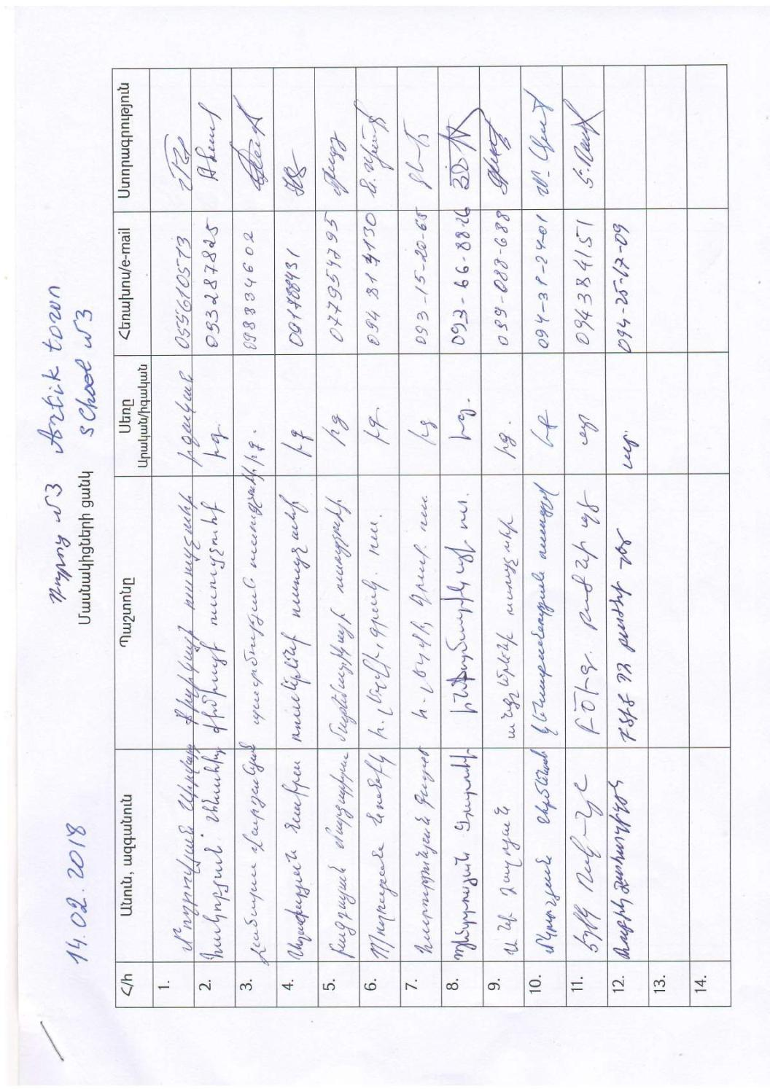
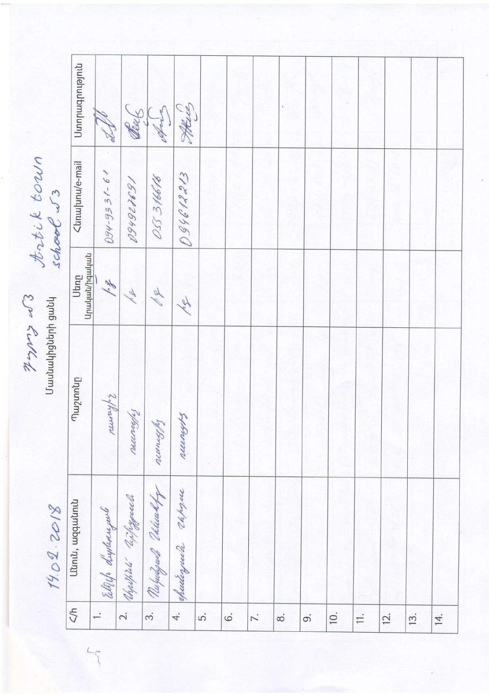
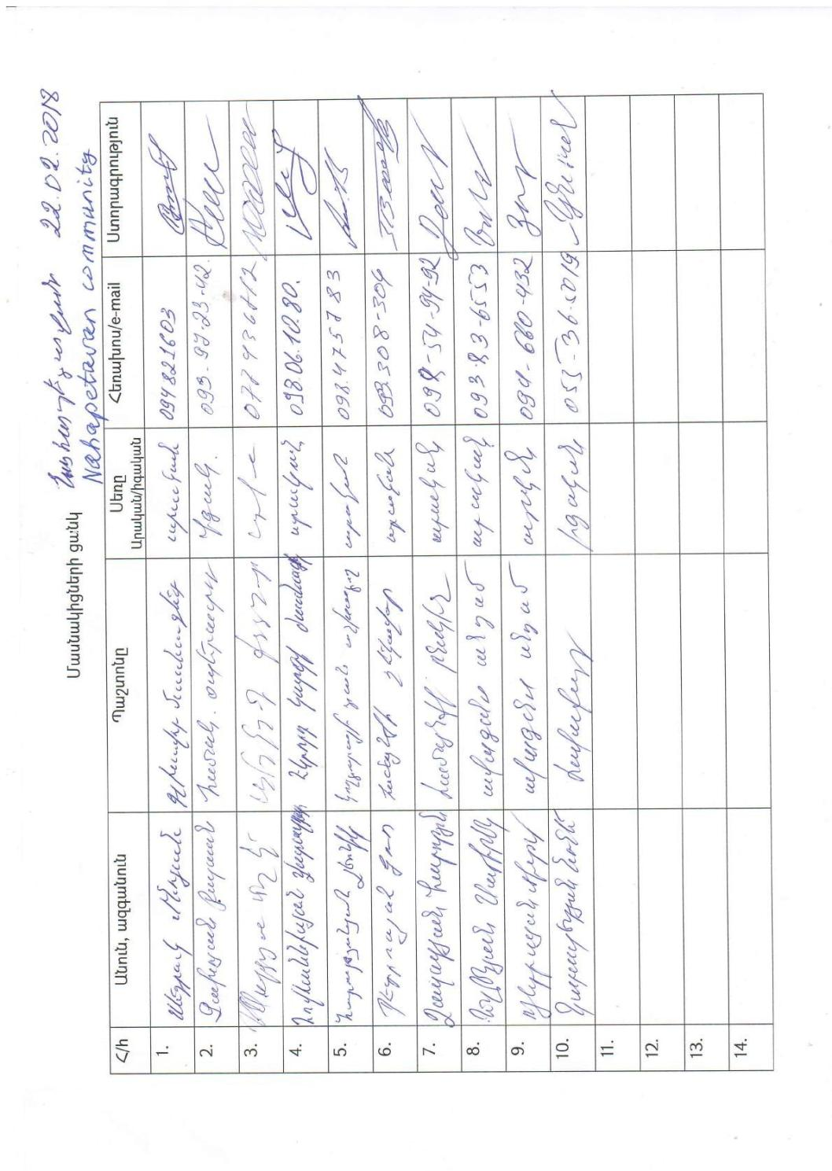
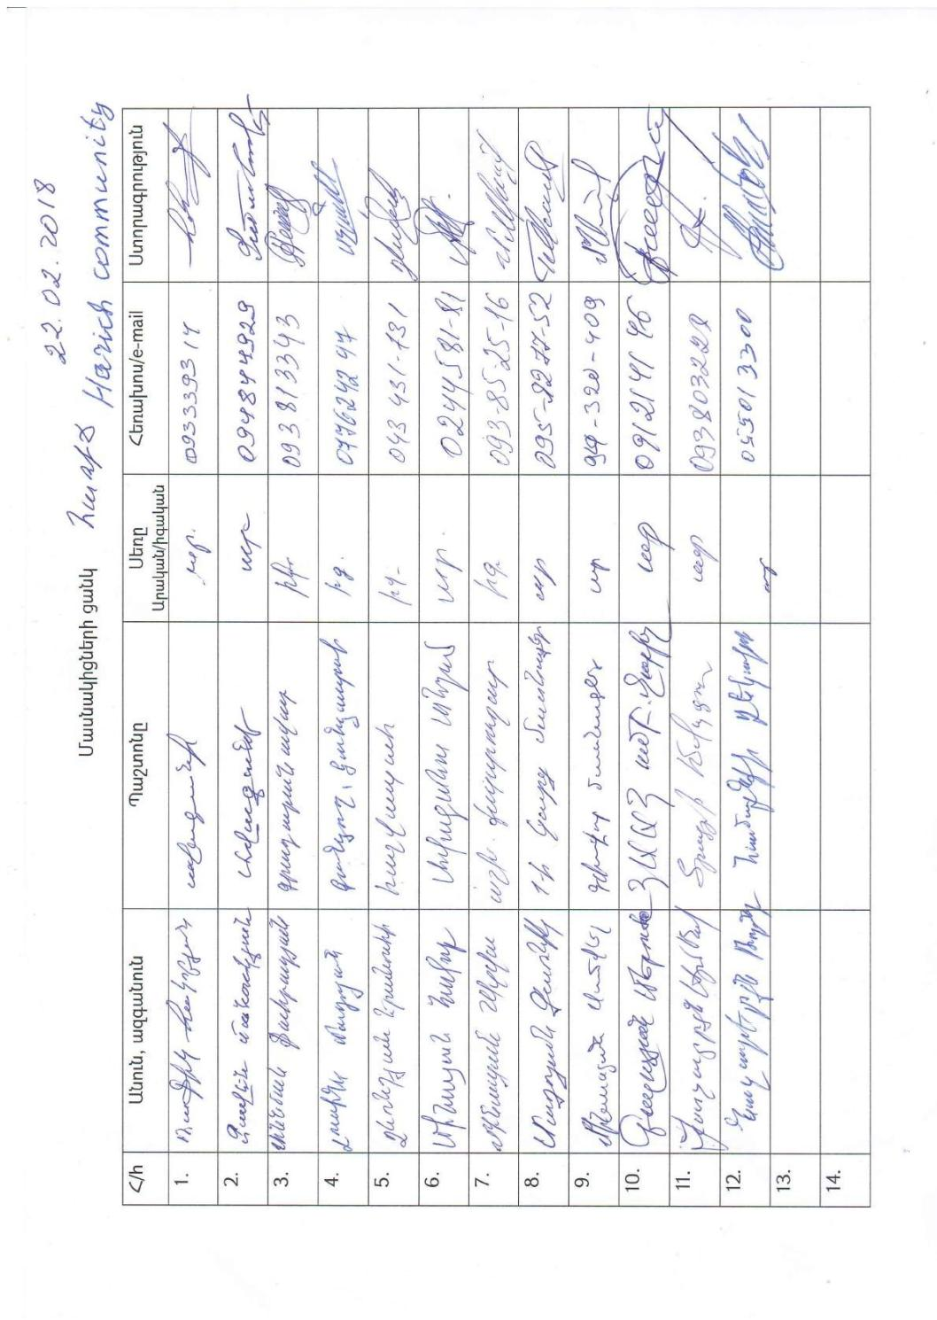
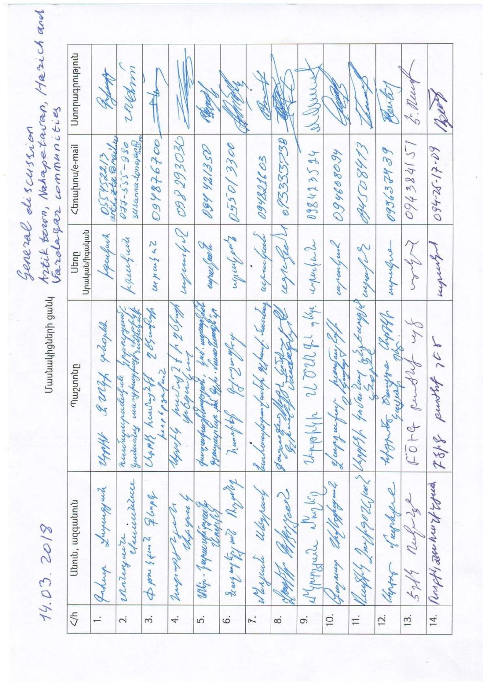

Annex 4 TO OPG GENDER POLICY AND ACTION PLAN. www.adaptation-fund.org/wp- content/uploads/2016/04/OPG-ANNEX4_Gender-Policies-and-Action-Plan_approved-in-March-2016-1.pdf.
http://www.arlis.am RA Law on Urban Developement
http://www.arlis.am/DocumentView.aspx?DocID=43044 Regulation on on examination of urban development documents
http://www.parliament.am/legislation.php?lan RA Land Code
N38http://minurban.am/lows/files/25_07_12_1.pdf9
http://www.arlis.am/DocumentView.aspx?Do
The AF utilized OECD/DAC terminology for its results framework. Project proponents may use different terminology but the overall principle should still apply

